

# DEPARTMENT OF MASTER OF COMPUTER APPLICATIONS

**LABORATORY MANUAL**

**III Semester Batch:2024-26**

**Name: LIKHITHA B K USN: 1MS24MC049**

**Course: Cloud Computing Course code: 24MCASS3 Course Credits: 0 : 1: 2**

RAMAIAH INSTITUTE OF TECHNOLOGY

#### (Autonomous Institute, Affiliated to VTU)

**Accredited by National Board of Accreditation & NAAC with 'A+' Grade, MSR Nagar, MSRIT Post, Bangalore-560054**

[**www.msrit.edu**](http://www.msrit.edu/)

## Table of Lab Programs

|  |  |
| --- | --- |
| **Sl.**  **No.** | **Programs/Exercise/Topic.** |
| 1**.** | AWS Account Setup and Configuration. AWS Console Overview. Enable MFA. Create  AWS budget alert. |
| 2. | AWS Identity Access Management (IAM) User and Group creation. Enable AWS IAM MFA. Create  an AWS Account Alias (for Alternate Sign-in URL) |
| 3. | Amazon S3 – Introduction, Bucket Creation and upload objects (files). |
| 4. | Amazon S3 – Static Website Hosting (Multi-Page website), Versioning,  Cross-Region Replication rule. |
| 5. | Overview of EC2.  To Launch a Windows EC2 Instance and Connect via RDP Client. |
| 6. | Launch a Linux EC2 Instance and Connect using SSH through PowerShell and PuTTY on Windows machine.  Launch a Linux EC2 Instance and Connect using SSH through Linux terminal on Linux machine.  Launch a Linux EC2 Instance and Connect through EC2 connect option on the console. |
| 7. | Hosting a static website on EC2 instance:   * Manual Installation of Apache (httpd) Web Server on EC2 for Static Website Hosting. * Launching an EC2 Instance with User Data Script to Automatically Install Apache and Host a Static Website. |
| 8. | Custom AMI   * Create a Custom AMI from a Working EC2 Instance. * Launch an EC2 Instance using a Custom AMI. * Delete the custom AMI [Deregister and delete snapshot] |
| 9. | **Mini-Project:** Hosting a Multi-Page Website using EC2 and S3  Submission: 11-11-2025, Marks: 5 |
| 10. | Creation and Configuration of a Custom AWS **Virtual Private Cloud** (VPC).  [Including Public and Private Subnets, Internet Gateway, NAT Gateway, Route Tables] |
| 11. | Launching and Configuring EC2 Instances for **Web Server in Public Subnet** and **Database**  **Server in Private Subnet** Using NAT Gateway for Outbound Access. |
| 12. | Deploying and Testing a **Load-Balanced Web Application**  By Creating a Web Server, Building a Custom AMI, Configuring a Target Group, Launching an Application Load Balancer (ALB), Registering the Instance in the Target Group, and Testing the ALB DNS. |
| 13. | **Stress Testing** a Linux EC2 Instance (CPU Load Test) |
| 14. | **Mini Project:**  Deploying a Load-Balanced Web Application using **Application Load Balancer** (ALB), **Auto Scaling Group** (ASG), Custom AMI, and Target Group on AWS with CloudWatch Alarms & Stress Testing for Auto Scaling Validation.  Submission: 22-11-2025, Marks: 5 |

|  |  |
| --- | --- |
| 15. | Hosting a WordPress Content Management Website on Amazon **Lightsail**. (only demo) |
| 16. | Building a Basic Python Flask Web Application — Fundamentals of Web Requests & Form  Handling (**Pre-Requisite for AWS RDS Connectivity Lab**) |
| 17. | Flask Web App with Registration & Login Using AWS **RDS** (MySQL)  (Full Deployment on AWS EC2 + AWS RDS) |
| 18. | Creating and Operating a NoSQL Key-Value Database using Amazon **DynamoDB** |
| 19. | **ElastiCache** (Redis) as an In-Memory Cache |
| 20. | Deploy a simple Flask application on AWS **Elastic Beanstalk** and verify it using the public  URL. |
| 21. | Deploy a Flask App on AWS **Elastic Beanstalk** and Perform CRUD on **DynamoDB** (Using  AWS SDK/boto3) |
| 22. | **CloudFormation** – Launch EC2 (Amazon Linux 2023) + Install Apache using UserData |
| 23. | Static Content Pulled from S3 using **CloudFormation** [EC2 + S3] |
| 24. | AWS **Lambda:** Input Processing, Business Logic Execution, and CloudWatch Logging. |
| 25. | Event-Driven Notification System using **AWS Lambda** and Amazon **SNS** |
| 26. | Analyze data in a CSV File stored in S3 Using **Amazon Athena** (No Server) |
| 27. | Smart Sensor Monitoring System using **AWS IoT Core**. Cloud-Based IoT Data Ingestion and Processing using AWS |
| 28. | Accelerate an S3 Static Website Using **Amazon CloudFront** (CDN) |
|  | **Mini Project** – Global Static Website Delivery using S3 + CloudFront with Cache Update |
|  | **Mini Project** – Deploying a Containerized App on AWS using **Amazon EKS** |

**Date: 8-10-2025**

**Exercise 1:** AWS Account Setup and Configuration. AWS Console Overview. Enable MFA. Create AWS budget alert.

AWS Console overview / AWS Home page/ AWS Dash board

Widgets – default view/ Add or remove widgets - small panels on the dashboard showing metrics or shortcuts; users can add or remove them as needed.

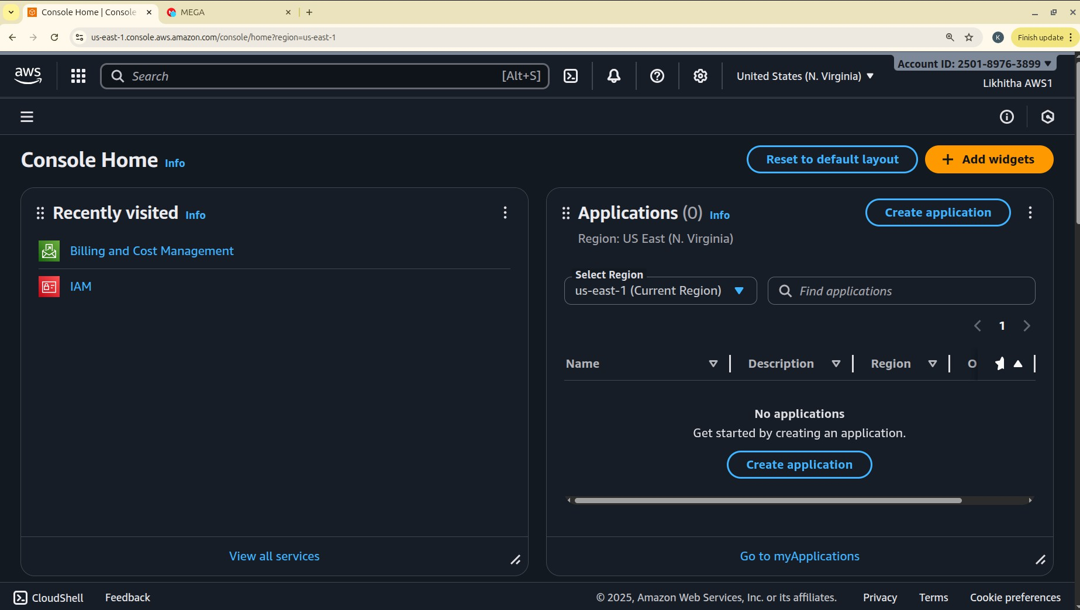

Region – Specifies the geographical data center location where your AWS resources are deployed.

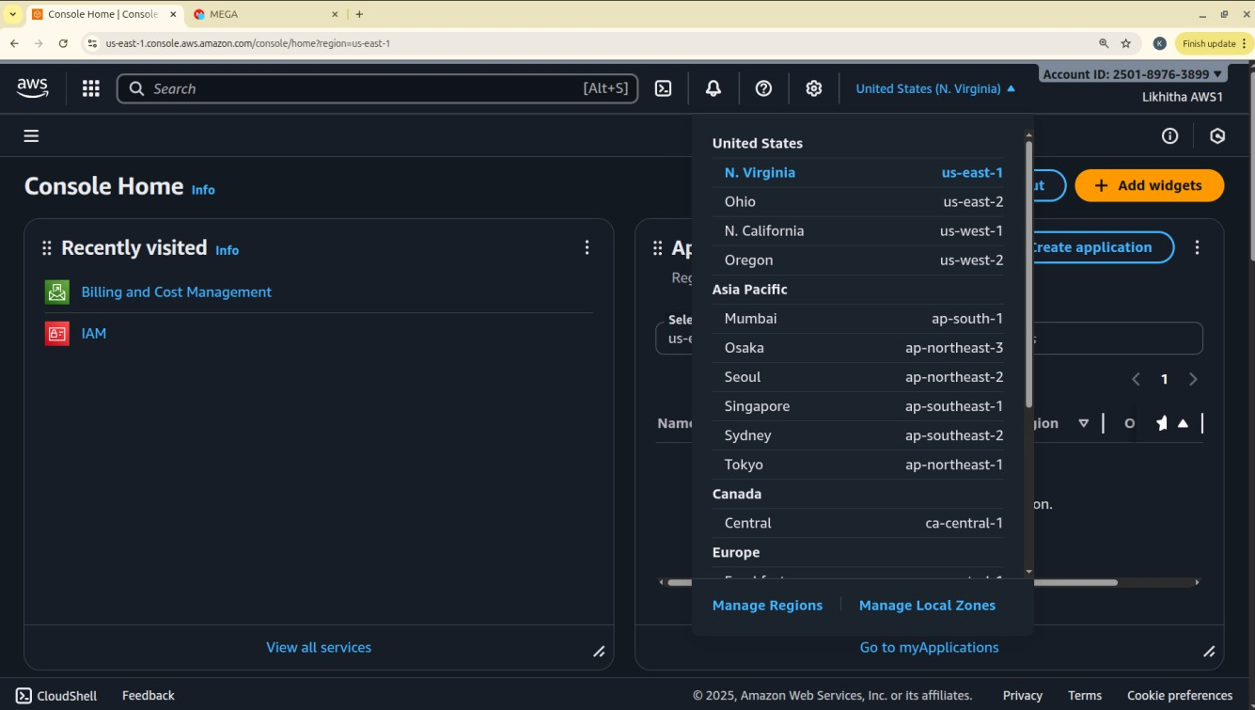

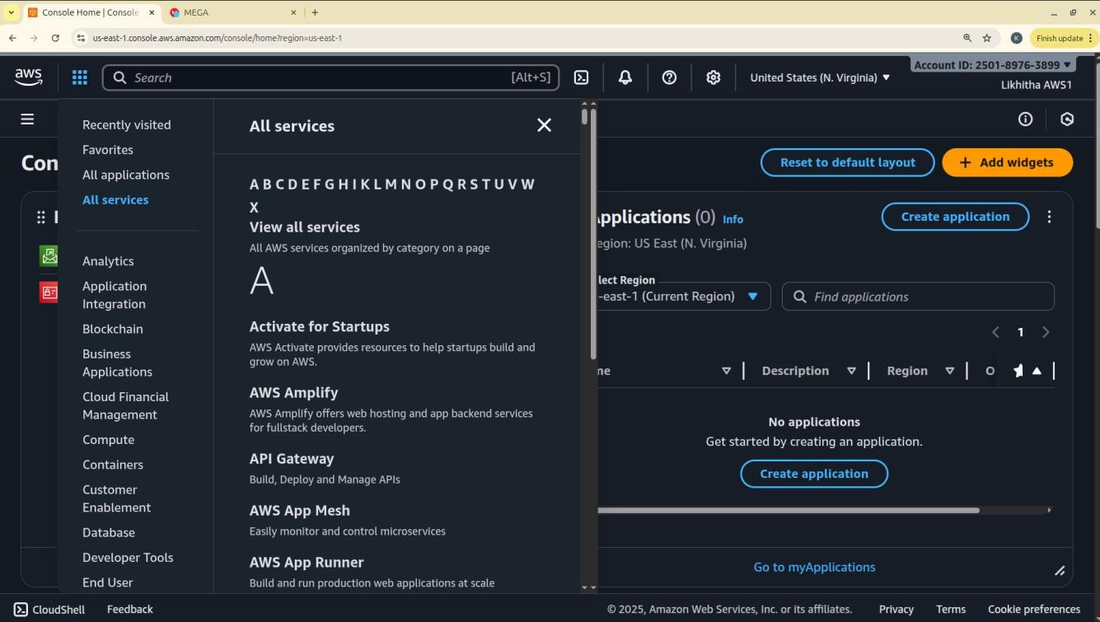

Services – A categorized list of all AWS offerings such as Compute, Storage, Database, etc.

Search bar – A quick-access bar to search and pin frequently used services for faster access.



pin the most used services to console by clicking on star next to the service name.

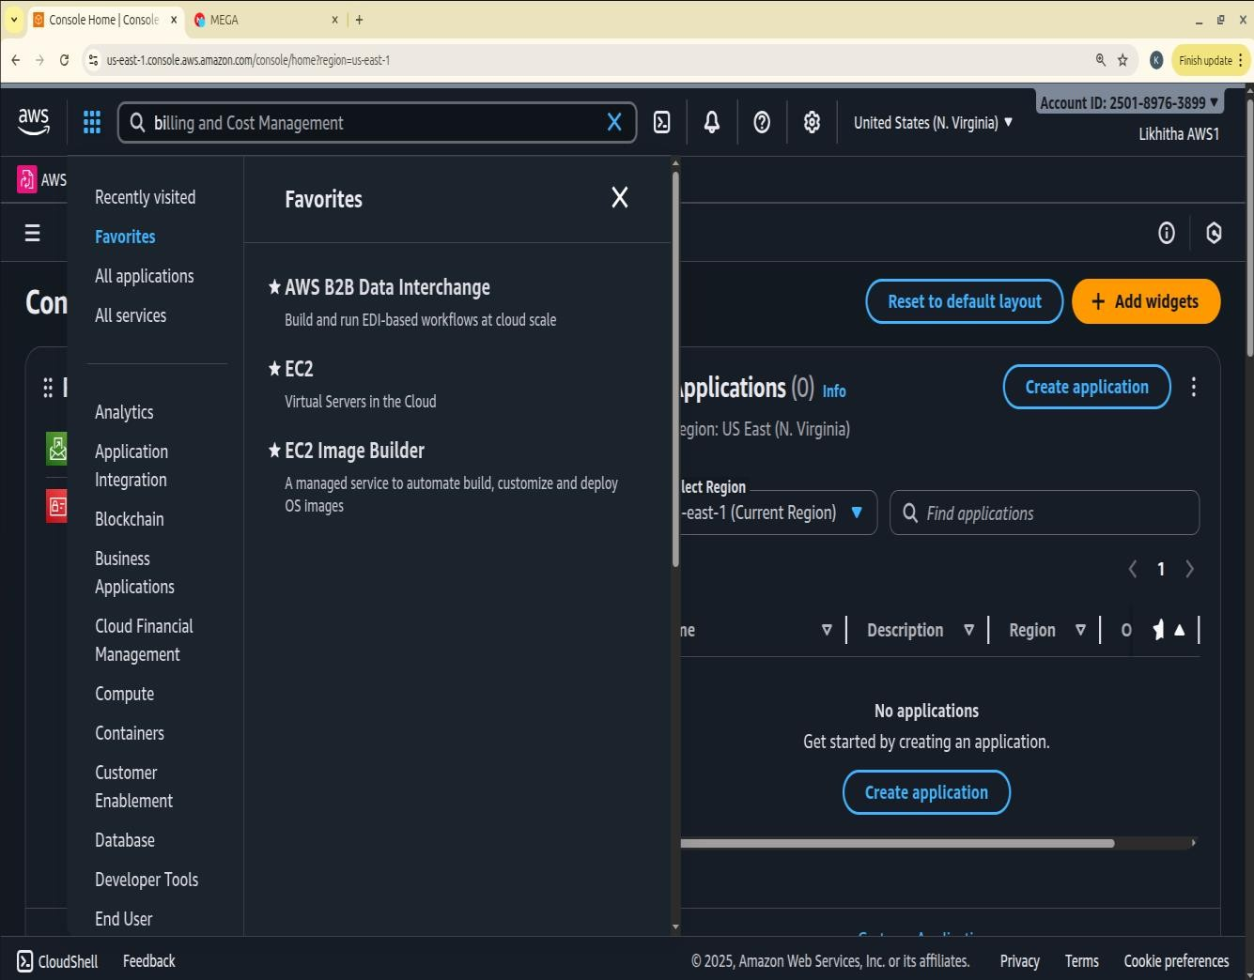

**Enable MFA**

#### Notes

* Make sure your phone is unlocked, Bluetooth is on, and it uses a screen lock (fingerprint/PIN).

**Option 1: Add a Passkey for Easier Login Step1: Go to Security Credentials**

* **Sign in to AWS console.**
* Go to **your username → Security credentials**.
* Under **Multi-factor authentication (MFA)** click **“Assign MFA device.”**
* Choose **“Passkeys and security keys”** → **Next**.
* On the next screen choose **“Phone or tablet”**.
* AWS will show a **browser pop-up** asking to use a device.
  1. Select **your phone** (or “Use another device” if it prompts).
* Look at your phone — you should get a **“Use passkey”** or **biometric prompt**.
* Approve using **fingerprint or phone PIN**.
* Back in AWS, click **Finish**. The passkey is now your MFA method.

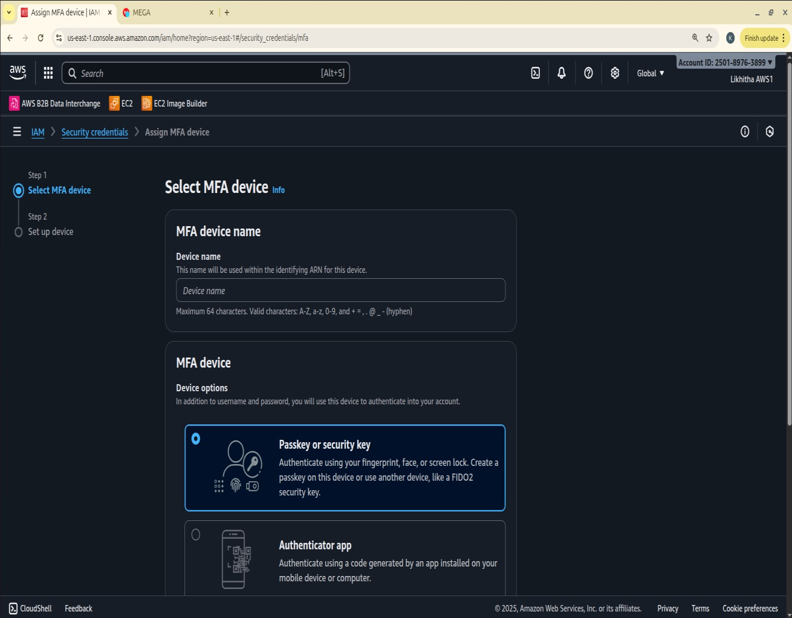

Next time you sign in, just choose **“Sign in with a passkey” → approve on phone**. **Step 2: Test the Login**

* Sign out of AWS.
* Go to the login page.
* Choose “Sign in with a passkey” → Select your phone.
* Approve the prompt on your phone — you should be signed in without any MFA codes.

#### Option 2: Authenticator App

This uses a 6-digit code from Google Authenticator / Authy / Microsoft Authenticator.

1. In **Security credentials**, click **“Assign MFA device.”**
2. Select **“Authenticator app”** → **Next**.
3. A QR code appears.
4. Open your authenticator app on your phone → **Add account → Scan QR code**.
5. The app shows a 6-digit code.
6. Enter that code back in AWS → **Assign MFA**. You’ll use the 6-digit code from the app each time you log in.

Create AWS budget alert

Allows to create a simple budget and to send alarms to registered email. Example: if you are close to or exceeding your designated budget.

By setting a budget you can monitor budget threshold from the start. Creating a budget

Step 1:

In the search bar type budgets and under the search results:

Select ‘Budgets’ from the Features group, which is essentially a feature of Billing and Cost Management service.

Step 2: After the ‘Budgets’ page loads Click on Create Budget button

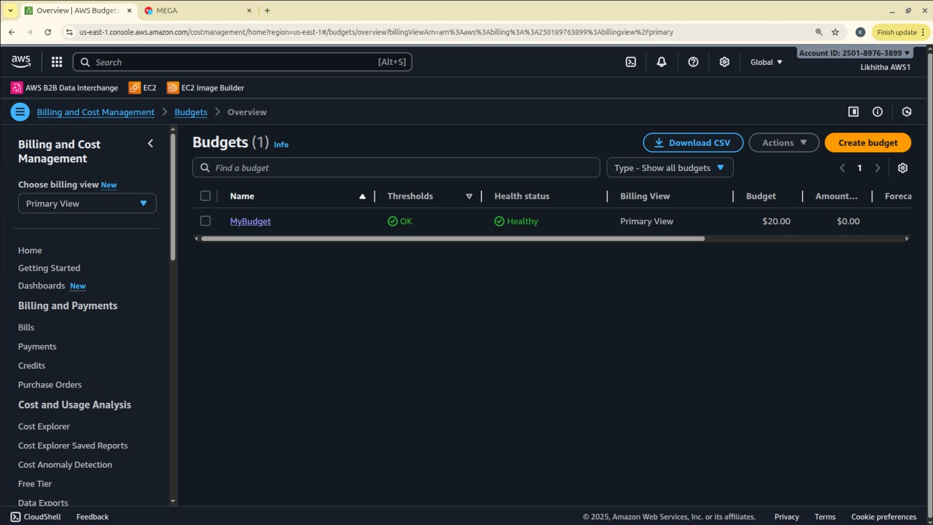

Under Budget setup select ‘Customize’ option

Under Budget types select ‘Cost budget’ option Click on Next button.

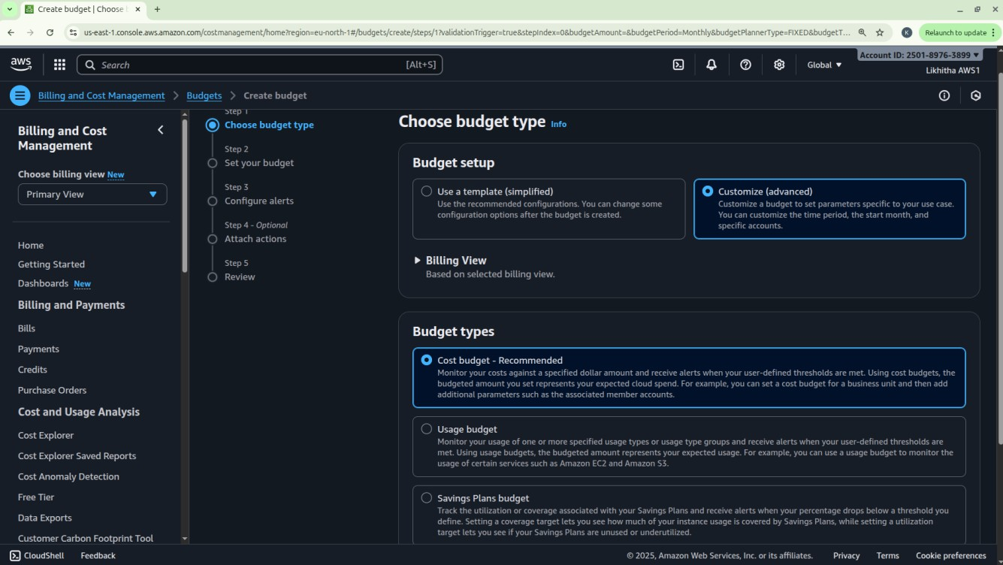

Step 3: Set your budget page loads and fill in the details: MyBudget, Monthly, Recurring budget, set Month and Year, select Fixed – Budgeting method - Enter your budgeted amount – 20.00, select ‘All AWS services’ Scope options. Advanced options – leave it on default.

Click on Next button.

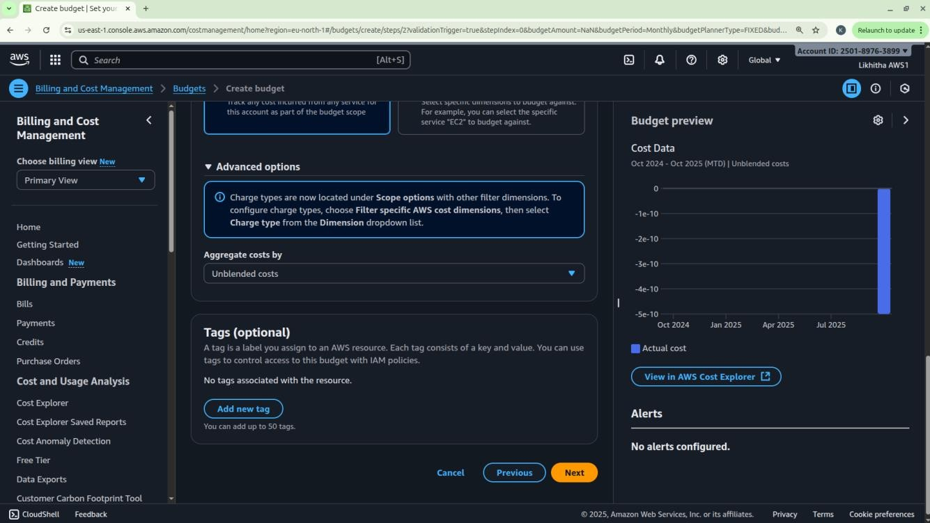

Step 4: Configure alerts

Click on Add an alert threshold Under Set alert threshold

Set Threshold: 80 and Trigger: Actual Email recipients: enter your email id. Click on Next button.

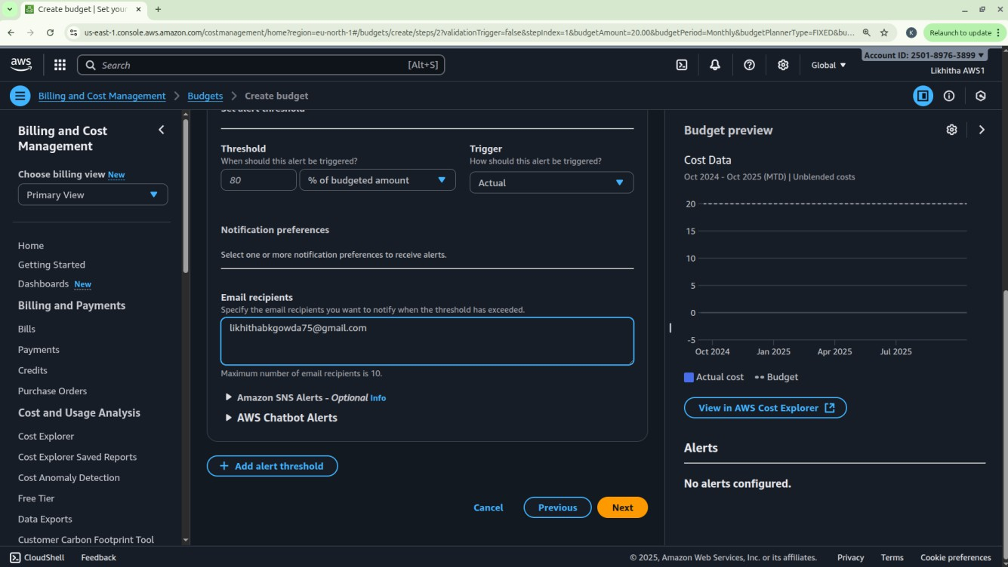

Step 5: Under Attach actions – leave it on default Click on Next button.

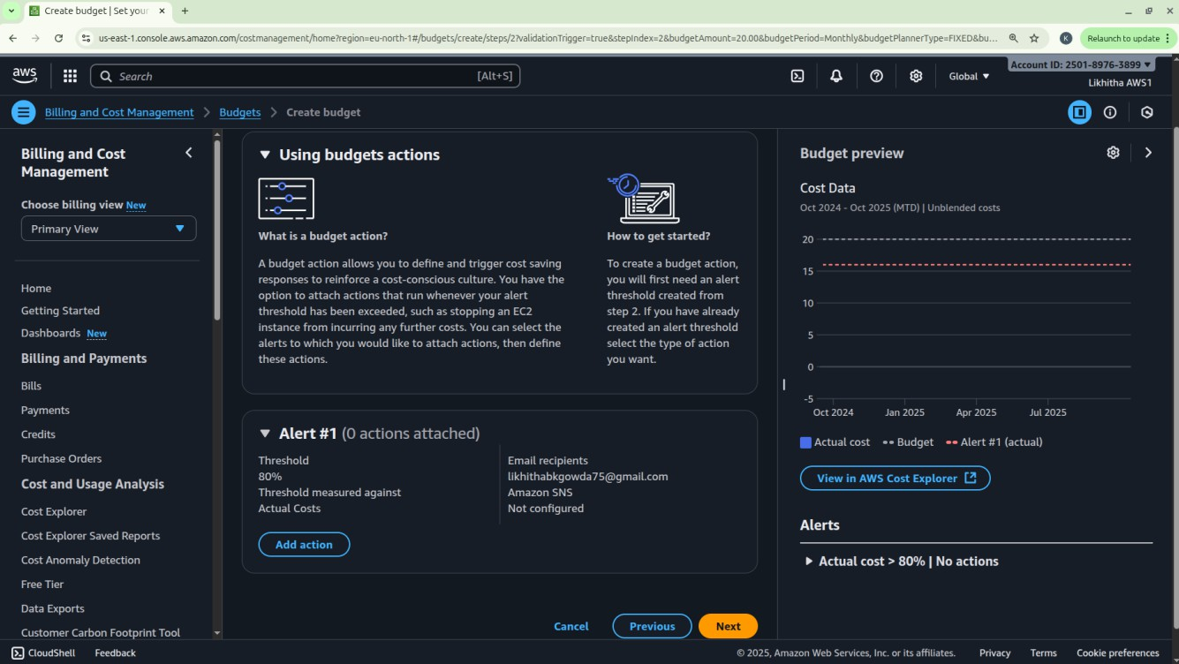

Step 6: In review page – check and review all the options are set to what is desired.

Click on Create budget button.

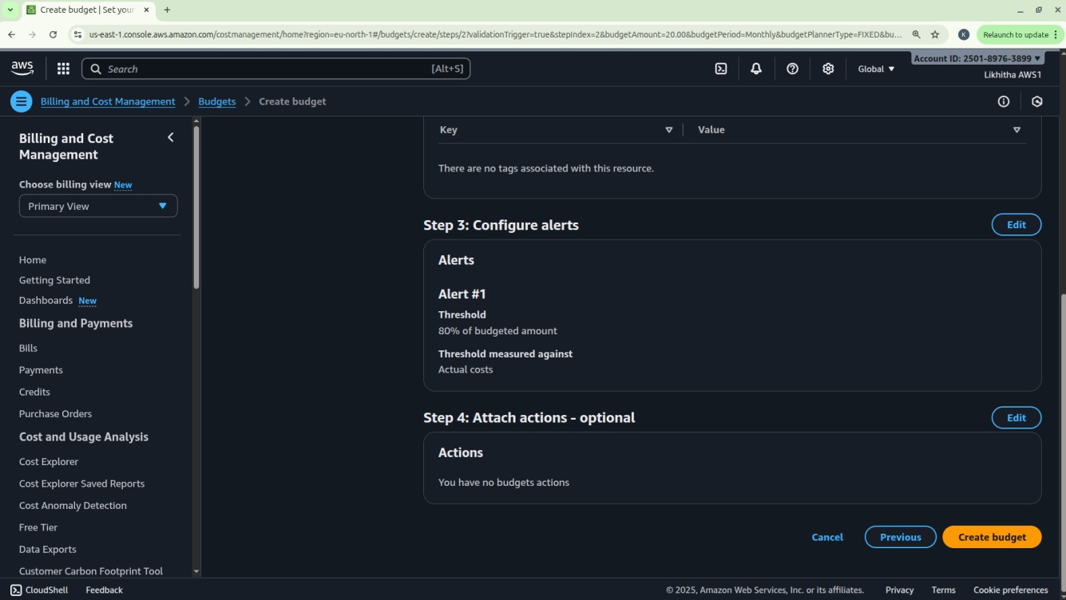

Now, the budget has been created.

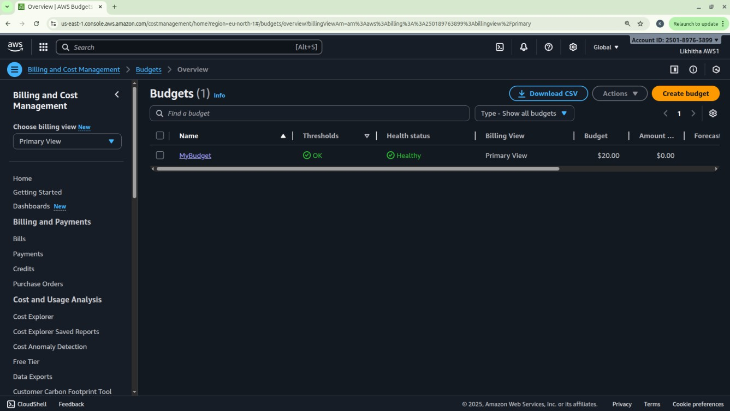

## Date: 9-10-2025

**Exercise 2:** AWS Identity Access Management (IAM) User and Group creation. Enable AWS IAM MFA. Create an AWS Account Alias (for Alternate Sign-in URL)

AWS Identity and Access Management (IAM) is a security service that helps you control who can access your AWS resources and what actions they can perform. It is a global AWS service. It allows you to securely manage users, groups, roles, and permissions in your AWS account.

|  |  |
| --- | --- |
| Concept | Description |
| Root User | The account owner who created the AWS account. Has full access and should be used  only for account setup. |
| Group | A collection of IAM users that share the same permissions. For example, a “Developers” group or “Students” group. |
| User | A person or application that interacts with AWS (e.g., student1, admin, developer). Each user has its own username, password, and access keys. |
| Policy | A JSON document that defines what actions are allowed or denied (e.g., “allow S3  read access”). |
| Role | A set of permissions that can be temporarily assumed by a user, service, or application  — often used by EC2 instances or Lambda functions. |

#### STEPS for AWS IAM User Group Creation Step 1: Sign in to AWS Console

Log in to your AWS Management Console using an administrator account. From the Services menu, search for IAM and open it.

#### Step 2: Open Groups Section

* In the IAM dashboard, look at the left sidebar.
* Click on “User groups” → then click “Create group”.

#### Step 3: Name the Group

* Enter a Group name (example: Developers, Admins, Students, etc.).
* Group names must be unique within your account.

#### Step 4: Attach Permissions Policies

* You can attach IAM policies to define what members of the group can do. Select the following:
  + AdministratorAccess → Full access to all services.
  + IAMUserChangePassword

#### Step 5: Review and Create

* Review all details (group name + permissions).
* Click “Create group” to finalize.

#### Group Successfully Created

* The new group now appears in the IAM dashboard.
* Any user added to this group automatically inherits all permissions attached to the group.

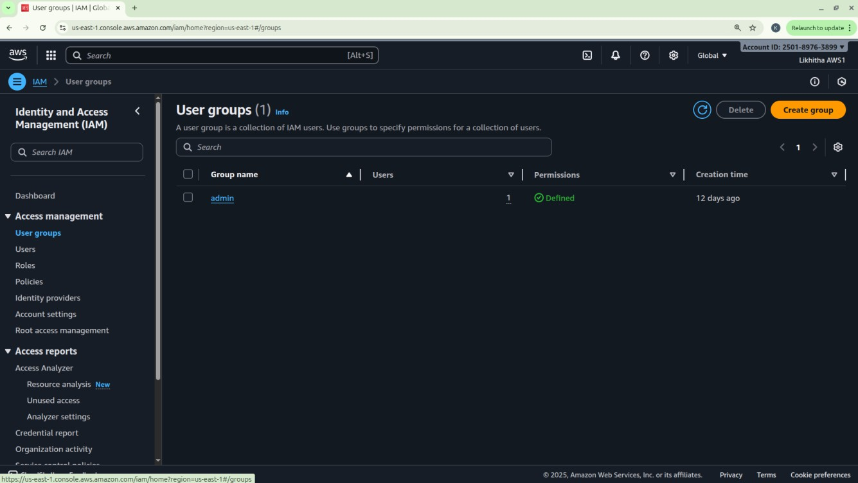

**STEPS for AWS IAM User Creation**

#### Step 1: Sign in to AWS Management Console

* Login to the AWS Management Console using your root user credentials.
* In the search bar, type IAM and open IAM service.

#### Step 2: Navigate to Users Section

* In the IAM dashboard’s left panel (info panel), click on Users.
* Then click on the “Add users” button.

#### Step 3: Set User Details

* Enter a user name.
* Checkbox – ‘Provide user access to the AWS Management Console’.
* Select ‘I want to create an IAM user’ option

#### Step 4: Set Permissions

You can grant permissions to the new user in three ways:

1. Add user to group – Assign predefined permission groups.
2. Copy permissions from an existing user.
3. Attach existing policies directly.

Recommended: Use IAM **groups** to manage permissions easily.

#### Step 5: Set User Details and Tags (Optional)

* + Add tags like Department: MCA or Role: Faculty/Student for easy identification.
  + Click Next to review.

#### Step 6: Review and Create User

* + Review all settings (user name, permissions, tags).
  + Click Create user.

#### Step 7: Save Credentials

* + After creation, AWS displays:
    - Console sign-in URL
    - Username
    - Password

**NOTE:** Download or copy these credentials immediately — they cannot be retrieved later.

#### Step 8: Test the User Login

* + Visit the IAM login URL provided (unique for your AWS account).
  + Log in with the newly created username and password.
  + Verify access and permissions.

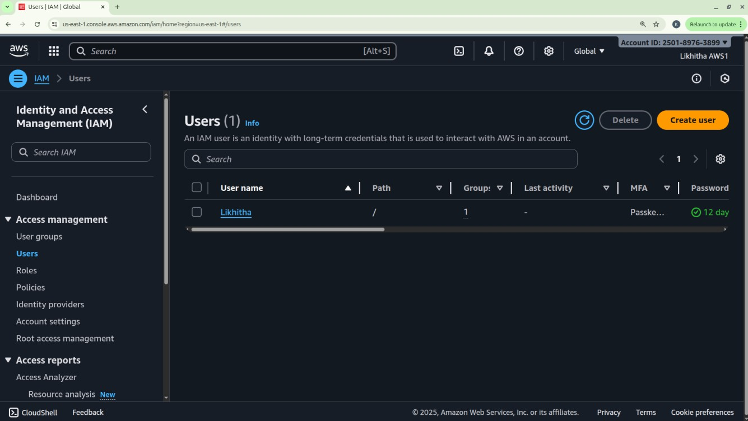

Enable AWS IAM MFA

**Step 1:** Sign in to AWS Console as root user

#### Step 2: Open IAM Dashboard

* + In the search bar, type IAM and select IAM (Identity and Access Management).
  + From the left navigation pane, select Users.

#### Step 3: Select a User

* + Click the user name for whom you want to enable MFA.
  + This opens the User Summary page.

#### Step 4: Go to Security Credentials Tab

* + Click the Security credentials tab.
  + Scroll down to the section “Multi-factor authentication (MFA)”.

#### Step 5: Assign MFA Device

* + Click “Assign MFA device”.
  + Choose the MFA type:

1. Virtual MFA device (e.g., Google Authenticator, Authy — most common)
2. Security key (hardware-based, e.g., YubiKey)
3. Authenticator app on phone

#### Step 6: Configure Virtual MFA

* + If you select Virtual MFA device:

1. Open your Google Authenticator or Authy app on your phone.
2. Scan the QR code shown on the AWS screen.
3. The app starts generating 6-digit codes.

#### Step 7: Verify MFA

* + Enter two consecutive codes from your app in the verification fields.
  + Click “Assign MFA”.

#### Step 8: Confirm Setup

* + You will see a green checkmark confirming MFA is successfully assigned.
  + The user now requires MFA each time they sign in.

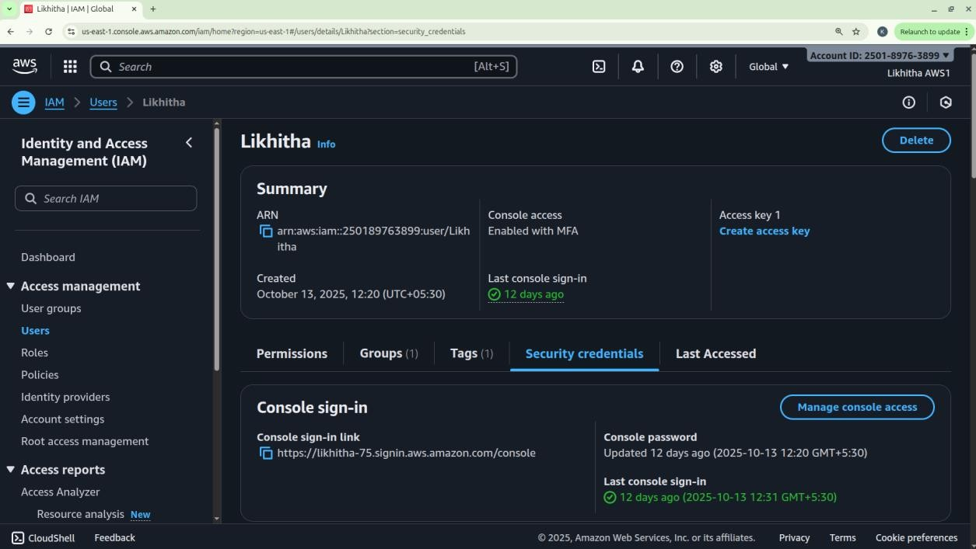

Create an AWS Account Alias (for Alternate Sign-in URL)

As an IAM user you can sign in using the default URL or create an account alias for it.

An Account Alias gives your AWS account a name instead of using the long numeric Account ID in your sign-in URL.

This makes it easier for IAM users to remember and log in.

#### Step 1:

* + Sign in to the AWS Management Console using root user or an IAM user with administrative privileges.
  + In the search bar, type IAM, and open the IAM service.

#### Step 2:

* + In the left navigation pane, scroll down and select Dashboard.

#### Step 3:

* + Under the “AWS Account” section, find “Account Alias”.
  + Click on “Create” (or “Edit” if one already exists).

#### Step 4:

* + In the pop-up box, enter your preferred alias name.
  + Click “Create alias”.

#### Step 5:

* + Once created, you’ll see a new Sign-in URL displayed.

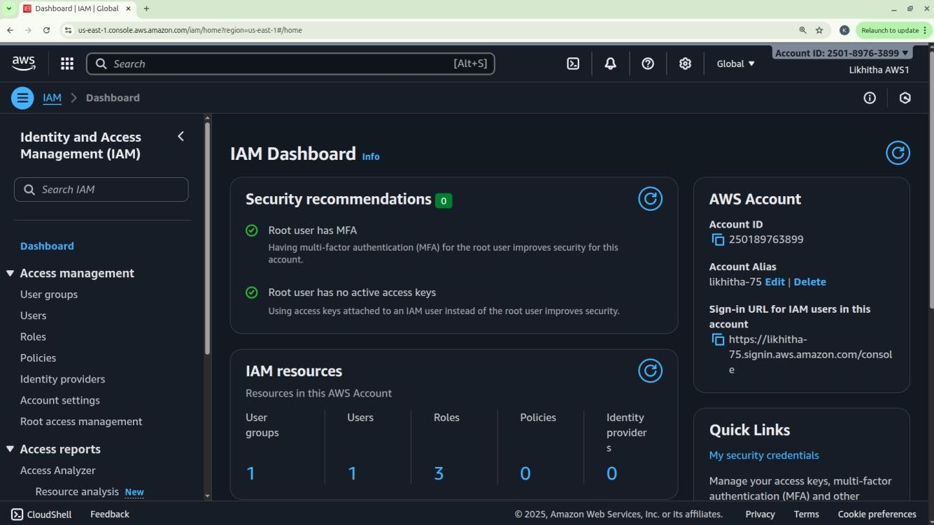

## Date: 14-10-2025

**Exercise-3:** Amazon S3 – Introduction, Bucket Creation and upload objects (files).

Amazon S3 (Simple Storage Service) is a fully managed, object-based storage service offered by AWS. It allows you to store and retrieve unlimited amounts of data from anywhere on the web.

Unlike traditional file systems that store data in folders, S3 stores data as objects inside buckets. Each object has:

1. Data (the actual file),
2. Metadata (information about the file),
3. Unique key (its name within the bucket).

You can store unlimited data in Amazon S3.

However, each AWS account can create up to 100 buckets by default (can be increased by request). Each object (file) can be up to 5 TB (terabytes) in size.

Single upload limit: 5 GB (may vary), but larger files can be uploaded using Multipart Upload.

Amazon S3 is designed for:

* + Durability: 99.999999999% (11 nines) – this means your data is extremely safe.
  + Availability: 99.99% uptime – your data is almost always accessible.
  + S3 automatically stores multiple copies of your data across multiple Availability Zones in a region.

Storage classes: S3 offers different storage classes depending on cost and frequency of access.

|  |  |
| --- | --- |
| Storage Class | Description |
| S3 Standard | For frequently accessed data (default). |
| S3 Intelligent-Tiering | Automatically moves data between frequent - infrequent access tiers. |
| S3 Standard-IA | For infrequently accessed data but still quickly available. |
| S3 Glacier | For archival storage (low cost, slower retrieval). |
| S3 Glacier Deep Archive | For long-term archival (lowest cost). |

Each object can be accessed through a **unique URL**. S3 is commonly used for:

Backup and archival Static website hosting Application data storage Media content delivery

|  |  |
| --- | --- |
| **Feature** | **Description** |
| Buckets | Top-level containers for storing objects. |
| Objects | Actual files stored in S3 (e.g., images, HTML, PDFs). |
| Region | Each bucket is created in a specific AWS region. |
| Versioning | Maintains multiple versions of the same object for recovery. |
| Static Website Hosting | Allows you to host HTML pages directly from an S3 bucket. |

**Steps to Create an S3 Bucket and Upload an Image**

#### Step 1: Open the S3 Service

* + Sign in to your AWS Management Console.
  + In the search bar, type S3 and click Amazon S3.

#### Step 2: Create a New Bucket

* + Click “Create bucket”.
  + Bucket type: General purpose
  + Bucket name: Enter a name (Bucket names must be globally unique and lowercase.)
  + AWS Region: Choose the region nearest to you.
  + Scroll down and uncheck:

“Block all public access” → Uncheck this (for viewing file publicly). Confirm the warning checkbox.

* + Keep all other settings as default.
  + Click Create bucket.

#### Step 3: Upload an Image File

1. Click on the newly created bucket name.
2. Click Upload → Add files.
3. Choose any image file from your computer.
4. Scroll down and click Upload.

#### Step 4: Make the Object Public

By default, S3 objects are private. To view them in a browser, make the file public.

1. After upload, go to the Objects tab inside your bucket.
2. Select the uploaded file.
3. Click Actions → Make public using ACL (or Object actions → Make public, depending on console version).
4. Confirm.

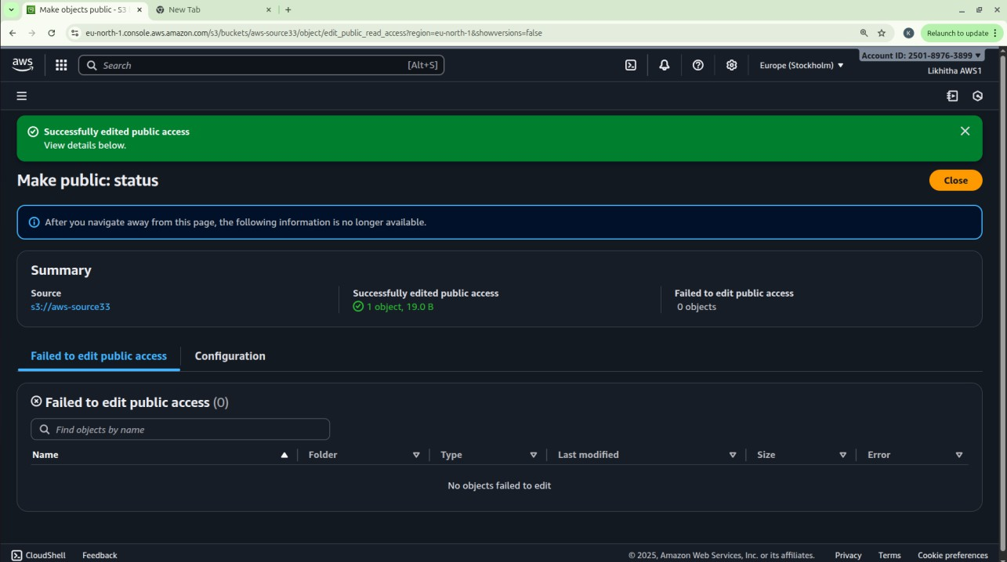

#### Step 5: Copy the Object URL

1. Open the object again by clicking its name.
2. Scroll down to the **Object URL** section.
3. Copy this URL and open it in a new browser tab.

The image is displayed directly from the S3 bucket — meaning AWS S3 is serving that object over HTTP.

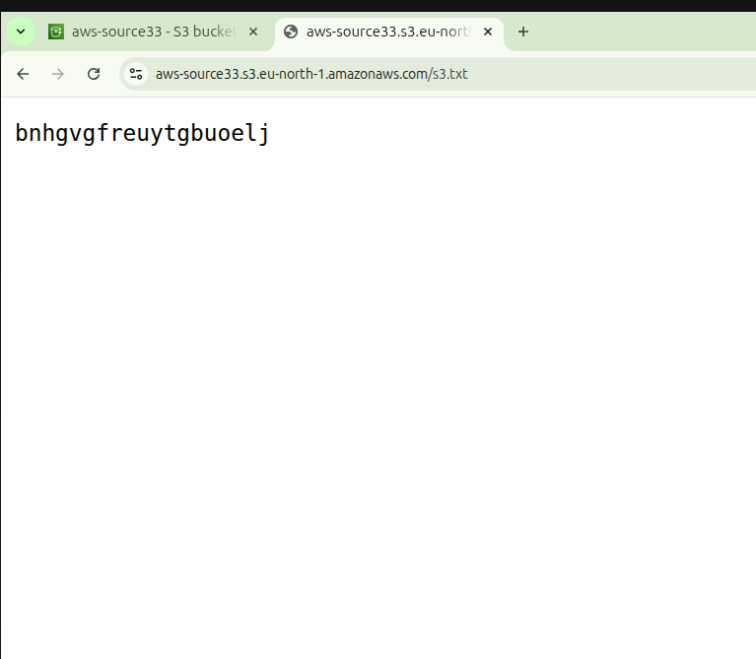

## Date: 16-10-2025, 23-10-2025

**Exercise-4:** Amazon S3 – Static Website Hosting (Multi-Page website), Versioning, Cross- Region Replication rule.

**Amazon S3 Static Website Hosting**

Amazon S3 can host a static website – [a website consisting of only HTML, CSS, JavaScript, images, etc. – no server-side scripting like PHP or Python].

When you enable “Static Website Hosting,” your S3 bucket acts like a web server, and AWS provides a public website URL to access it.

You can create a multi-page static website (e.g., index.html, about.html, contact.html) and upload it to S3. Links within these pages allow users to navigate between them just like a normal website.

**Steps to Create a Multi-Page Static Website on S3 Step 1:** Create an S3 Bucket

* Open the AWS Management Console → Navigate to S3.
* Click Create bucket.
* Select Bucket type: General purpose
* Enter a unique bucket name (e.g., my-static-web-demo).
* Select ACLs enabled under Object Ownership section.
* Uncheck “Block all public access” → acknowledge.
* Click Create bucket.

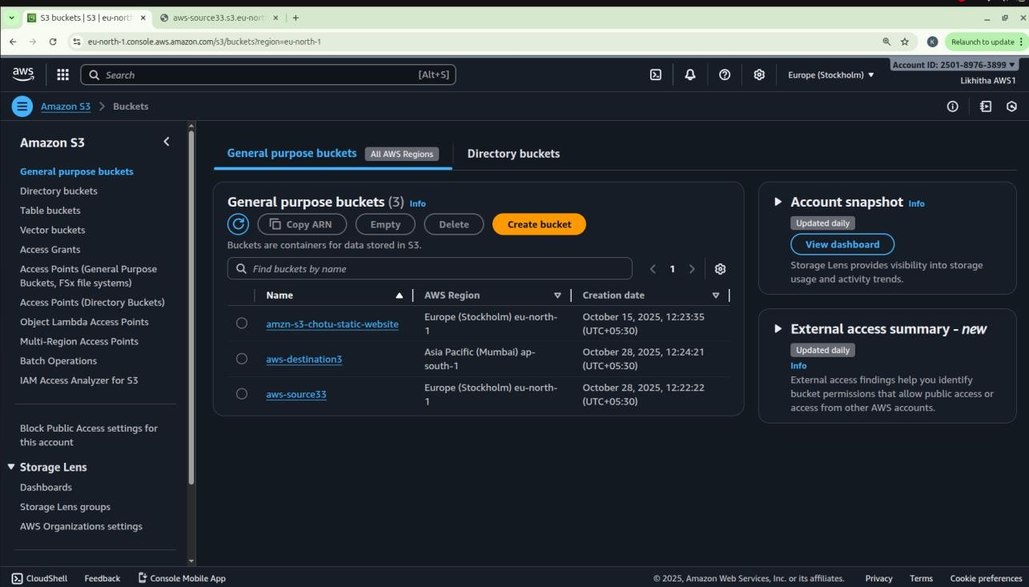

**Step 2:** Prepare Website Files

Before uploading, organize your files in a folder structure as follows: my-website/

│

├── index.html

├── about.html

├── contact.html

├── error.html

└── images/

└── banner.jpg

Each HTML file should include navigation links.

**Step 3:** Upload Website Files

* Open your S3 bucket → Click Upload.
* Add all files and folders (HTML, CSS, JS, images).
* Click Upload to store them in S3.

**Step 4:** Enable Static Website Hosting

* Go to the **Properties** tab of the bucket.
* Scroll down to Static website hosting → Click Edit.
* Choose Enable and select ‘Host a static website’.
* Set:
  + Index document: index.html
  + Error document: error.html
* Click Save changes.

**Step 5:** Make Files Public (Bucket Policy)

By default, your files are private. To make them public:

* Go to the **Permissions** tab → Bucket Policy → Edit.
* Paste the following policy (replace bucket name):

{

"Version": "2012-10-17",

"Statement": [

{

"Sid": "PublicReadGetObject", "Effect": "Allow",

"Principal": "*", "Action": "s3:GetObject",

"Resource": "arn:aws:s3:::my-static-web-demo/*"

}

]

}

* Save the changes.

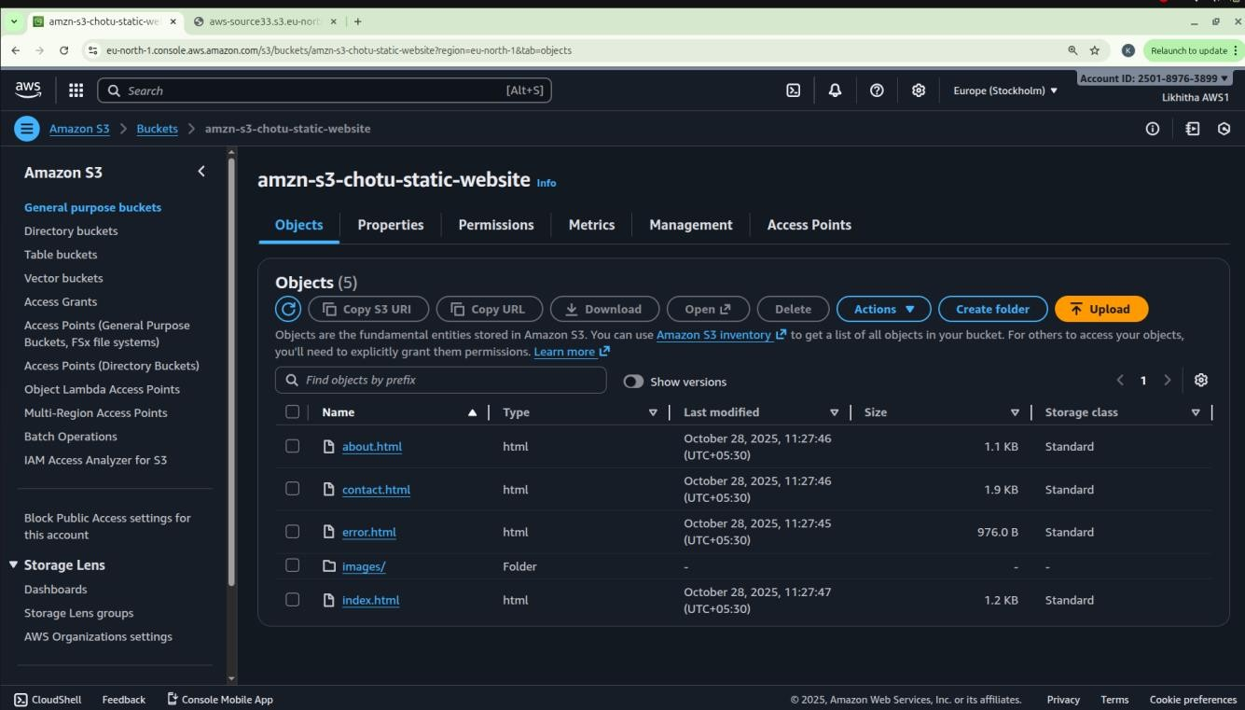

**Step 6:** Access Your Website

* Go to the Properties tab → Scroll to Static website hosting.
* Copy the Bucket Website Endpoint URL.
* Paste it into your browser — your homepage (index.html) should appear.

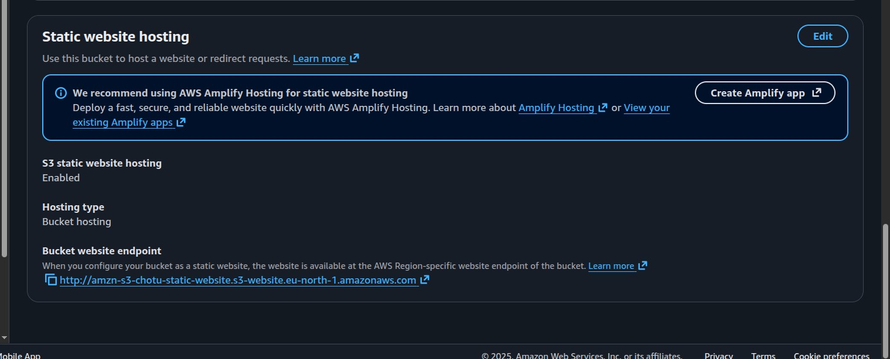

* Use the header links to navigate between pages (About, Contact, etc.).

#### When Will the Error Page Be Shown?

If a user enters a wrong URL or tries to access a file that doesn’t exist (e.g., /abc.html), Amazon S3 automatically displays the file you set as the **Error document** (error.html).

**Amazon S3 Versioning**

Versioning allows you to keep multiple versions of an object in a bucket.

If a file is accidentally deleted or overwritten, you can recover the previous version. Each version gets a unique version ID.

**Steps to Enable Versioning**

* Go to your S3 bucket
* Open the Properties tab
* Scroll to Bucket Versioning
* Click Edit → Enable
* Click Save changes

Now whenever you upload a file with the same name, S3 will keep both versions.

**Note:** You can view versions by clicking “List versions” in the bucket objects page.

**To Restore or Delete a Specific Version**

* Click the object name → Versions
* Select the desired version → Download / Delete (Deleting only adds a delete marker — older versions are still stored.)

**Cross-Region Replication (CRR) – is a rule created on S3**

CRR automatically copies objects from one S3 bucket (source) to another (destination) in a different AWS Region.

Used for disaster recovery, compliance, or low-latency access in another region. Requires Versioning to be enabled on both buckets.

**Steps to Set Up CRR**

**NOTE:** Enable Versioning on both: Source bucket

Destination bucket

**Step 1:** Choose a different region before you create Destination bucket Create Destination Bucket first.

**Step 2:** Create Source Bucket

Give replication permission:

Source bucket → Management tab→ Replication rules → Create rule

**Step 3:** Create Replication Rule page Enter a Replication rule name Status: Enabled

Source bucket section:

Choose a rule scope: select “Apply to all objects in the bucket”

Destination:

Select “Choose a bucket in this account” Bucket name: Select the destination bucket

IAM role:

Select “Create new role”

[An IAM role gives Amazon S3 permission to replicate objects from your source bucket to your destination bucket.

S3 replication won’t work unless you assign (or create) a role with the right permissions. IAM Role: Either create a new role automatically or choose an existing one]

**Step 4:** Save

Any new objects uploaded to the source bucket will automatically replicate to the destination region.

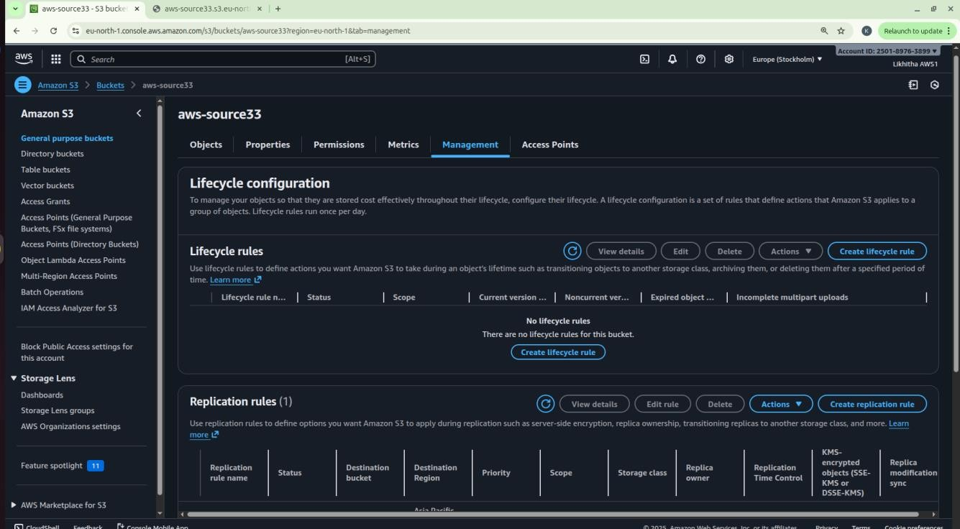

**Note:** Replication is not retroactive — only new uploads after enabling CRR are copied.

Reminder – Resource cleanup – to release/delete/terminate the resources created.

## Date: 29-10-2025

**Exercise-5:** Overview of EC2, To Launch a Windows EC2 Instance and Connect via RDP Client

**Amazon Elastic Compute Cloud (EC2)** is a core AWS Compute service that lets you run virtual servers (instances) in the cloud.

Amazon EC2 is an Infrastructure as a Service (IaaS) offering from AWS.

It allows you to launch virtual machines to host applications and manage them remotely – wherever you are in the world.

#### Key concepts:

**Instance -** A virtual machine running in the AWS cloud.

**AMI (Amazon Machine Image) -** A pre-configured template that includes: OS (Linux, Windows, etc.), Application software, other configurations.

**Instance Type -** Defines hardware power:

|  |  |  |
| --- | --- | --- |
| **Family** | **Example** | **Use Case** |
| General Purpose | t2.micro | Basic web apps |
| Compute Optimized | c5.large | High-performance computing |
| Memory Optimized | r5.large | Databases, analytics |
| Storage Optimized | i3.large | Data warehousing |
| GPU Instances | g4dn.xlarge | ML/AI, graphics |

**EBS (Elastic Block Store) -** Persistent storage for your EC2 instance. Acts like a hard drive — data remains even after instance stops. Types: SSD, HDD, etc.

**Security Groups -** Virtual firewalls controlling inbound and outbound traffic. Example: Allow HTTP (port 80), SSH (port 22), HTTPS (port 443)

**Key Pair -** Used for secure login (SSH for Linux, RDP for Windows). Consists of a public key (stored in AWS) and private key (.pem) that you download.

#### Common Ways to Access EC2

* SSH (Linux instances)
* RDP (Windows instances) - Use Remote Desktop with Administrator password.
* User Data Script: Run automation commands during instance launch.

#### EC2 Use Cases

* Hosting static or dynamic websites
* Deploying web servers (Apache/Nginx)
* Running applications, APIs, or databases
* Machine Learning model hosting
* Batch processing jobs

#### Pricing Models

* On-Demand: Pay per hour/second; flexible.
* Reserved Instances: 1–3 year commitment; cheaper.
* Spot Instances: Unused capacity; up to 90% cheaper.
* Free Tier: t2.micro or t3.micro free for 6 months.

#### Lifecycle of an Instance

|  |  |
| --- | --- |
| **Step** | **Description** |
| Launch | Choose AMI, type, key, security group |
| Running | Accessible and operational |
| Stop | Instance paused, EBS persists |
| Start | Boot again from same EBS |
| Terminate | Deleted permanently, data lost unless backed up |

**Two types of IPv4 addresses**

When you launch an EC2 instance, AWS automatically assigns two types of IPv4 addresses depending on your network settings (VPC, subnet, etc.):

#### Private IPv4 Address

* + Purpose: Used for internal communication within the same VPC (Virtual Private Cloud).
  + Assigned Automatically: Yes, by AWS from the subnet’s private IP range.
  + Visibility: Not accessible from the Internet.
  + Use Case:
    - Instance-to-instance communication inside AWS (e.g., web server ↔ database server).
    - Internal services that do not need public internet access.
  + Persistence: The private IP remains attached to the instance until it is terminated.

#### Public IPv4 Address

* + Purpose: Used for communication over the Internet.
  + Assigned Automatically:
    - Yes, if your subnet is public (i.e., auto-assign public IP enabled).
    - No, if it’s a private subnet.
  + Visibility: Accessible from the Internet.
  + Use Case:
    - Accessing the instance via SSH or HTTP from your local system.
    - Hosting web applications publicly.
  + Persistence:
    - The public IP changes each time you stop/start the instance.
    - To make it permanent, you can assign an Elastic IP (static public IP).

**Remote Desktop Protocol [RDP],** is a secure communication protocol developed by Microsoft that allows a user to connect to and control another computer remotely. It establishes an encrypted channel to transmit keyboard and mouse inputs from the client to the remote computer and send screen information back to the client, providing a graphical user interface for remote access.

An **RDP client** is the software or app that you use to make this remote connection. It connects to a remote Windows server or Windows EC2 instance that is running an RDP server (which listens on port **3389**). It is pre-installed in Windows.

#### Steps to Launch a Windows EC2 Instance and Connect via RDP Client Step 1: Sign in to AWS Management Console

Select the **Region** closest to you.

#### Step 2: Open the EC2 Dashboard

In the AWS Console, search for **EC2** in the search bar. Click on EC2 → Instances → Launch Instance.

Under Name and Tags, give your instance a name.

#### Step 3: Choose an Amazon Machine Image (AMI)

Under Application and OS Images (Amazon Machine Image) → click Browse more AMIs or choose: Microsoft Windows Server 2022 Base (Free tier eligible).

#### Step 4: Choose Instance Type

Choose t3.micro (Free-tier eligible).

#### Step 5: Configure Key Pair

Under Key pair (login), choose an existing key pair or create a new one. If creating a new key pair:

* + - Choose type: RSA
    - Format: .pem
    - Download and save it safely — it’s required to decrypt your Windows password later.

#### Step 6: Configure Network Settings

Leave default VPC and Subnet settings.

Under Firewall (security group) →

* + - Select Create security group.
    - Allow RDP (port 3389) access from My IP (for better security) or anywhere (0.0.0.0/0).

**Step 7: Launch the Instance** Review all configurations. Click Launch Instance.

Wait until the Instance state changes to Running and Status check = 3/3 passed.

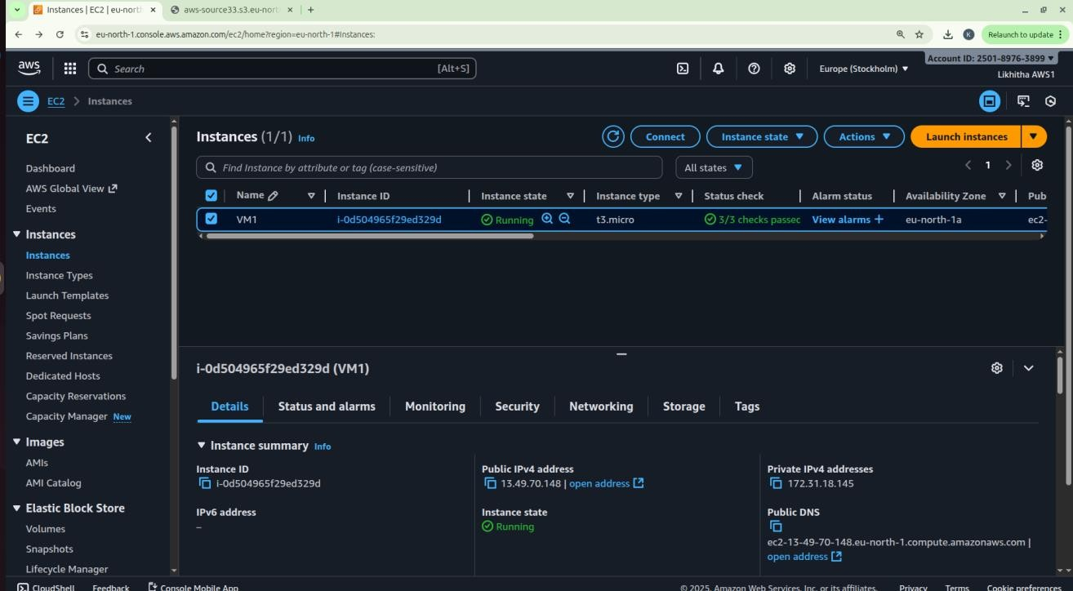

#### Note:

Wait approximately 5 minutes after instance launch to allow AWS to fully initialize the instance and make the Administrator password available.

When a Windows EC2 instance is first launched, AWS needs a few minutes to:

Initialize the instance, Attach the root volume, Generate the Windows Administrator password (encrypted using your key pair.

#### Step 8: Get the Administrator Password

Select your running instance → click Connect → choose RDP Client tab. Click Get Password (you must wait about 4 minutes after launch).

Upload your .pem key file and click Decrypt Password.

Copy the Public IPv4 address and Administrator Password shown.

#### Step 9: Connect Using RDP Client

On Windows system:

1. Open Remote Desktop Connection (from Start Menu).
2. Enter your instance’s Public IPv4 address.
3. Click Connect → Enter:
   * Username: Administrator
   * Password: *(the decrypted password from AWS)*
4. Click OK → accept the certificate → the remote Windows desktop opens!

#### Step 10: Verify Connection

* You should now see a Windows Server desktop running inside your local window.
* You can open File Explorer, browse settings, or install software (within the free-tier limits).

#### Note:

* Always **Stop** (not Terminate) the instance when not in use to avoid charges.
* RDP uses port 3389, so ensure it’s open in the security group.
* Avoid sharing your decrypted password or key pair.

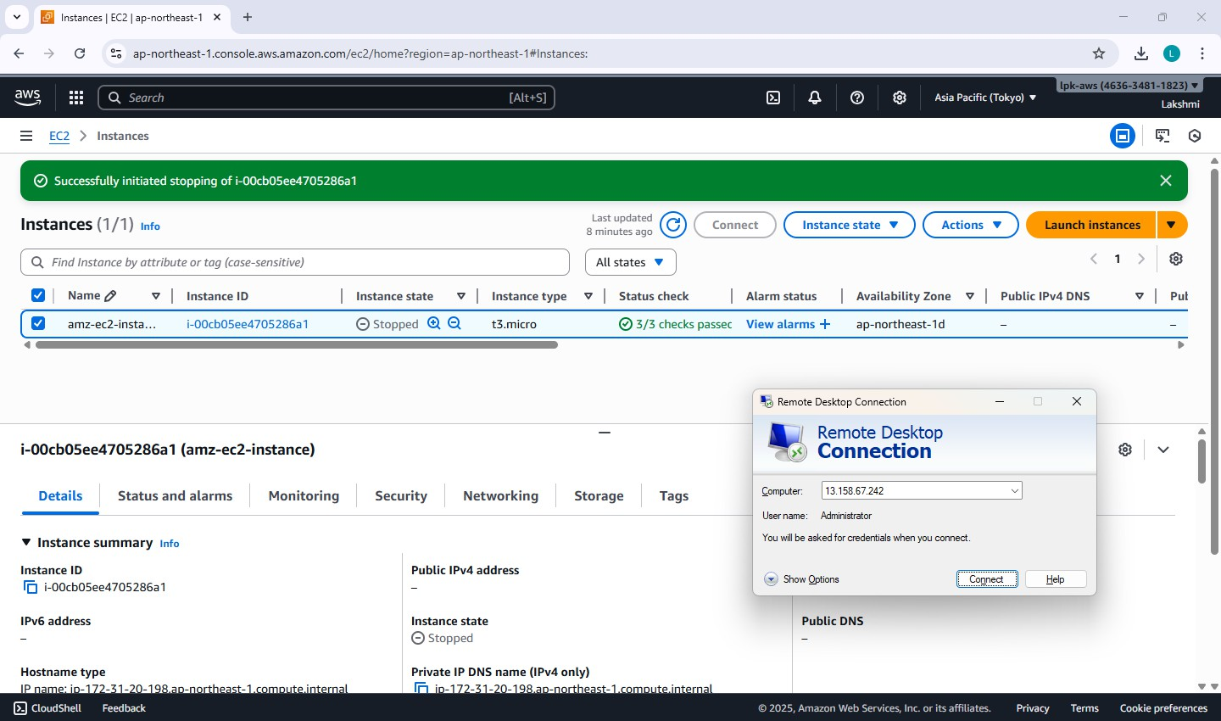

## Date: 30-10-2025

**Exercise-6:** Launch a Linux EC2 Instance and Connect using SSH through PowerShell/Linux Terminal and PuTTY on Windows.

#### Note: Choosing the Correct Key Pair Format

While creating a Key Pair, you are asked to select the Private Key File Format — either .pem or .ppk. The correct choice depends on the operating system and the method you will use to connect to your EC2 instance.

|  |  |  |
| --- | --- | --- |
| Scenario | Key File Format | Explanation |
| Using PuTTY on Windows | .ppk | The .ppk file is specific to the GUI based PuTTY appli- cation, a popular SSH client for Windows system. |
| Using PowerShell on Win- dows, Linux terminal on Linux | .pem | The .pem file is the default AWS key format used by the OpenSSH client available in PowerShell (Win- dows), Linux, and macOS terminals. Used for CLI. |

**Steps to Launch a Linux EC2 Instance and Connect using SSH through PowerShell/Linux**

#### Step 1: Sign in to AWS Management Console

select the nearest AWS Region.

#### Step 2: Open EC2 Service

In the search bar, type EC2 and click EC2 Dashboard. Select Instances → Launch Instance.

#### Step 3: Configure Instance Details

Under Name and Tags, give your instance a name, e.g., *Linux-SSH-Demo*.

Under Application and OS Images (AMI) → select Amazon Linux 2 AMI (Free tier eligible). Under Instance type, choose t3.micro (Free-tier eligible).

#### Step 4: Create or Select a Key Pair

Under Key pair (login) → choose Create new key pair. Choose:

* + Key pair type: RSA
  + Private key file format: .pem (for SSH via PowerShell/Linux) Click Create key pair → the .pem file will automatically download. Save it securely on your local machine (you’ll need it for SSH login).

#### Step 5: Configure Network Settings

Under Network settings, leave the defaults.

In Firewall (security group) → select Create security group. Ensure SSH (port 22) is allowed:

* + Type: SSH
  + Protocol: TCP
  + Port Range: 22
  + Source: My IP (recommended for security) or Anywhere (0.0.0.0/0).

#### Step 6: Launch the Instance

Review the configuration → click Launch Instance.

Wait for the Instance State to show Running and Status Checks: 3/3 passed.

#### Step 7: Get the Public IP Address

Select your instance → In the summary section →

Copy the Public IPv4 address — you’ll use this to connect.

#### Step 8: Connect using SSH

1. **On Windows using PowerShell**
   * Open **PowerShell** (search “PowerShell” from the Start menu).
   * Navigate to the folder where your .pem file is saved: cd "C:\Users\<YourName>\Downloads"
   * Connect using the SSH command:

ssh -i "keyfile.pem" ec2-user@<Public-IP-address>

* + When prompted, type **yes** to continue connecting.
  + You’ll now be logged into your EC2 Linux terminal.

#### On Linux Terminal (Ubuntu / macOS)

* + Open **Terminal**.
  + Navigate to the directory where your .pem file is stored.
  + Set proper permission for the key file: chmod 400 keyfile.pem
  + Connect to the instance:

ssh -i keyfile.pem ec2-user@<Public-IP-address>

* + Type **yes** when prompted.
  + You will be connected to your EC2 instance remotely.

#### Step 9: Verify Connection

* + Once connected, the command prompt will appear as: [ec2-user@ip-172-31-xx-xx ~]$
  + Try a few commands:

uname -a and sudo yum update -y to confirm access.

#### Step 10: Stop Instance after Use

Go to the EC2 console.

Select your instance → Instance State → Stop Instance (to avoid charges).

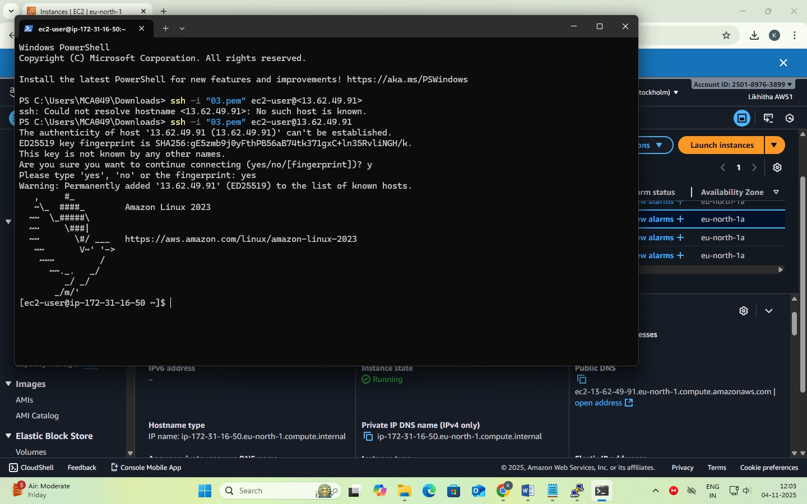

**Steps to Install PuTTY on Windows**

PuTTY is a client program for the SSH, Telnet and Rlogin network protocols. These protocols allow you to interact with a remote server as if you were sitting right in front of it.

It is primarily used in the Windows platform.

In an era where cloud computing and remote servers are the norm, being able to securely connect and interact with these servers is vital. It provides a secure and reliable way to connect to these remote systems. It supports a range of network protocols including the secure ones like SSH.

Use the correct, safe download link: Official download page: This is the only genuine PuTTY source. <https://www.chiark.greenend.org.uk/~sgtatham/putty/latest.html>

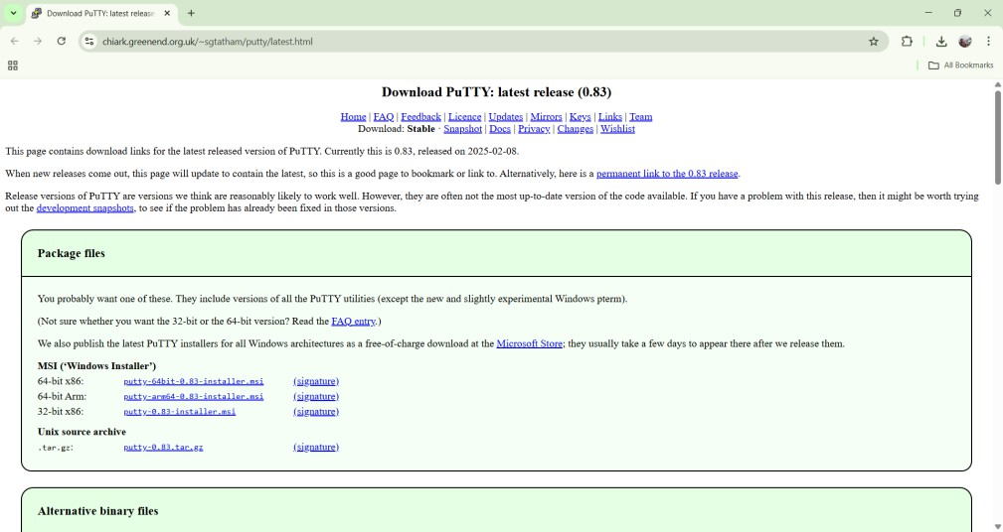

Under the **Package files** section, look for: MSI (‘Windows Installer’)

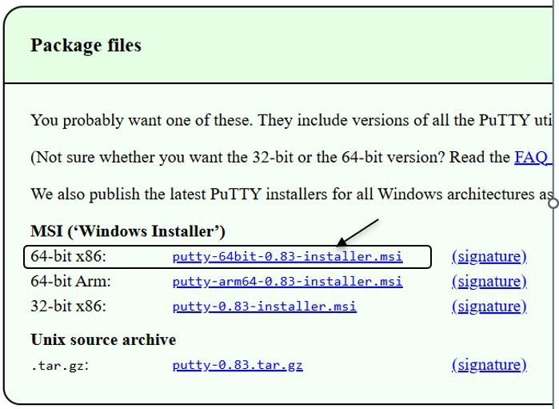64-bit x86: putty-64bit-0.83-installer.msi Click the link: **putty-64bit-0.83-installer.msi**

Once it downloads, open the file and follow: Next → Next → Install → Finish

#### After installation, you will have:

* + PuTTY – to connect to your EC2 instance via SSH
  + PuTTYgen – to convert .pem to .ppk (if needed)
  + Pageant – optional key manager

You can open PuTTY by typing **PuTTY** in the Windows search bar/start menu.

**Steps to Launch a Linux EC2 Instance and Connect using PuTTY on Windows**

#### Step 1: Sign in to AWS Management Console

Select your nearest AWS Region.

#### Step 2: Open the EC2 Service

In the AWS Console search bar, type EC2 and select EC2 Dashboard. Click Instances → Launch Instance.

#### Step 3: Configure Instance Details

Under Name and Tags, enter an instance name, e.g., *Linux-PuTTY-Demo*.

Under Application and OS Images (AMI) → choose Amazon Linux 2 AMI (Free tier eligible). Under Instance Type, select t2.micro (Free tier eligible).

#### Step 4: Create or Select a Key Pair

Under Key pair (login) → select Create new key pair. Choose the following:

* + - Key pair type: RSA
    - Private key file format: .ppk *(for PuTTY on Windows)* Click Create key pair → a .ppk file will download automatically. Save it securely — this file is required to connect later.

#### Step 5: Configure Network Settings

Under Network settings, leave default VPC/Subnet settings. Under Firewall (security group):

* + - Select Create security group.
    - Ensure SSH (port 22) is allowed:
      * Type: SSH
      * Protocol: TCP
      * Port Range: 22
      * Source: anywhere.

**Step 6: Launch the Instance** Review all configurations. Click Launch Instance.

Wait until the Instance State changes to Running and Status Check = 3/3 passed.

#### Step 7: Obtain the Public IP

Select your instance → In the summary section →

Copy the Public IPv4 address or Public DNS (IPv4) — you’ll use this to connect from PuTTY.

#### Step 8: Connect using PuTTY

Open **PuTTY** on your Windows system.

In the **Host Name (or IP address)** field, enter: ec2-user@<Public-IP-address>

In the **Category** list on the left, expand: Connection → SSH → Auth → Credentials Click **Browse** → locate and select your .ppk key file downloaded earlier.

Click **Open**.

When prompted, click **Accept** to trust the host.

A terminal window opens — you’re now connected to your EC2 Linux instance!

#### Step 9: Verify Connection

Once connected, your prompt should look like: [ec2-user@ip-172-31-xx-xx ~]$ Try verifying: uname -a or update packages: sudo yum update -y

#### Step 10: Stop the Instance

Return to the EC2 Dashboard.

Select your instance → click Instance State → Stop Instance. This prevents charges when you’re not using it.

#### Note

* + Use .ppk format key when connecting with **PuTTY (Windows)**.
  + Use .pem format key when connecting with **PowerShell / Linux / macOS terminal**.
  + Both keys serve the same purpose — secure authentication to your EC2 instance.

The message **“Permission denied (publickey)”** or **“Permissions are too open”** appears when the .pem key file or SSH configuration has incorrect permissions or mismatched ownership.

Run this command in your local terminal before connecting: chmod 400 keypair.pem

Then connect again:

ssh -i "keypair.pem" ec2-user@<Public-IP>

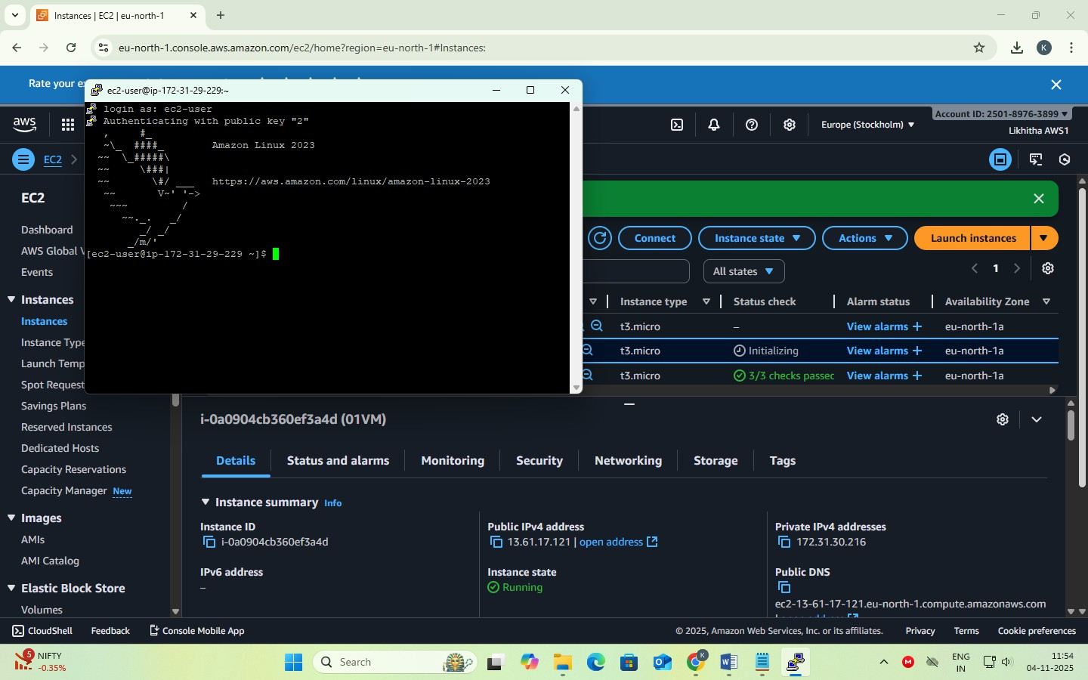

## Date: 5-11-2025

**Exercise-7:** Hosting a static website on EC2 instance.

* Manual Installation of Apache (httpd) Web Server on EC2 for Static Website Hosting.
* Launching an EC2 Instance with User Data Script to Automatically Install Apache and Host a Static Website.

**When you create an EC2 instance**, it’s just a **bare machine** — It does not have the software to host a website yet. To host a website:

* + You need a web server software → Apache (httpd)
  + You put your website files (HTML, CSS, etc.) in a special folder (usually /var/www/html)
  + Apache listens on port 80 (HTTP) or port 443 (HTTPS) for incoming connections

**Apache HTTP Server** (often called Apache or httpd) is a web server software.

It runs on a computer (like your EC2 instance) and delivers web pages (HTML, images, CSS, etc.) to users over the HTTP/HTTPS protocol.

So, whenever someone types your website’s URL (like [http://your-ec2-ip/),](http://your-ec2-ip/)) Apache receives that request and serves your webpage files from your server to the browser.

**httpd** stands for **HTTP Daemon**.

A *daemon* in Linux is a background service that keeps running to handle requests. So, httpd is the background process that runs the Apache web server.

When you install Apache, you’re really installing the **httpd service**.

**File Locations (default) –** Website files go into: /var/www/html

**Steps for Manual Installation of Apache (httpd) Web Server on EC2 for Static Website Hosting.**

**Part 1 – Creating an EC2 Instance**

**Step 1: Sign in to AWS Management Console**

In the search bar, type EC2 and open the EC2 Dashboard.

### Step 2: Launch a New Instance

Click “Launch Instance.”

Give a name. (e.g., MyApacheServer)

### Step 3: Choose an Amazon Machine Image (AMI)

Select Amazon Linux 2 AMI (Free tier eligible)

### Step 4: Choose Instance Type

Choose t3.micro (Free tier eligible).

### Step 5: Create / Select Key Pair

Under Key pair (login), choose:

Create new key pair → Give a name → File format = .pem Download the key file → Keep it safe.

### Step 6: Configure Network Settings

Click → Allow SSH traffic

→ Allow HTTP traffic from the internet. (This automatically opens port 80 for web access).

### Step 7: Launch Instance

Review → Click **Launch Instance**. Wait for the instance to start.

### Step 8: Connect to the Instance

**Using powershell type the following commands:**

* + Open PowerShell (search “PowerShell” from the Start menu).
  + Navigate to the folder where your .pem file is saved: cd "C:\Users\<YourName>\Downloads"
  + Connect using the SSH command:

ssh -i "keyfile.pem" ec2-user@<Public-IP-address> ssh -i "web.pem" ec2-user@ 13.53.136.50

* + When prompted, type yes to continue connecting.
  + You’ll now be logged into your EC2 Linux terminal.

### Part 2 – Manual Installation of Apache (httpd) Web Server Step 1: Update the Packages

sudo yum update -y

### Step 2: Install Apache (httpd)

sudo yum install httpd -y

*(This installs the Apache Web Server package.)*

### Step 3: Start the Apache Service

sudo systemctl start httpd

### Step 4: Enable Apache to Start on Boot

sudo systemctl enable httpd

### Step 5: Check Apache Status

sudo systemctl status httpd [It should show active (running). Press q to exit status view.]

### Step 7: Test Apache Server

Copy your Public IPv4 address from the EC2 dashboard. Paste it into a browser: http://

You should see the Apache Test Page

### Part 3 – Host a Static Website on Apache Step 1: Move to Web Root Folder

cd /var/www/html

### Step 2: Create your HTML file

sudo nano index.html

### Step 3: Add HTML content

Paste the following code:

<!DOCTYPE html>

<html>

<head>

<title>Welcome to My Website</title>

</head>

<body style="text-align:center; background-color: #f0f0f0;">

<h1>Hello from Apache on AWS EC2!</h1>

<p>This is a static website hosted on Apache web server.</p>

</body>

</html>

### Press Ctrl + O, Enter, then Ctrl + X to save and exit.

After Pressing Ctrl + O You’ll see:

File Name to Write: index.html [Just press Enter to confirm saving with that name].

To Exit Nano: press Ctrl + X [This closes the Nano editor and will be back to the Linux prompt]

### Step 4: Restart Apache

sudo systemctl restart httpd

### Step 5: View Website

* + In browser: http://<your-ec2-public-ip>
  + You’ll see your custom HTML page.

### Optional: Add Multiple Pages

* + Upload other pages like about.html, contact.html in the same directory.

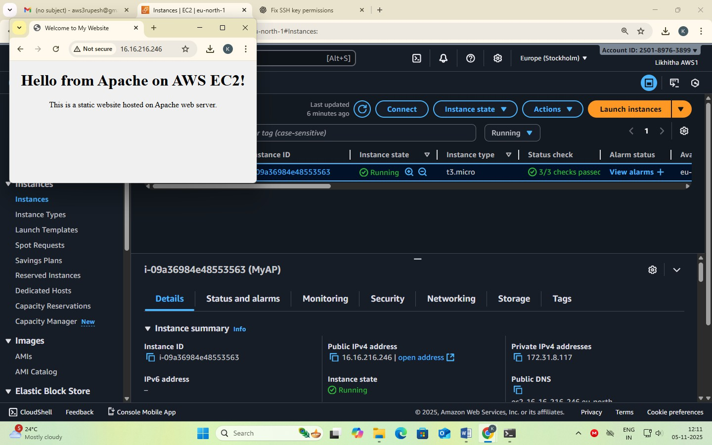

### Steps for launching an EC2 Instance with User Data Script to Automatically Install Apache and Host a Static Website.

In this method, you don’t manually install Apache or upload files after connecting. Instead, you write a **shell script** in the **User Data** section (during instance creation). When the EC2 instance starts for the first time, it automatically:

1. Installs Apache (httpd)
2. Starts the service
3. Creates an index.html webpage
4. Hosts your website immediately after launch

### Step 1: Sign in to AWS Management Console

Go to EC2 Dashboard → Click Launch Instance

### Step 2: Name and OS

Name: AutoApacheWebServer

AMI: Choose Amazon Linux 2 AMI (Free tier eligible) Instance Type: t3.micro

### Step 3: Key Pair

Select existing key pair (or create new) → Format = .pem

### Step 4: Network Settings

Allow HTTP traffic from the Internet (port 80) Allow SSH traffic (port 22)

### Step 5: Add User Data Script

Scroll down to Advanced Details → User data box.

This script:

* Updates all packages
* Installs and starts Apache
* Creates a sample index.html webpage in /var/www/html Paste the following shell script:

#!/bin/bash

# Update packages yum update -y

# Install Apache Web Server yum install -y httpd

# Start Apache systemctl start httpd systemctl enable httpd

# Create website content echo *"<html>*

*<head><title>Welcome to My Auto Web Server</title></head>*

*<body style='text-align:center; background-color:#e9f5ff;'>*

*<h1>Welcome to EC2 Instance</h1>*

*<h2>Apache Installed Automatically via User Data Script</h2>*

*<p>This is a static website hosted on EC2 using User Data automation.</p>*

*</body>*

*</html>"* > /var/www/html/index.html

### Step 6: Launch the Instance

Click Launch Instance

Wait for the status → Running

### Step 7: Test Your Web Server

Copy the Public IPv4 address of your instance. Paste it in your browser: http://<your-public-ip>

You should immediately see your webpage without logging into EC2!

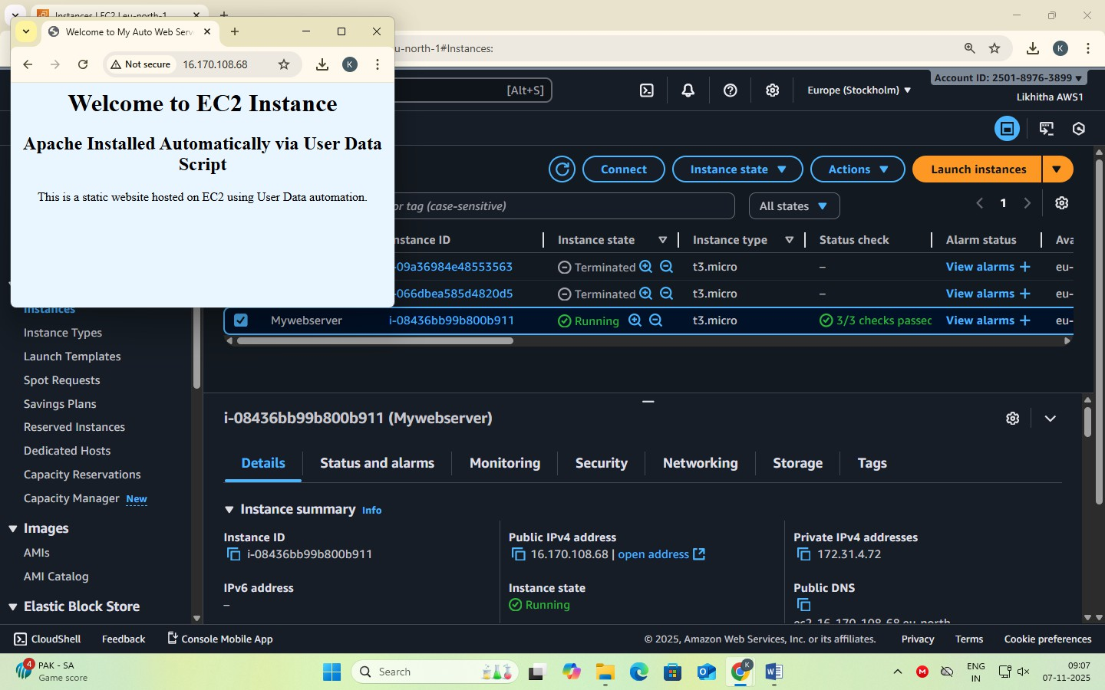

## Date: 7-11-2025

**Exercise-8:** Create a Custom AMI from a Working EC2 Instance. Launch an EC2 Instance using a Custom AMI. Delete the custom AMI

**AMI (Amazon Machine Image)** is a pre-configured template that contains only Operating System (e.g., Amazon Linux, Ubuntu, Windows) needed to launch an EC2 instance.

When you launch a new EC2 instance, you select an AMI as the base image.

A **Custom AMI** is created from your *own running EC2 instance* after you’ve installed software, uploaded website files, or applied settings.

### Benefits:

1. **Reusability** – Launch multiple identical servers quickly.
2. **Backup** – Acts as a snapshot of your configured instance.
3. **Auto Scaling** – Used by Auto Scaling Groups to create identical instances automatically.
4. **Disaster Recovery** – You can recreate your setup if the original instance fails.
5. **Time-saving** – No need to reinstall Apache or re-upload files each time.

A Custom AMI is like a master copy of your EC2 setup. It ensures your website or app can be duplicated instantly and consistently.

### Steps to Create a Custom AMI from a Working EC2 Instance

To capture the current configuration — installed packages, website files, and settings — into a reusable Amazon Machine Image (AMI).

### Step 1: Select the running instance

Go to EC2 → Instances.

Select the instance that already hosts your website. Or create an instance (add user data for web hosting)

### Step 2: Create Image

From the Actions → Image and templates → Create image.

### Step 3: Enter details

Image name: MyWebsiteAMI

Description: AMI created from configured Apache website instance Leave “No reboot” unchecked (so the filesystem is consistent).

### Step 4: Storage volumes

The root volume will appear automatically; keep defaults unless you need more space.

### Step 5: Create image

Click **Create image**.

A confirmation message appears; note the **Image ID**. **Step 6: Verify creation**

In left panel → **AMIs** → refresh until **Status = Available**.

Your custom AMI is now saved in that region and can be used to launch identical webserver instances.

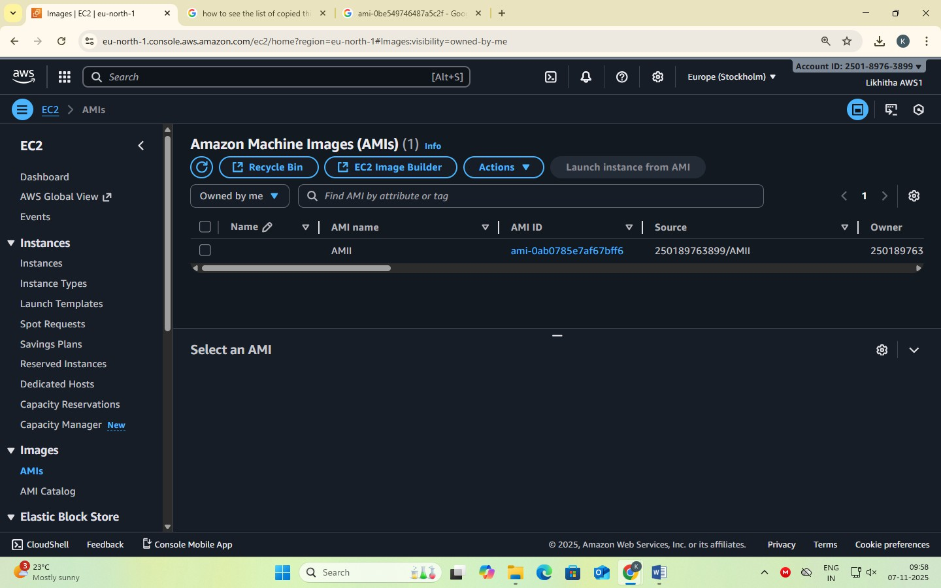

### Steps to Launch an EC2 Instance using a Custom AMI

To launch a new EC2 instance from a previously created Custom Amazon Machine Image (AMI)

— containing your configured website and software.

### Step 1: Go to AMIs

Open the EC2 Service dashboard.

In the left navigation pane, click AMIs (under “Images”).

### Step 2: Select Your Custom AMI

Locate the AMI you created earlier (e.g., MyWebsiteAMI). Ensure Status = Available.

### Step 3: Launch Instance from AMI

Select the AMI → click Launch instance from image.

### Step 4: Configure Instance Details

Name: WebServer-from-Custom-AMI Instance type: t3.micro (Free Tier eligible)

Key pair: Choose an existing .pem key for SSH access. Network settings:

VPC: Default Subnet: Public

Security Group: Allow HTTP (80) and SSH (22)

### Step 5: Storage (EBS Volume)

Keep default root volume (e.g., 8 GB gp3).

### Step 6: Review and Launch

Click Launch instance.

Wait until the instance state becomes Running.

### Step 7: Access the Website

Copy the Public IPv4 address from the instance details. Open in a browser → http://<Public-IP>

You should see your same website, confirming the custom AMI works.

A new EC2 instance is successfully launched using the Custom AMI, automatically containing the OS, Apache, configurations, and website files — no manual setup required.

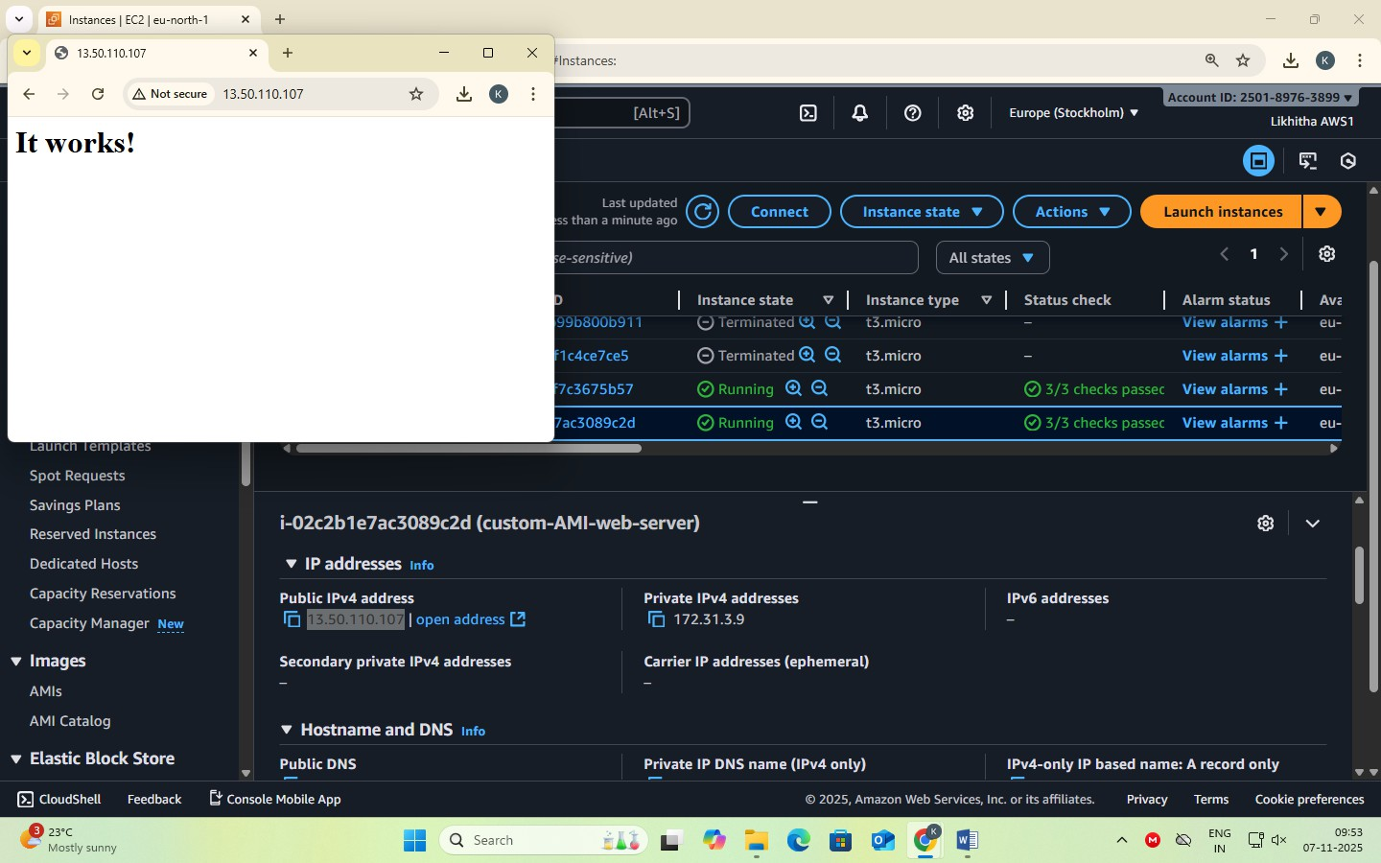

### Steps to Delete the custom AMI

Deleting a **custom AMI** involves **deregistering** the image and then **deleting its associated EBS snapshot**.

When you deregister an AMI, it is removed from your account and can no longer be used to launch new instances.

However, the **snapshot** that was created along with the AMI still remains in your storage and continues to incur charges, so you must delete it separately to free up space and stop costs.

This ensures your AWS environment remains clean and cost-efficient.

### Step 1 – Open EC2 Dashboard

Sign in to the AWS Management Console. Navigate to EC2 service.

In the left navigation pane, scroll down to Images → AMIs.

### Step 2 – Locate Your Custom AMI

In the Owned by me tab, you will see all AMIs you created (custom AMIs). Select the AMI you want to delete.

You can identify it by Name or AMI ID.

### Step 3 – Deregister the AMI

Select the AMI → Click on Actions dropdown. Choose Deregister AMI.

Confirm by clicking Deregister in the pop-up.

This removes the AMI record, but not the underlying snapshot(s)*.*

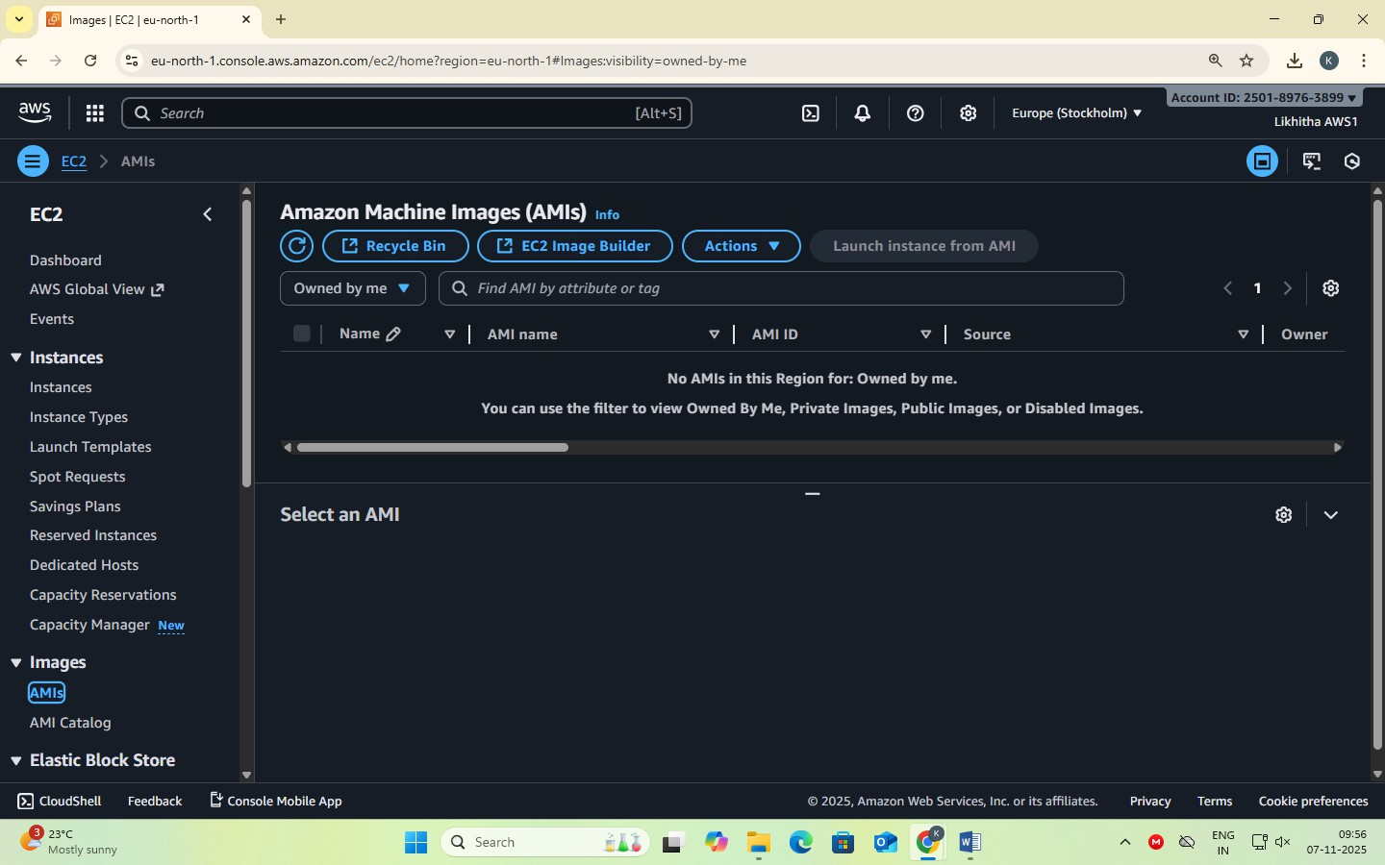

**EXERCISE 9: Mini-Project Hosting a Multi-Page Website using EC2 and S3**

Amazon Web Services (AWS) offers cloud-based resources for hosting and managing web applications.

In this experiment, two AWS services are used together:

* **Amazon S3 (Simple Storage Service):** Used to store image files and make them publicly accessible via HTTPS URLs.
* **Amazon EC2 (Elastic Compute Cloud):** A virtual server used to host and serve the web- site’s HTML and CSS files using **Apache** as the web server.

This setup demonstrates the concept of **decoupling compute and storage** — the website files are served from EC2 while the images are fetched from S3.

**Steps:**

### Login to AWS Management Console.

Navigate to the AWS dashboard using your account credentials.

### Create an S3 Bucket.

* + Go to **S3 Service → Create bucket**.
  + Provide a unique bucket name (e.g., *my-website-images-123*).
  + Select the region (e.g., *us-east-1*).
  + Uncheck “Block all public access”.
  + Click **Create bucket**.

### Upload Images to S3.

* + Upload images (cloud1.jpg, cloud2.jpg, cloud3.jpg).
  + Use **Object actions → Make public using ACL** (or apply a bucket policy) to make the images publicly accessible.
  + Note the **Object URLs** of each image.

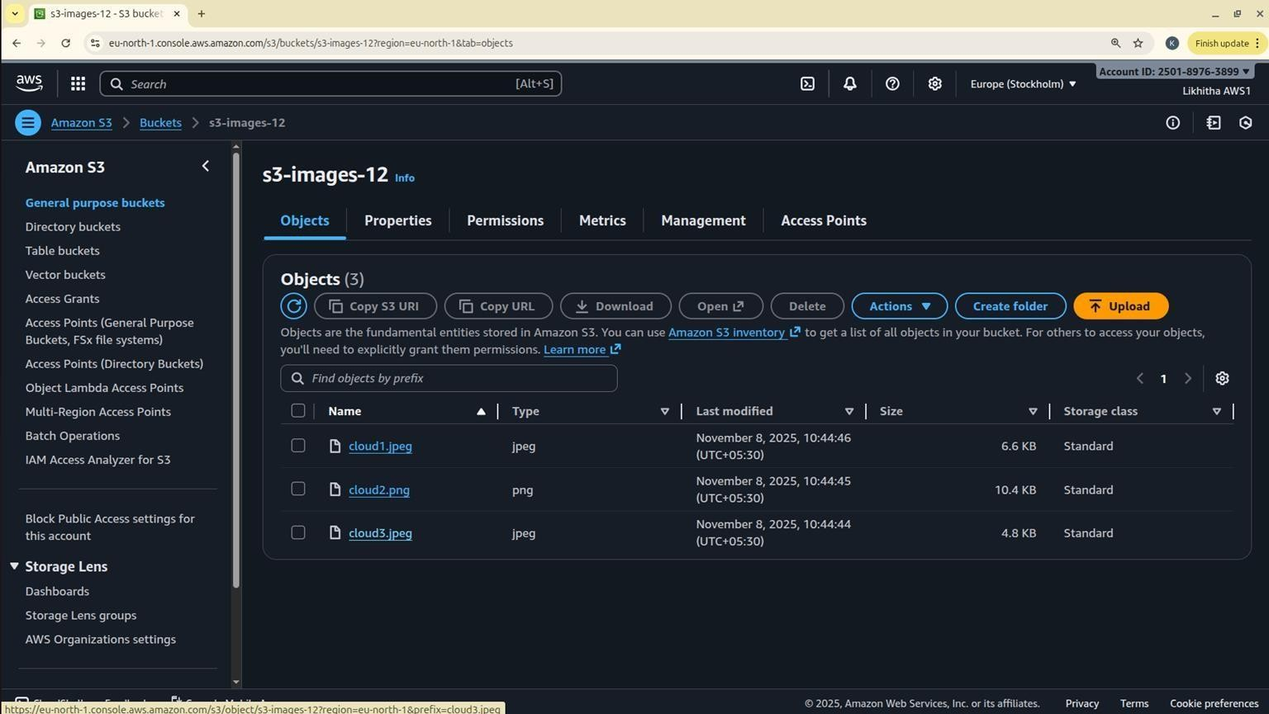

### Launch an EC2 Instance.

* + Open **EC2 Service → Launch instance**.
  + Choose **Amazon Linux 2025 AMI** and instance type **t3. micro** (Free Tier).
  + Create or select an existing key pair.
  + Allow **HTTP (80)** and **SSH (22)** in the Security Group.
  + In **Advanced details → User data**, paste your files or upload your files.

# ----- index.html -----

#!/bin/bash sudo yum -y update sudo yum -y install httpd sudo systemctl ena- ble httpd sudo systemctl start httpd

BUCKET="your-bucket-name" REGION="your-region" WEBROOT="/var/www/html" sudo rm -rf ${WEBROOT}/*

sudo tee ${WEBROOT}/index.html > /dev/null <<'EOF'

<!DOCTYPE html><html><head><meta charset="UTF-8">

<title>Home - Apache Hosted Website</title>

<link rel="stylesheet" href="styles.css"></head>

<body><h1>Website Hosted on Apache</h1>

<p>This website is hosted on AWS EC2 using Apache and displays images from an S3 bucket.</p>

<a href="/about.html">About</a> | <a href="/gallery.html">Gallery</a> | <a href="/contact.html">Contact</a>

</body></html>

# ----- about.html -----

sudo tee ${WEBROOT}/about.html > /dev/null <<'EOF'

<!DOCTYPE html><html><head><meta charset="UTF-8">

<title>About</title><link rel="stylesheet" href="styles.css"></head>

# ----- gallery.html -----

<body><h1>About this Project</h1>

<p>This project demonstrates hosting a static website on AWS EC2 using Apache and S3.</p>

<ul><li>EC2 hosts web files</li><li>S3 stores images</li></ul>

<a href="/">Home</a></body></html>

sudo tee ${WEBROOT}/gallery.html > /dev/null <<EOF

<!DOCTYPE html><html><head><meta charset="UTF-8">

<title>Gallery</title><link rel="stylesheet" href="styles.css"></head>

<body><h1>Gallery</h1>

<p>Images loaded directly from S3:</p>

<img src="https://${BUCKET}.s3.${REGION}.amazonaws.com/images/photo1.jpg" width="300">

<img src="https://${BUCKET}.s3.${REGION}.amazonaws.com/images/photo2.jpg" width="300">

<img src="https://${BUCKET}.s3.${REGION}.amazonaws.com/images/photo3.jpg" width="300">

<a href="/">Home</a></body></html>

# ----- styles.css -----

sudo tee ${WEBROOT}/styles.css > /dev/null <<'EOF' body{font- family:Arial;text-align:center;margin:0;background:#fafafa} h1{color:#b22222;margin-top:20px} a{text-decoration:none;margin:0 10px;color:#b22222;font-weight:bold} img{margin:10px;border- radius:8px}

sudo chown -R apache:apache "$WEBROOT" sudo chmod -R 755 "$WEBROOT"

sudo systemctl restart httpd

* 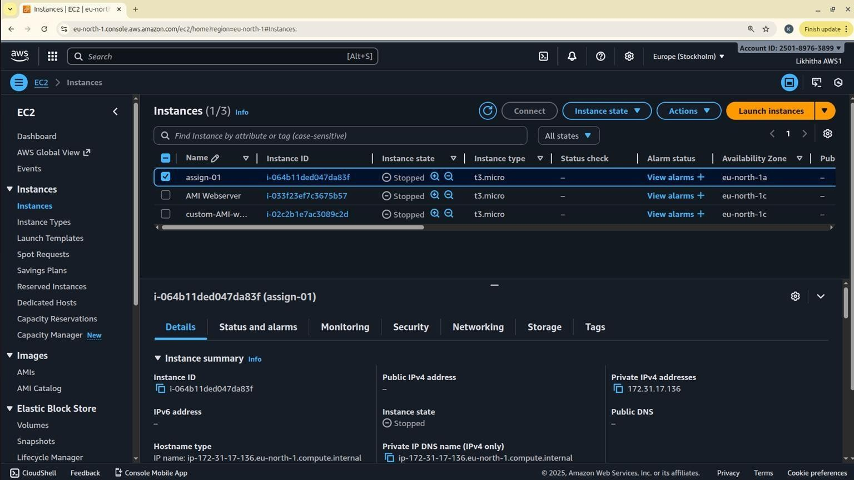Launch the instance.

### Access the Website.

* + Once the instance state is “running”, copy the **Public IPv4 address**.
  + Open a web browser and visit: http://<PublicIPv4>
  + The home page will display links to *Home*, *About*, *Gallery.*
  + The *Gallery* page loads the images directly from the S3 bucket via HTTPS links.

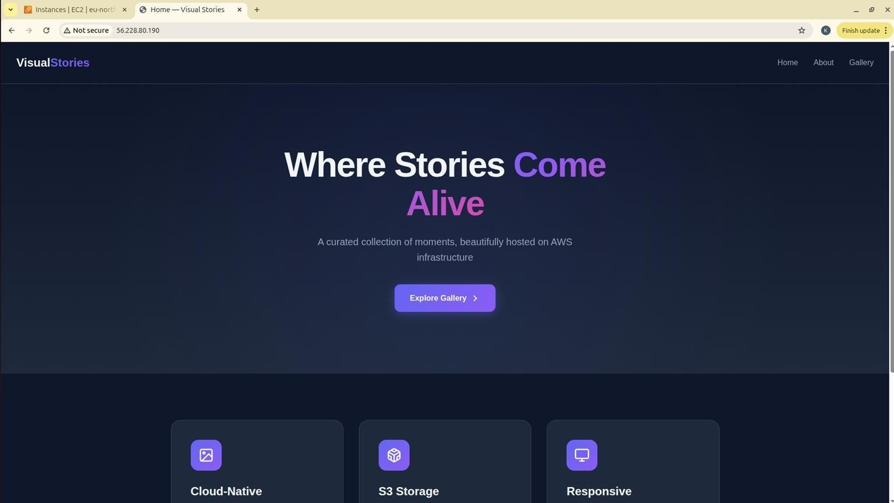

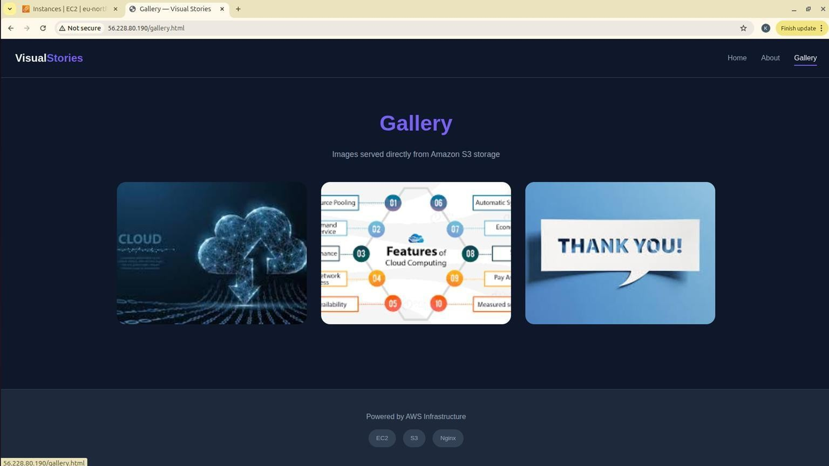

### Verify Hosting.

* + Confirm that HTML pages are served by EC2 .
  + Verify that all images load successfully from S3.
  + If required, restart httpd using: sudo systemctl restart httpd

**Date: 12-11-2025**

**Exercise 10: Creation and Configuration of a Custom AWS Virtual Private Cloud (VPC) [Including Public and Private Subnets, Internet Gateway, NAT Gateway, Route Tables]**

**Virtual Private Cloud [VPC]**

It is a logically isolated section of the AWS Cloud where you can launch your AWS resources (like EC2 instances, databases, etc.) in a customized, secure network environment — similar to having your own private data center inside AWS.

It is a virtual network dedicated to your AWS account.

It gives you complete control over your networking environment, including IP address ranges, subnets, route tables, and network gateways.

#### Components of a VPC

|  |  |
| --- | --- |
| **Component** | **Description** |
| CIDR Block (IP Range) | The range of IP addresses for your VPC (e.g., 10.0.0.0/16). |
| Subnets | Smaller divisions inside your VPC; can be Public (accessible from internet) or Private (internal only). |
| Internet Gateway (IGW) | Allows internet access for resources in public subnets. |
| Route Tables | Define how traffic is directed between subnets and gateways. |
| NAT Gateway / NAT Instance | Enables instances in private subnets to connect to the internet without being exposed. |
| Security Groups | Virtual firewalls that control inbound/outbound traffic at the instance level. |
| Network ACLs  (Access Control Lists) | Additional firewall at the subnet level. |
| VPC Peering | Connects two VPCs so they can communicate privately. |

**Default VPC** and **Custom VPC Characteristics of Default VPC**

When you first create an AWS account, AWS automatically creates a default VPC for you in each region.

|  |  |
| --- | --- |
| **Feature** | **Description** |
| Best For | Beginners, quick testing, learning environments, or temporary setups. |

|  |  |
| --- | --- |
| Created Automatically | One Default VPC per AWS Region (created by AWS). |
| Ready to Use | You can launch EC2 instances immediately — no setup needed. |
| CIDR Block | Always uses 172.31.0.0/16. |
| Subnets | One default subnet in each Availability Zone within the region. |
| Internet Connectivity | Each default subnet is a public subnet  (has a route to Internet Gateway). |
| Route Table | Already configured to connect to the Internet Gateway. |
| Security Groups & NACLs | Default ones are automatically created and allow basic communication. |

#### Characteristics of Custom VPC

A Custom VPC is created manually by the user to have complete control over the network configuration.

|  |  |
| --- | --- |
| **Feature** | **Description** |
| Best For | Production environments, enterprise setups, or multi-tier architectures. |
| Created Manually | You define the VPC and its settings yourself. |
| CIDR Block | You can choose your own IP range (e.g., 10.0.0.0/16). |
| Subnets | You decide how many subnets, and whether they are public or private. |
| Internet Connectivity | You attach your own Internet Gateway. |
| Route Tables | Must be created and configured manually. |
| Security | You can create custom Security Groups and NACLs as needed. |

#### Subnets

* Subdivisions inside a VPC, used to organize resources.
* Each subnet belongs to one Availability Zone.
* Two types:
  + **Public Subnet** → Connected to Internet Gateway; for web servers.
  + **Private Subnet** → No direct internet access; for databases or internal apps.
* CIDR examples:
  + Public: 10.0.1.0/24
  + Private: 10.0.2.0/24

#### Internet Gateway (IGW)

* A gateway that connects your VPC to the Internet.
* Required for instances in a public subnet to receive internet traffic.
* Must be attached to the VPC and referenced in the route table.
* Supports bi-directional communication (inbound and outbound).

#### NAT Gateway

* Enables outbound internet access for private subnet instances.
* Allows downloads and updates (e.g., OS patches) without exposing private IPs.
* Deployed inside a public subnet.
* Needs an Elastic IP for internet access.
* Traffic is one-way: private → internet only (not vice versa).

#### Route Tables

* Define rules (routes) that determine where network traffic goes.
* Each subnet must be associated with one route table.
* Common routes:
  + For public subnet → 0.0.0.0/0 → Internet Gateway
  + For private subnet → 0.0.0.0/0 → NAT Gateway
* Ensures proper separation between public and private networks.

#### Security Groups

* **Instance-level firewalls** controlling inbound and outbound traffic.
* Stateful: if inbound traffic is allowed, corresponding outbound is automatically allowed.
* Rules are based on protocol, port number, and source/destination.
* Example:
  + WebServer-SG: allows HTTP(80), HTTPS(443), SSH(22)
  + Database-SG: allows MySQL(3306) from WebServer-SG only

#### Network ACL (Access Control List)

* **Subnet-level firewall**, acts as an additional layer of security.
* **Stateless**: inbound and outbound rules must be defined separately.
* Default NACL allows all traffic; custom NACLs can be restrictive.
* Used for fine-grained control or compliance environments.

#### EC2 Instances

* Virtual machines running inside your subnets.
* Public subnet → hosts Web Server (Apache).
* Private subnet → hosts Database Server (MySQL).
* Public EC2s get a public IP; private ones use private IPs only.
* Controlled by their Security Groups and Route Tables.

#### Elastic IP (EIP)

* A **static, public IPv4 address** that can be attached to an EC2 or NAT Gateway.
* Remains constant even if the instance is stopped or restarted.
* Useful for **NAT Gateways**, load balancers, or fixed server access.

|  |  |  |  |
| --- | --- | --- | --- |
| Tier | Subnet | Function | Internet Access |
| Web Tier | Public Subnet | Hosts front-end web server | Yes (via IGW) |
| Database Tier | Private Subnet | Hosts back-end database | Outbound only (via NATGW) |

#### Example: Two-Tier Architecture

Create a new VPC for a web application:

* One **Public Subnet** for web servers (via Internet Gateway)
* One **Private Subnet** for databases (via NAT Gateway)
* Custom route tables and tighter security rules.

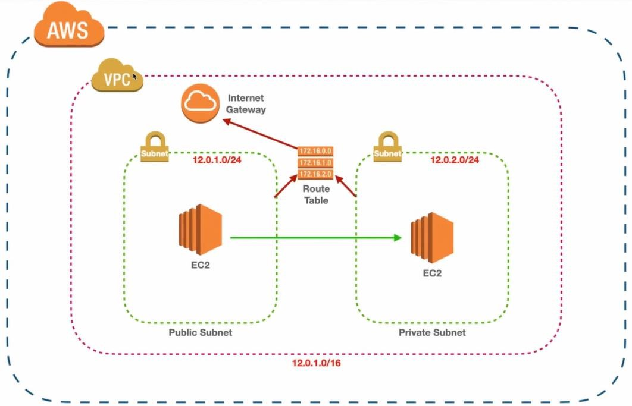

#### Objective

To design and configure a **Virtual Private Cloud (VPC)** in AWS with:

* One **Public Subnet** for web servers (via **Internet Gateway**)
* One **Private Subnet** for databases (via **NAT Gateway**)
* Separate **Route Tables** for public and private subnets

#### Step 1 – Create a New VPC

* Open AWS Management Console → VPC.
* Click Create VPC.
* Choose VPC only option.
* Enter:
  + Name → MyWebAppVPC
  + IPv4 CIDR block → 10.0.0.0/16
  + Tenancy → Default
* Click Create VPC.

This allocates a private IP range for your virtual network.

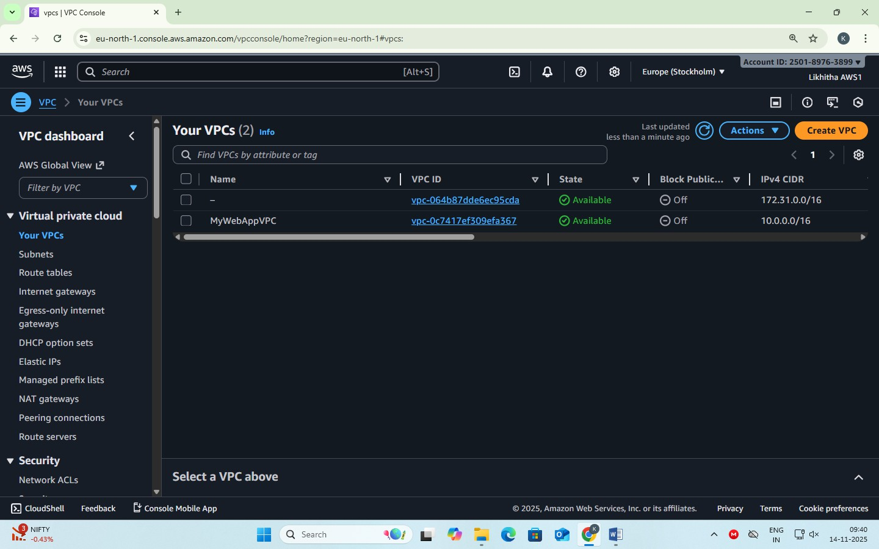

#### Step 2 – Create Subnets

We’ll create two subnets inside the VPC.

#### Public Subnet

* + Go to Subnets → Create subnet.
  + Select VPC: MyWebAppVPC.
  + Choose Availability Zone A.
  + Enter:
    - Name → PublicSubnet
    - IPv4 CIDR block → 10.0.1.0/24
  + Click Create subnet.

#### Private Subnet

* + Click Create subnet.
  + Select same VPC.
  + Choose Availability Zone B.
  + Enter:
    - Name → PrivateSubnet
    - IPv4 CIDR block → 10.0.2.0/24
  + Click Create subnet.

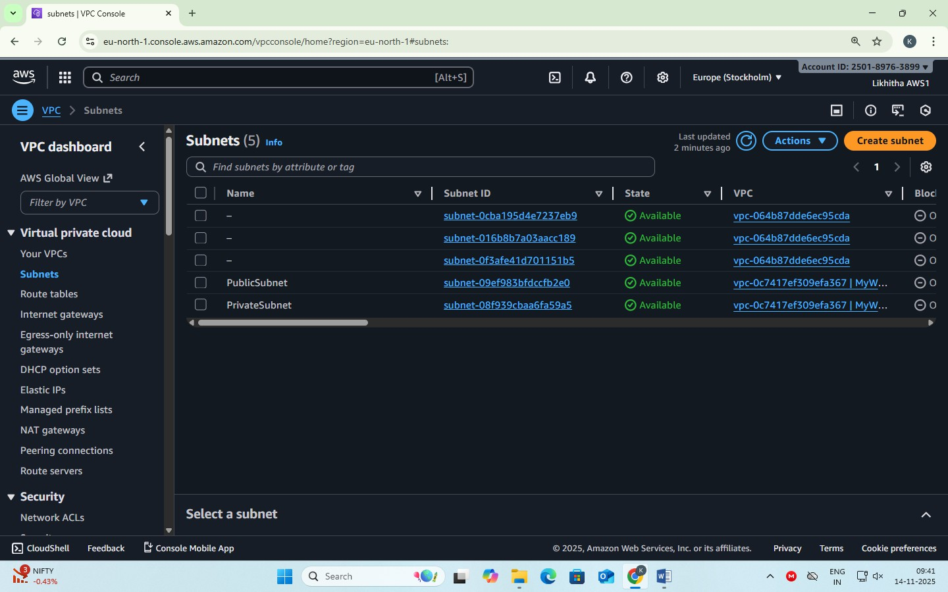

#### Step 3 – Create and Attach an Internet Gateway

* + In the left navigation pane, scroll down and click on “Internet Gateways”.
  + Internet Gateways → Create Internet Gateway.
    - Name: MyWebApp-IGW
  + Click Create Internet Gateway

At this point, the IGW exists but is not yet connected to your VPC.

* + **Attach the Internet Gateway to Your VPC**
    - Select the IGW you just created (checkbox).
    - Click on the **“Actions”** drop-down.
    - Choose **“Attach to VPC.”**
    - From the list, select your **VPC name**, e.g. MyWebAppVPC.
    - Click “Attach Internet Gateway.”

Now the IGW is linked to your VPC and the public subnet can reach the internet.

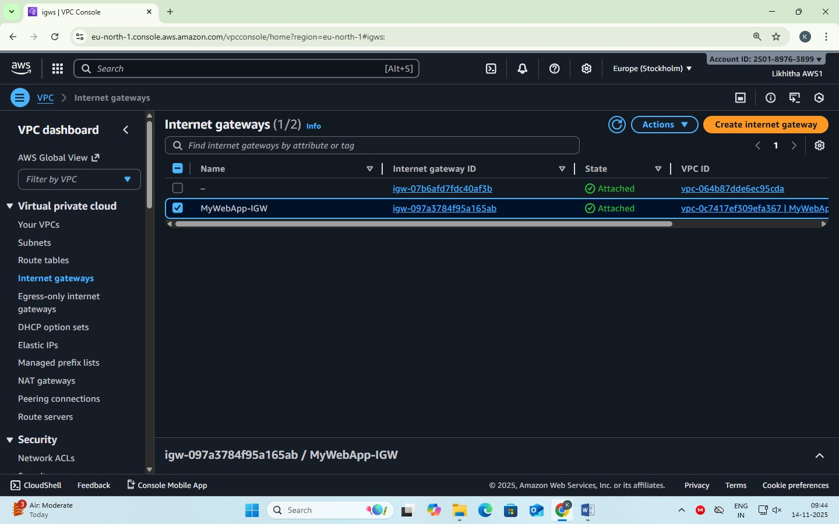

#### Step 4 – Configure Route Table for IGW Public Route Table

* + Go to Route Tables → Create route table.
    - Name → PublicRT
    - VPC → MyWebAppVPC
  + Under Routes → Edit routes → Add route
    - Destination: 0.0.0.0/0
    - Target: Internet Gateway (MyWebApp-IGW)
  + Under Subnet Associations → Edit subnet associations → Select PublicSubnet → Save. Now the PublicSubnet has internet access.

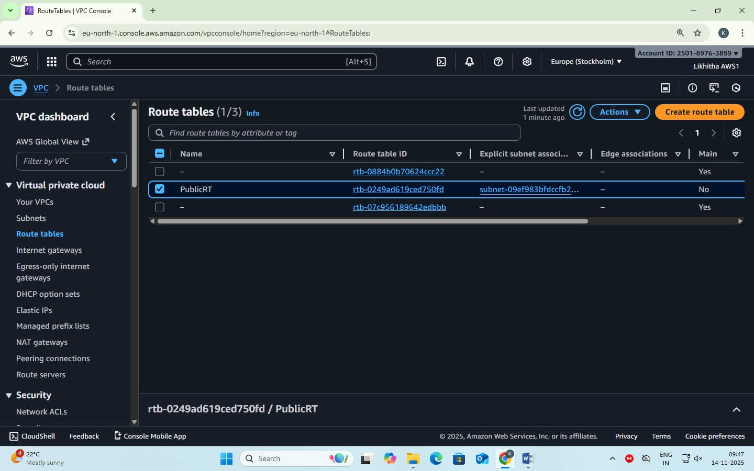

#### Step 5 – Create a NAT Gateway

**NOTE: NAT Gateway must always be created in a public subnet**

* + Go to NAT Gateways → Create NAT Gateway.
  + Name → NAT-GW
  + Choose:
    - Subnet → PublicSubnet
    - Elastic IP Allocation ID → Click Allocate Elastic IP
  + Click Create NAT Gateway.

This allows instances in private subnet to access the internet (e.g., for updates) without being exposed.

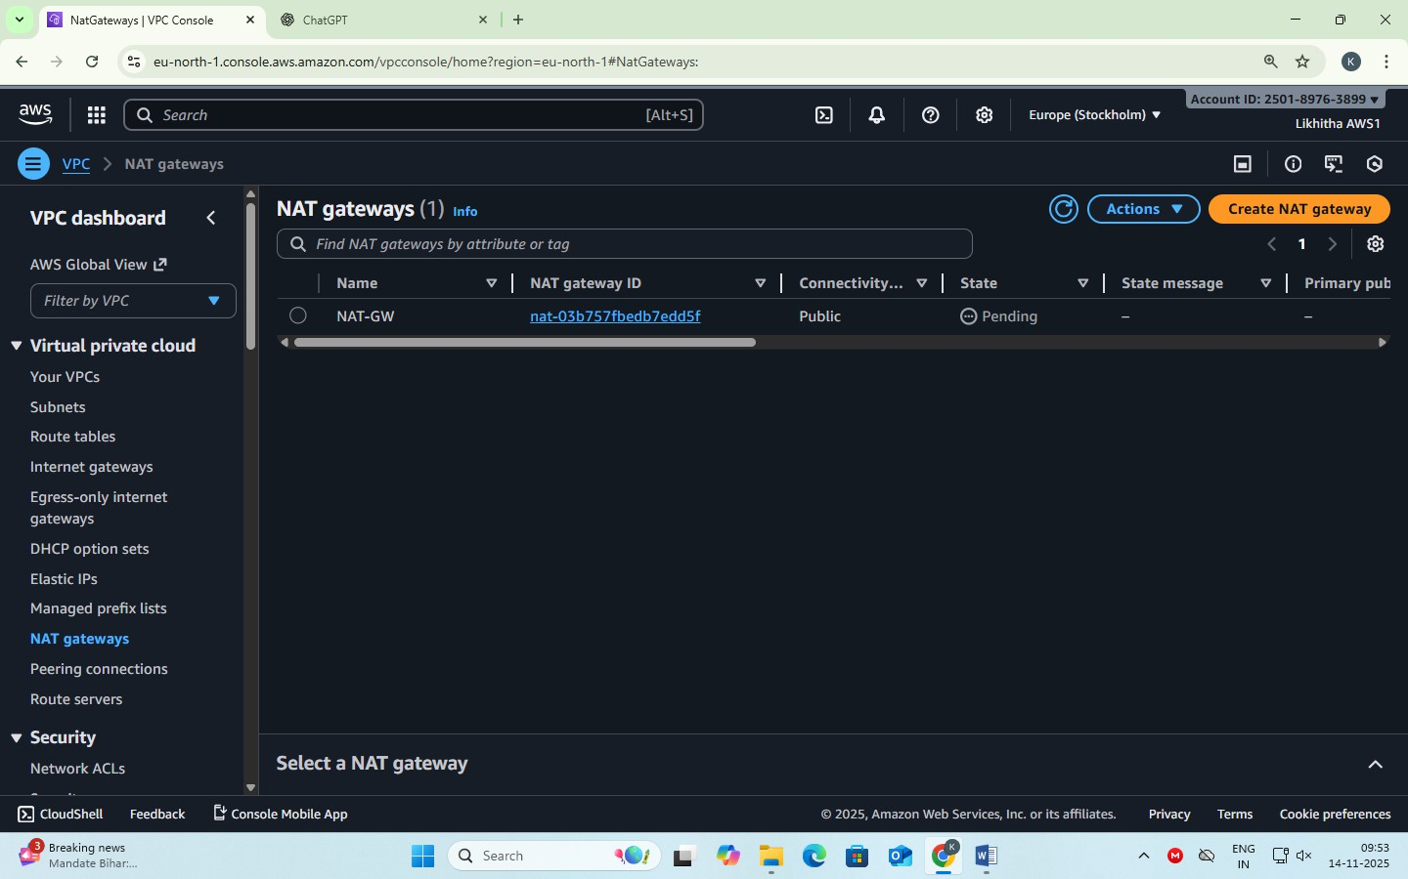

#### Note: NAT Gateway is a paid resource. Step 6 – Configure Route Table for IGW Private Route Table

* + Create another Route Table → Name PrivateRT.
  + Under Routes → Edit routes → Add route
    - Destination: 0.0.0.0/0
    - Target: NAT Gateway (MyWebApp-NATGW)
  + Under Subnet Associations → Select PrivateSubnet → Save. PrivateSubnet traffic goes through the NAT Gateway.

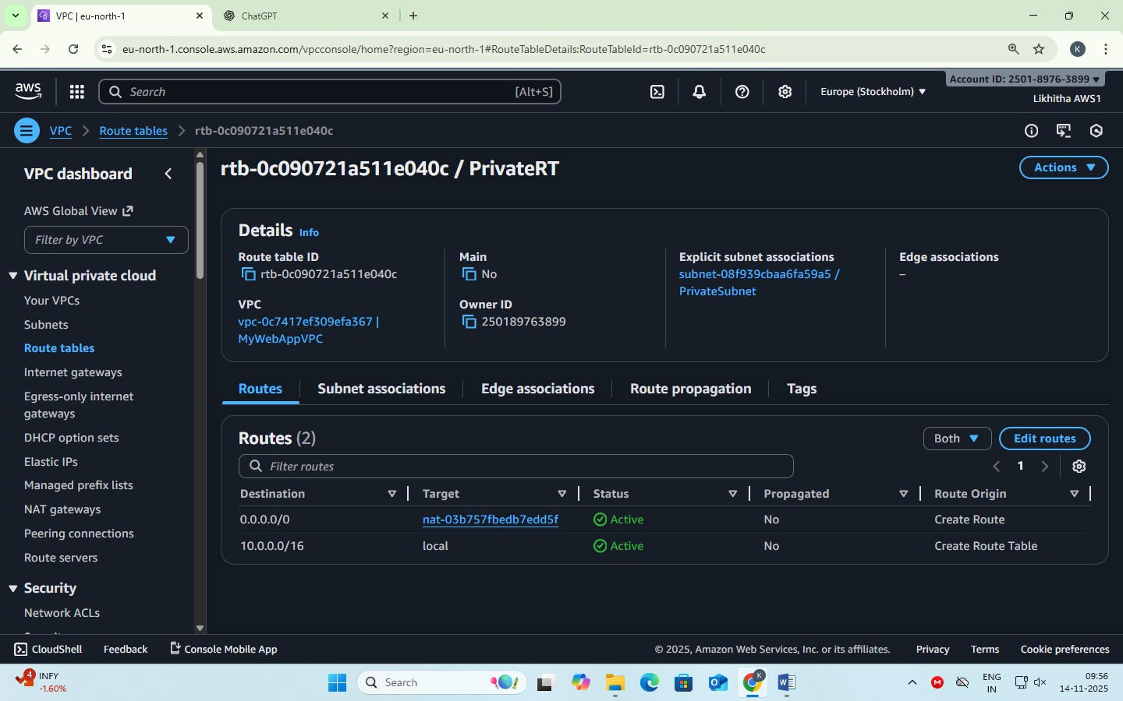

#### Note:

Each subnet in a VPC can be associated with **only one route table**.

If a subnet is not explicitly associated with a custom table, it will automatically use the **Main Route Table**

created by default with the VPC.

**DATE: 14-11-2025 EXERCISE-11**

**Launching and Configuring EC2 Instances for Web Server in Public Subnet and Database Server in Private Subnet Using NAT Gateway for Outbound Access**

**Step 1 — Launch Windows instance in Public Subnet**

* + Go to EC2 → Launch Instance.
  + Choose:
    - AMI → Windows Server (Free tier eligible)
    - Instance type → t3.micro
  + Select:
    - VPC → MyWebAppVPC
    - Subnet → PublicSubnet
    - Auto assign Public IP → Enable
  + Security Group:
    - Create WebInstance-SG
    - Allow:
      * RDP (3389) → Anywhere (for practice)
  + Launch instance using key pair (.pem).

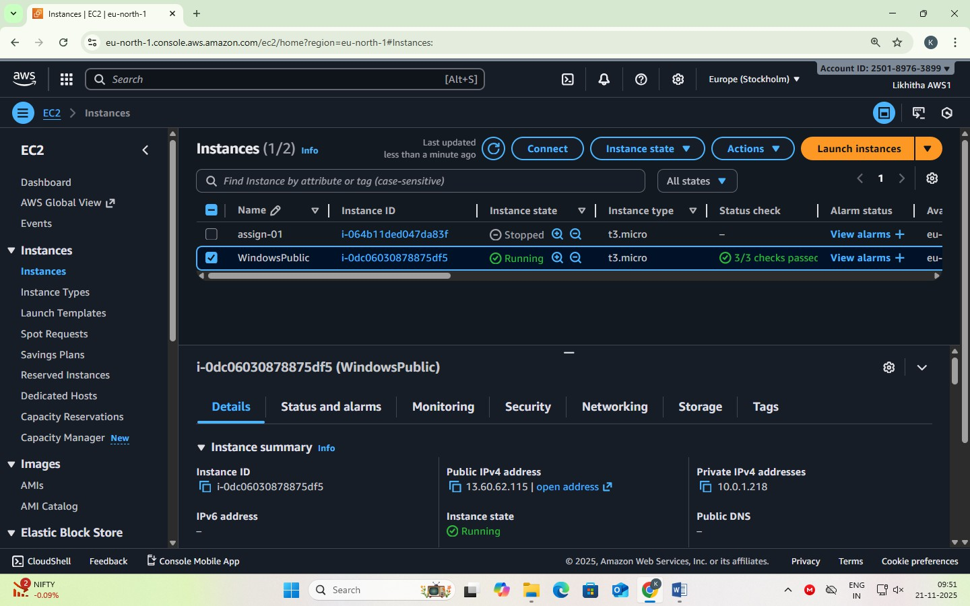

#### Step 2 — Launch Windows instance in Private Subnet

* + Click Launch Instance.
  + Choose:
    - Windows Server AMI
  + Select:
    - VPC → MyWebAppVPC
    - Subnet → PrivateSubnet
    - Auto assign Public IP → Disable
  + Security Group:
    - Create DBInstance-SG
    - Allow RDP only from WebInstance-SG
  + Launch instance.

The DBInstance is now **fully isolated** and cannot be accessed directly from the internet.

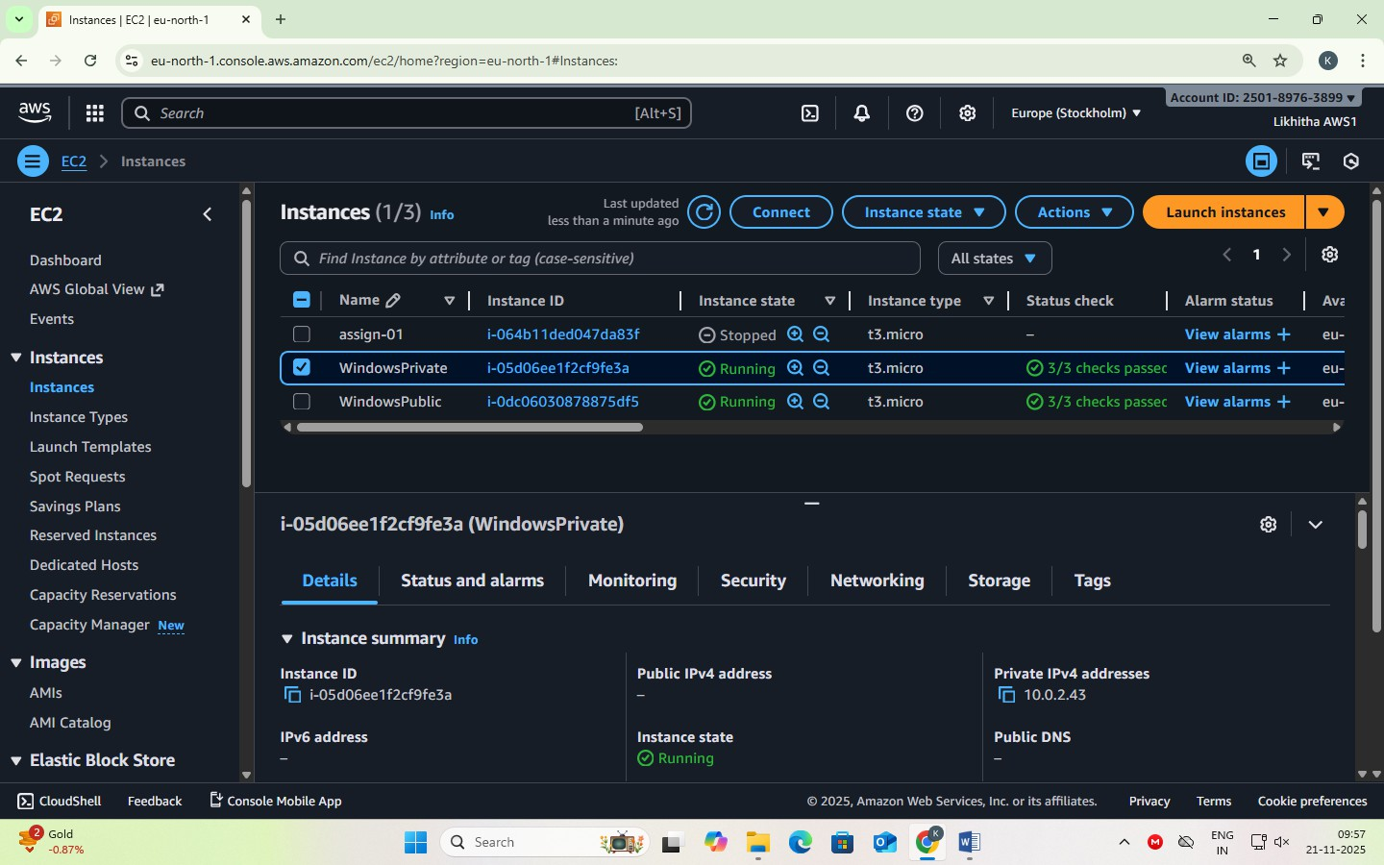

#### Step 3 — Connect to Public Windows Instance

1. Select WebInstance → Click Connect.
2. Choose RDP Client tab.
3. Click Get Password.
4. Upload your .pem key pair.
5. It shows the decrypted Windows Administrator password.
6. Copy the Public IP into a document for further use.

#### Connect using RDP

* + Open Remote Desktop Connection (mstsc).
  + In the dialog:
    - Computer → Public IP of WebInstance
  + Click Connect.
  + Credentials dialog:
  + Username → Administrator
  + Password → Paste decrypted password
  + Click OK.

You are now inside the public Windows instance.

#### Step 4 — connect to private windows instance

We cannot connect directly from your laptop → No Public IP.

We must connect **from within WebInstance** (jump server / bastion host).

#### Remote Login from WebInstance → DBInstance

* + While logged into WebInstance, open Remote Desktop Connection. **[mstsc]**
  + Enter:
    - Computer → Private IP of DBInstance
  + Click Connect.
  + Credentials:
    - Username → Administrator
    - Password → Paste the decrypted password (same key pair)
  + Click OK.

You are now inside the private Windows instance.

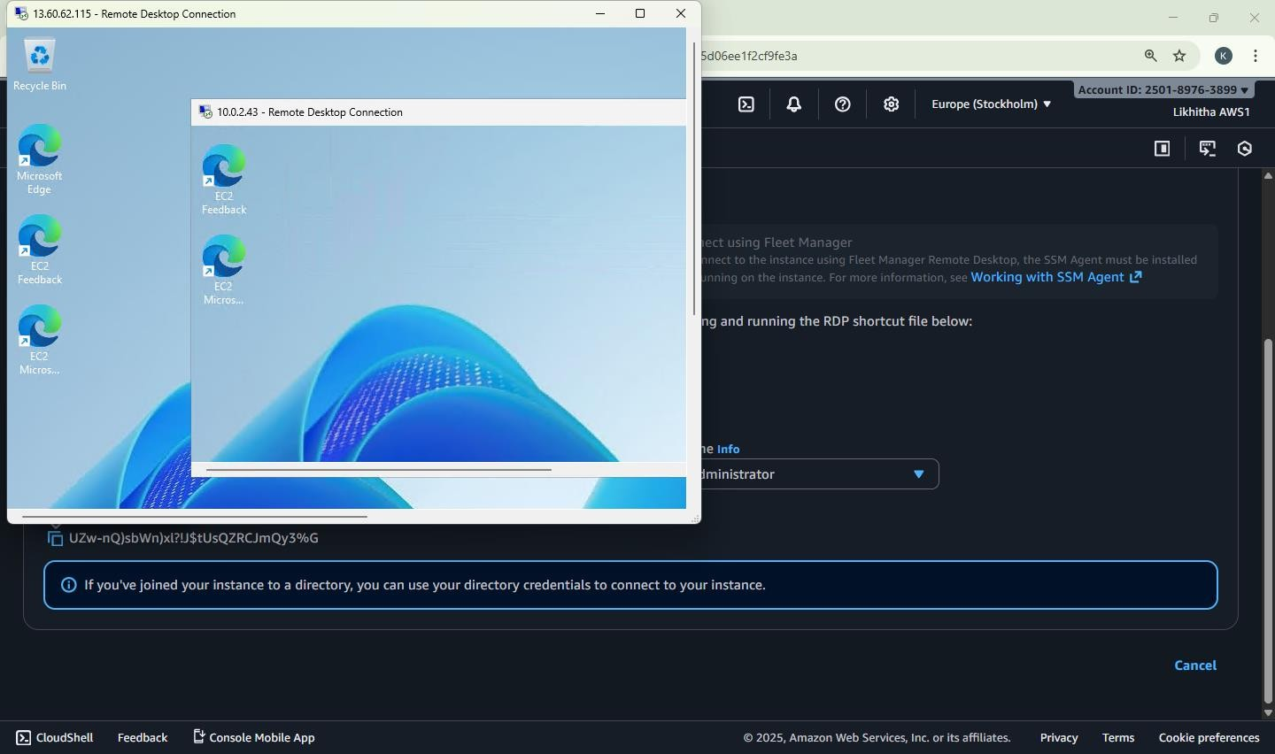

#### Step 5 — testing NAT gateway connectivity (Verify Internet Access) From WebInstance (Public Subnet)

* + Open a browser → Internet should work (through IGW).

#### From DBInstance (Private Subnet)

* + Open browser → Internet should also work (through NAT Gateway).
  + Internet icon will show "Internet Access".

#### Security Check

* + DBInstance cannot receive inbound traffic from internet.
  + Only outbound is allowed via NAT (safe for DB servers).

**Test:** From DBInstance (Private Subnet) → ping Google (Outbound Allowed)

### Steps

Connect to DBInstance (using RDP from WebInstance). Open Command Prompt inside DBInstance.

Type: ping google.com

Expected Result

* + It will successfully ping google.com
  + You will see replies like:

Reply from 142.250.xxx.xxx: bytes=32 time=20ms TTL=115

Why does this work?

* + Outbound traffic is allowed from Private Subnet → NAT Gateway → Internet.
  + NAT Gateway acts as a proxy for the private instance.
  + So the private instance can reach internet, but internet cannot reach the private instance.

What will NOT work?

From the Private DBInstance: ping <Your Own Public IP> or anyone trying to ping: ping <DBInstance Private IP>

Both will fail because:

* + Inbound traffic is blocked
  + DBInstance has no Public IP
  + SG allows inbound only from WebInstance-SG

**Private instance → internet = YES (via NAT Gateway) Internet → private instance = NO (fully blocked)** Because NAT Gateway is **one-way** only.

#### Elastic IP address

* + A static IP address is a permanent address that doesn't change. You can manually configure a device to have a static IP address.
  + An Elastic IP address is static and has to be used in a specific Region, it cannot be moved to a differ- ent Region.
  + An Elastic IP address comes from Amazon's pool of IPv4 addresses.
  + To use an Elastic IP address, you first allocate one to your account, and then associate it with your instance or a network interface.
  + When you associate an Elastic IP address with an instance or its primary network interface, if the in- stance already has a public IPv4 address associated with it, that public IPv4 address is released back into Amazon's pool of public IPv4 addresses and the Elastic IP address is associated with the in- stance instead.
  + You can disassociate an Elastic IP address from a resource, and then associate it with a different re- source.
  + A disassociated Elastic IP address remains allocated to your account until you explicitly release it.
  + You are charged for all Elastic IP addresses in your account, regardless of whether they are associat- ed or disassociated with an instance.
  + Static IP addresses are especially important in cases where a device has to be quickly found over the internet on a permanent basis.
  + Web Servers: A website must have one or more static IP addresses to be assigned to the domain al- ways point to the correct server.

# DATE: 19-11-25

### Exercise–12 Deploying and Testing a Load-Balanced Web Application

By Creating a Web Server, Building a Custom AMI, Configuring a Target Group, Launching an Application Load Balancer (ALB), Registering the Instance in the Target Group, and Testing the ALB DNS

### Objective

To deploy a scalable and highly available web application on AWS by configuring:

* + EC2 web server
  + Custom AMI
  + Target Group
  + Application Load Balancer (ALB)
  + Testing the ALB DNS

### Description for Each Component EC2 Web Server

**What:** A virtual Linux machine that hosts your web application files.

**Why:** It serves the actual website content that users access through the ALB.

### Custom AMI

**What:** A snapshot/template of your configured EC2 instance (with Apache + website files). **Why:** Ensures every new instance launched by the Auto Scaling Group has the same setup automatically.

### Target Group

**What:** A collection of EC2 instances that the ALB sends traffic to.

**Why:** It allows the load balancer to forward requests only to healthy instances in the Auto Scaling Group.

### Application Load Balancer (ALB)

**What:** A managed service that distributes incoming HTTP traffic across multiple EC2 instances.

**Why:** Ensures high availability and balanced traffic distribution for the web application.

### Security Group

**What:** A virtual firewall controlling inbound/outbound traffic to EC2 instances and ALB.

**Why:** Ensures only required traffic (HTTP/SSH) is allowed for the application components.

### VPC + Subnets

**What:** A private network environment where all resources run.

**Why:** Provides isolation, routing, and a structured network setup for public & private components.

### Launch Template

**What:** A reusable blueprint containing AMI, instance type, key pair, and security group settings.

**Why:** The ASG uses this template to launch identical EC2 instances.

### STEP 1 — Launch Base EC2 Instance

* + Open AWS Console → EC2 → Launch Instance
  + Name: Base-WebServer
  + AMI: Amazon Linux 2
  + Instance type: t3.micro
  + Key Pair: your .pem file
  + Security Group:
    - HTTP (80) → Anywhere
    - SSH (22) → My IP
  + 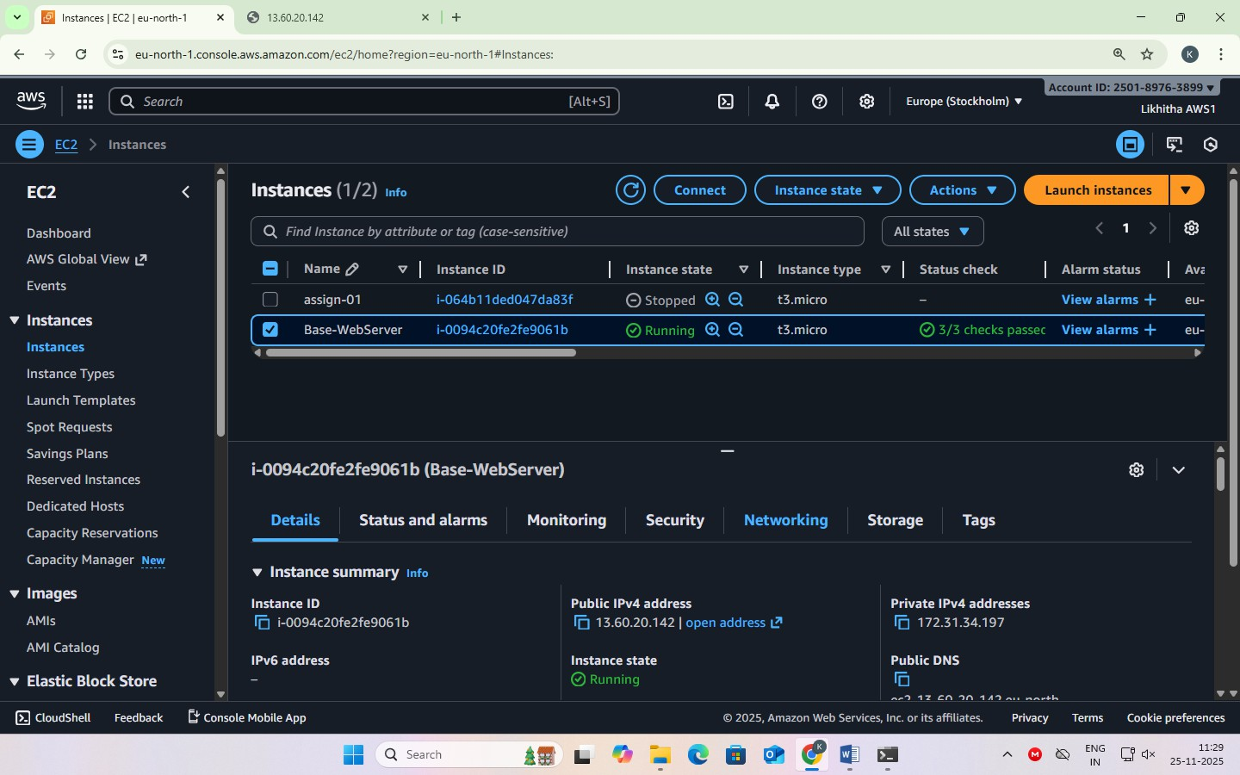Launch the instance

### STEP 2 — Install Apache and Create Web Page

* + SSH into the instance.
  + Install Apache:
    - sudo yum install httpd -y
    - sudo systemctl start httpd
    - sudo systemctl enable httpd
  + Move to Web Root Folder **-** cd /var/www/html
  + Create a webpage with hostname:
    - echo "<h1>Hello from Instance 1 — $(hostname)</h1>" | sudo tee

/var/www/html/index.html Test in browser using the instance’s public IP.

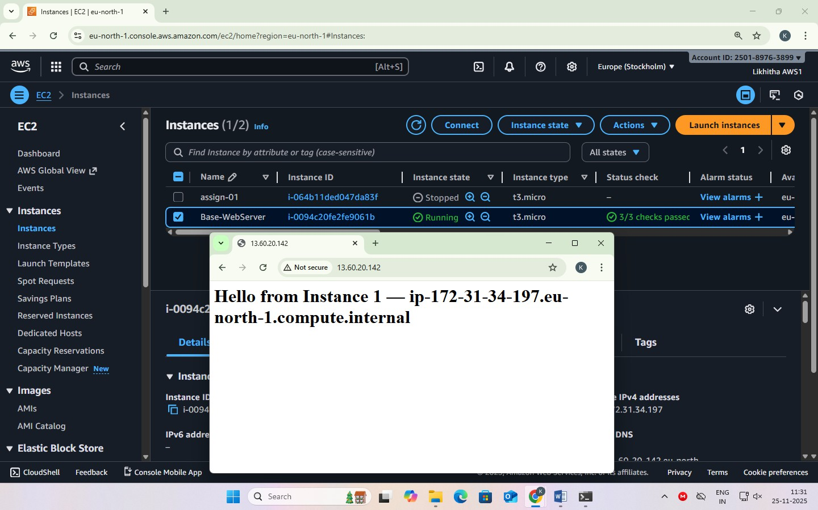

### STEP 3 — Create Custom AMI

* + Go to EC2 → Instances
  + Select Base-WebServer
  + Actions → Image and Templates → Create Image
  + Name: WebServer-AMI
  + Create
  + Wait until AMI status = Available

This AMI now contains Apache + your index.html.

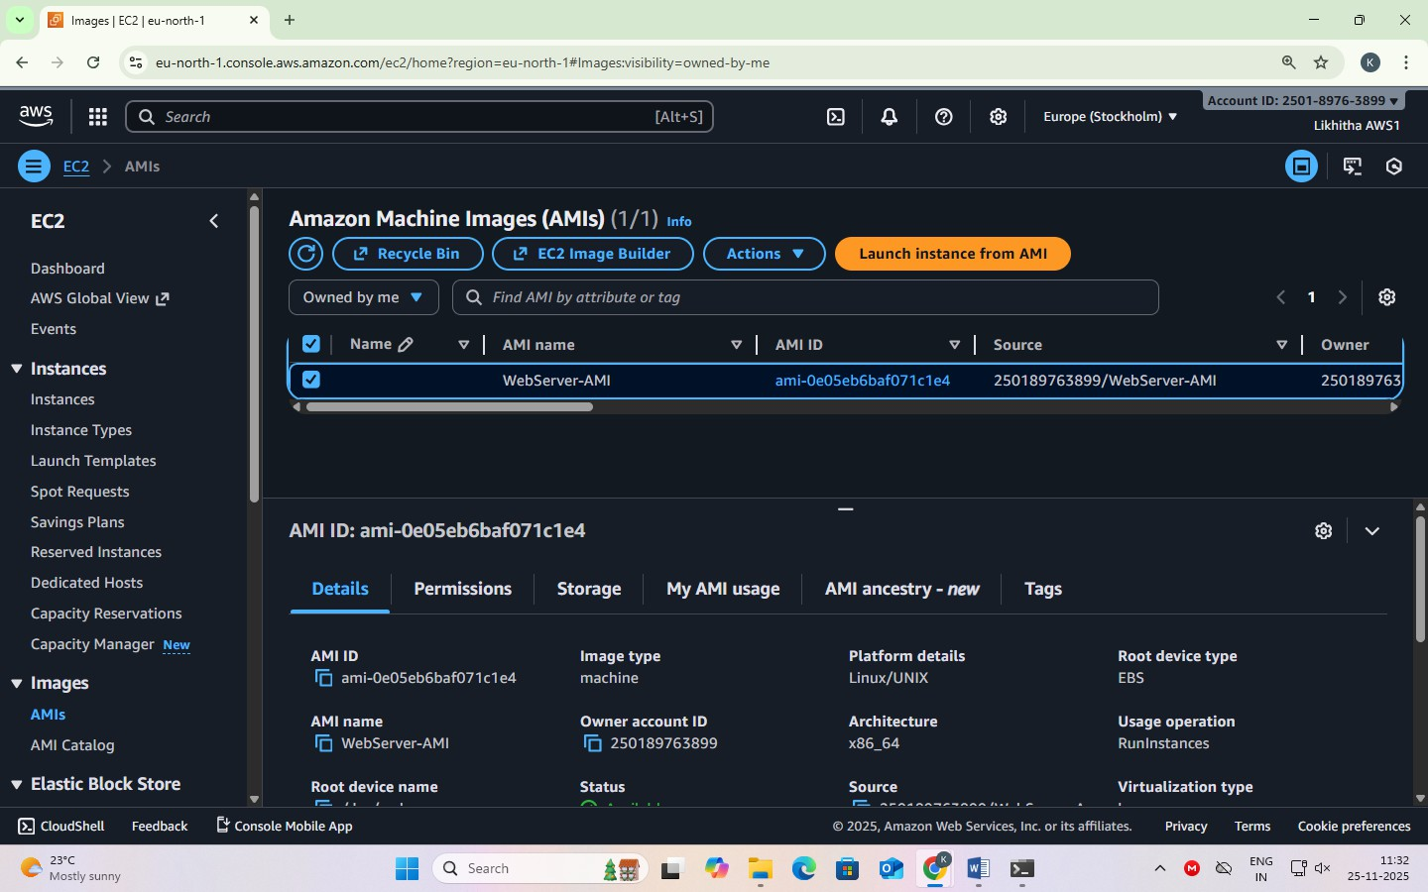

### STEP 4 — Create Target Group

* + EC2 → Target Groups → Create Target Group
  + Target type: Instances
  + Name: WebApp-TG
  + Protocol: HTTP
  + Port: 80
  + Health Check Path: /
  + Create (do not register instances manually)

**Purpose:** Target Group holds the list of EC2 instances behind the Load Balancer.

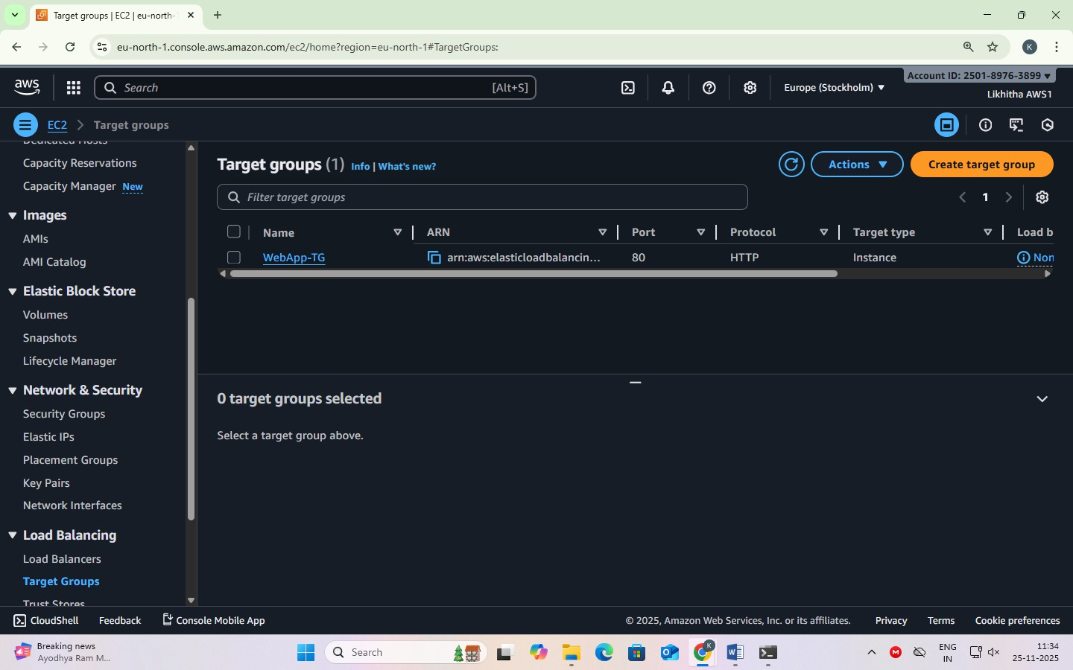

### STEP 5 — Create Application Load Balancer (ALB)

* + EC2 → Load Balancers → Create Load Balancer
  + Choose Application Load Balancer
  + Name: WebApp-ALB
  + Scheme: Internet-facing
  + Listeners: HTTP (80)
  + Select two public subnets
  + Security Group: allow HTTP (port 80)
  + Forward to Target Group → WebApp-TG
  + Create

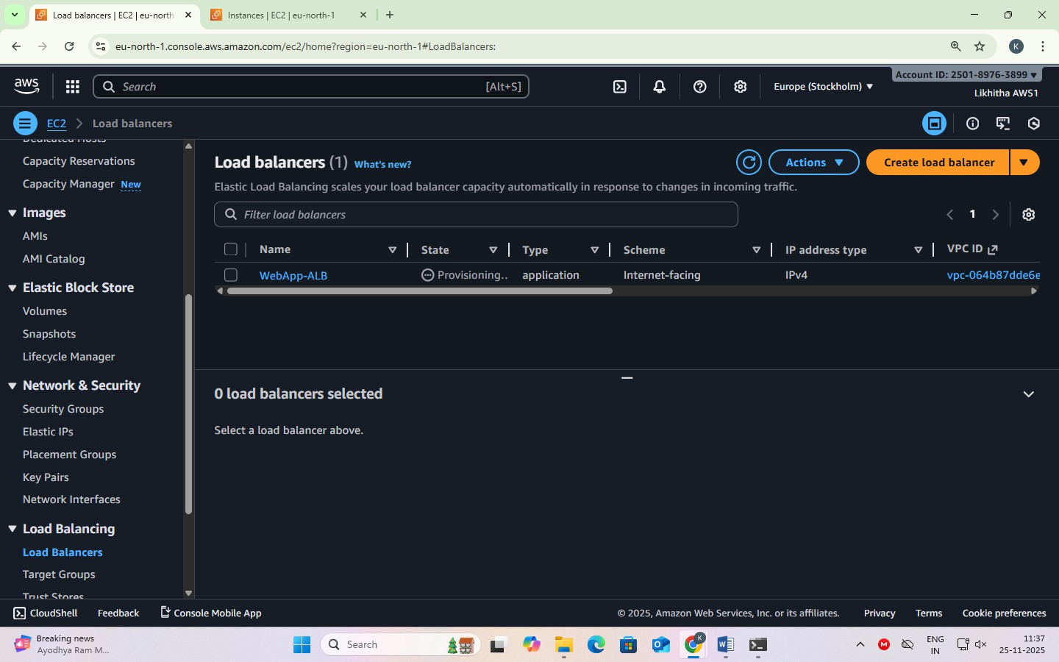

### STEP 6 — Test the Load Balancer Using ALB DNS

* + Go to AWS Console → EC2 → Load Balancers
    - Select your ALB: ALB-WebServer
  + Copy the ALB DNS Name
    - You will see something like:
    - WebApp-ALB-123456789.ap-south-1.elb.amazonaws.com
  + Open a Browser and Paste the DNS Name
    - Enter: http://<your-alb-dns-name>
    - Example: [http://WebApp-ALB-123456789.ap-south-1.elb.amazonaws.com](http://WebApp-ALB-123456789.ap-south-1.elb.amazonaws.com/)
  + View the Output
    - You should see the webpage you created earlier:
    - Hello from Instance 1 — ip-xx-xx-xx-xx
    - This confirms that: The ALB is working
    - The Target Group is routing traffic
    - The instance created from your custom AMI is serving the web page.

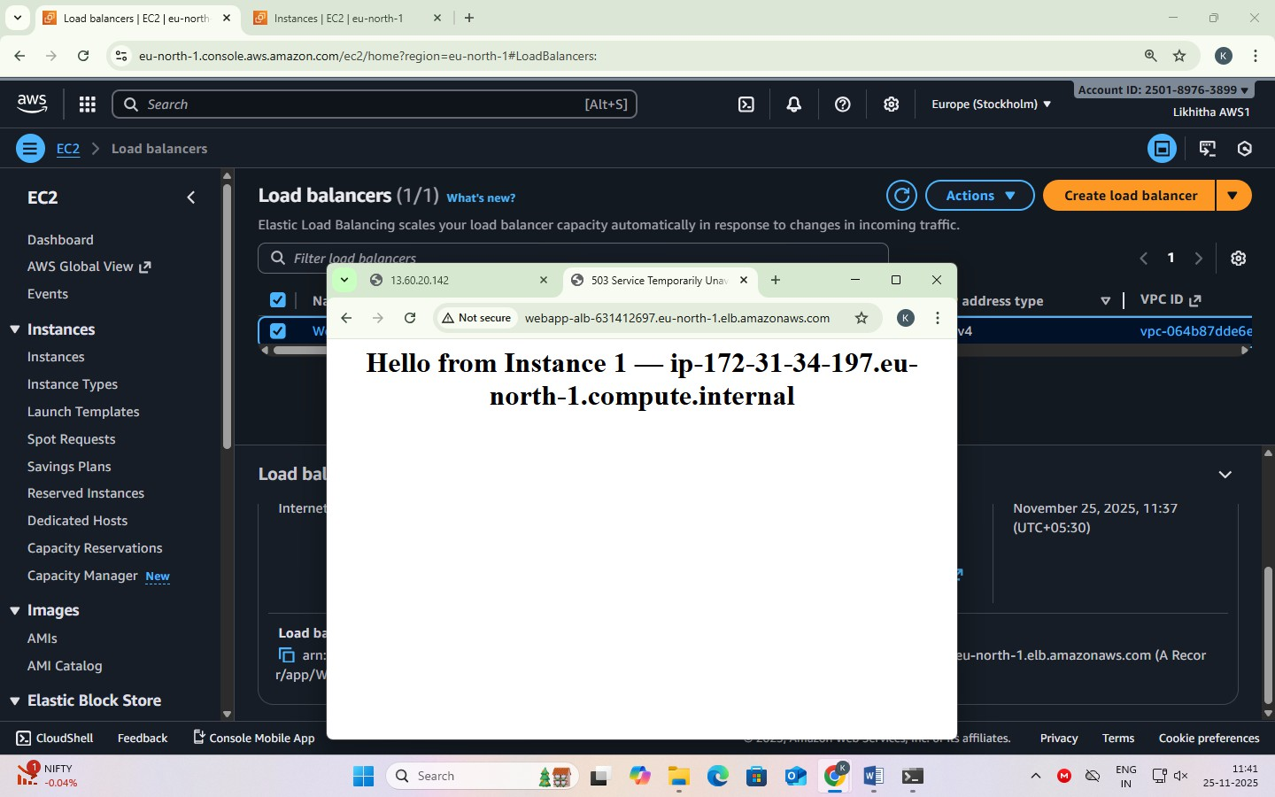

* + Optional – Refresh Multiple Times
    - If you later use Auto Scaling with multiple instances:
    - Clicking Refresh will show different hostnames
    - This confirms load balancing across multiple servers

# DATE: 20-11-25

### Exercise–13 Stress Testing a Linux EC2 Instance (CPU Load Test) Objective:

To generate high CPU load on an Amazon EC2 Linux instance using the stress-ng tool and observe CPU utilization in CloudWatch.

### Step 1 — Launch a Linux EC2 Instance

1. Log in to the AWS Console.

### Go to EC2 → Instances → Launch Instance.

1. Name: **StressTest-EC2**

### AMI: Amazon Linux 2023 (Free Tier eligible)

1. Instance type: **t2.micro** / **t3.micro**
2. Key pair: Select or create a .pem key.
3. Security Group:
   * Allow **SSH (22)** from My IP.
   * Allow **HTTP (80)** from anywhere (optional).
4. Launch the instance.

### Step 2 — Connect to the EC2 Instance

Use Windows PowerShell

Navigate to the folder where pem file is located and type the following command: ssh -i "your-key.pem" ec2-user@<public-ip>

### Step 3 — Install Apache (Optional, to verify the instance is working)

sudo yum install httpd -y sudo systemctl start httpd sudo systemctl enable httpd Create a test web page:

echo "<h1>EC2 Stress Test Demo — $(hostname)</h1>" | sudo tee /var/www/html/index.html

### STEP 4 — Install and Run the Stress Testing Tool (stress-ng)

(For Amazon Linux 2023 EC2 Instances)

Move to the ec2-user home directory

(It is recommended to run stress-ng from the home folder) cd ~

Install stress-ng

Amazon Linux 2023 includes stress-ng directly through dnf, so install it using:

sudo dnf install stress-ng -y Run a CPU Stress Test

Generate high CPU load using 4 CPU workers for 2 minutes: stress-ng --cpu 4 --timeout 120

Expected Result

* Terminal becomes busy during the 120-second load test
* After completion, you will see: successful run completed in 120.02s
* CPU usage will spike to 90–100% (you can check using top)

### Step 5 — Run Stress Test (CPU Load Generation)

Move to home directory to avoid permission issues: cd ~

Run CPU stress for 2 minutes using 4 CPU workers: stress-ng --cpu 4 --timeout 120

You should see messages like:

stress-ng: info: dispatching hogs: 4 cpu

stress-ng: info: successful run completed in 120.02s This will increase CPU usage to **~**100% for the duration.

### Step 6 — Observe CPU Utilization in CloudWatch

Go to CloudWatch → Metrics → EC2 → Per-Instance Metrics Select:

CPUUtilization → InstanceId → your instance View graph in 1-minute or 5-minute intervals.

You should see a sharp spike during the 2-minute stress period.

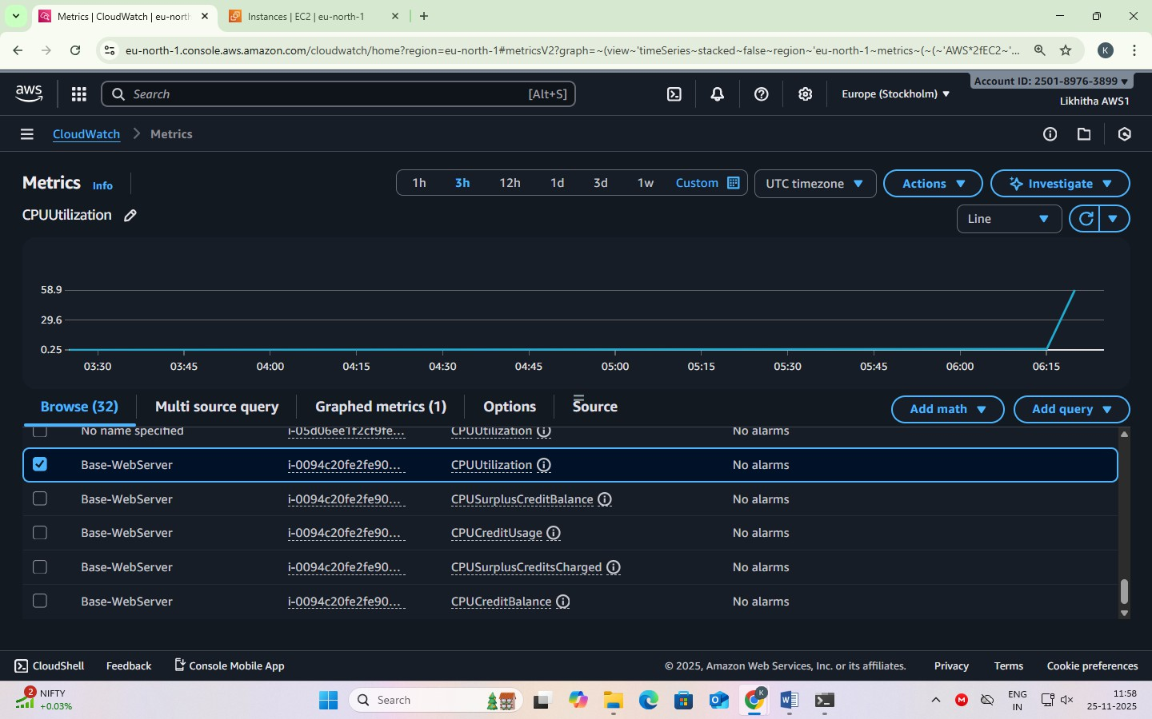

### Step 7 — Stop or Terminate the Instance

To avoid charges:

Option A — Stop the instance (safe):

Actions → Instance State → Stop

Option B — Terminate (permanently delete): Actions → Instance State → Terminate

### Expected Output

* CPU Utilization in CloudWatch should reach 90–100%.
* Stress test completes without errors.
* Students understand how CPU load affects EC2 metrics.

# DATE: 21-11-25

**Exercise–14 Mini Project –**

### Deploying a Load-Balanced Web Application using Application Load Balancer (ALB), Auto Scaling Group (ASG), Custom AMI, and Target Group on AWS with CloudWatch Alarms & Stress Testing for Auto Scaling Validation.

**Auto Scaling Group (ASG)**

**What:** A service that automatically launches or terminates EC2 instances based on demand.

**Why:** Provides scalability so your application can handle variable traffic.

### CPU-Based Scaling Policies

**What:** Rules that add or remove EC2 instances based on CPU usage thresholds.

**Why:** Ensures your application automatically scales up during heavy load and scales down to save cost.

### Stress Testing (using stress/stress-ng tool)

**What:** A method to artificially increase CPU load on instances.

**Why:** Used to validate whether the Auto Scaling Group is scaling up/down correctly.

### STEP 7A — Create Launch Template

Go to EC2 → Launch Templates → Create launch template Template Name

* + Launch template name: LT- WebServer Choose AMI (Custom AMI)

Under Application and OS Images (AMI):

* + - Click My AMIs
    - Select your custom AMI: AMI-WebServer (the AMI you created earlier) Instance Type

Under Instance type: Select t3.micro Key Pair

Under Key pair (login): Select your existing key pair (pemfile1.pem) Security Group

Under Network settings → Firewall (security groups):

* + - Choose Select existing security group
    - Select a security group that allows:
      * SSH (Port 22)
      * HTTP (Port 80)

Example: launch-wizard-1 (already has both rules) Storage

Leave default: 8 GiB gp3 (root volume) Create Template

Click Create launch template

### Launch Template is now ready to be used by the Auto Scaling Group.

**STEP 7B — Create Auto Scaling Group (ASG)**

(Using the Launch Template you created in Step 7A)

Open ASG Wizard

Go to EC2 → Auto Scaling Groups → Create Auto Scaling Group Name and Choose Launch Template

Auto Scaling group name: ASG-WebServer Launch template: Choose LT-WebServer Click Next.

Select Network (VPC + Subnets)

Since we are using default VPC, select:

VPC: vpc-0c952a6cabfbe594b (Default VPC) Subnets (select ANY 2)

Example: ap-south-1a and ap-south-1b

(These are public subnets in default VPC — good for web servers) Click Next.

Attach Load Balancer

Under Load balancing options:

Select: Attach to an existing load balancer Under Select load balancers to attach:

Choose: Choose from your load balancer target groups Under dropdown:

Select your Target Group: TG-WebServer (or whatever name you created) AWS will automatically show:

* Load balancer: ALB-WebServer
* Type: Application/HTTP Click Next.

Configure Group Size

Set:

Desired capacity = 1 Minimum capacity = 1 Maximum capacity = 3

We are not adding scaling policies now (stress test comes later), so: Select No scaling policies

Click Next.

Skip Notifications and Tags No changes.

Click Next.

Review and Create

Check:

* Launch template = LT-WebServer
* Load balancer = ALB-WebServer
* Target group = TG-WebServer
* Subnets = 2 selected
* Desired = 1 instance

Then click: Create Auto Scaling Group

### ASG Creation Done

**Check if ASG launched an instance.**

Verify ASG Instance Creation

Go to EC2 → Auto Scaling Groups → ASG-WebServer Open it and check: Under Activity tab

You should see: Successful — Launching a new EC2 instance

Under Instances tab: You should see an instance like: i-xxxxxxxxxxxx (Running)

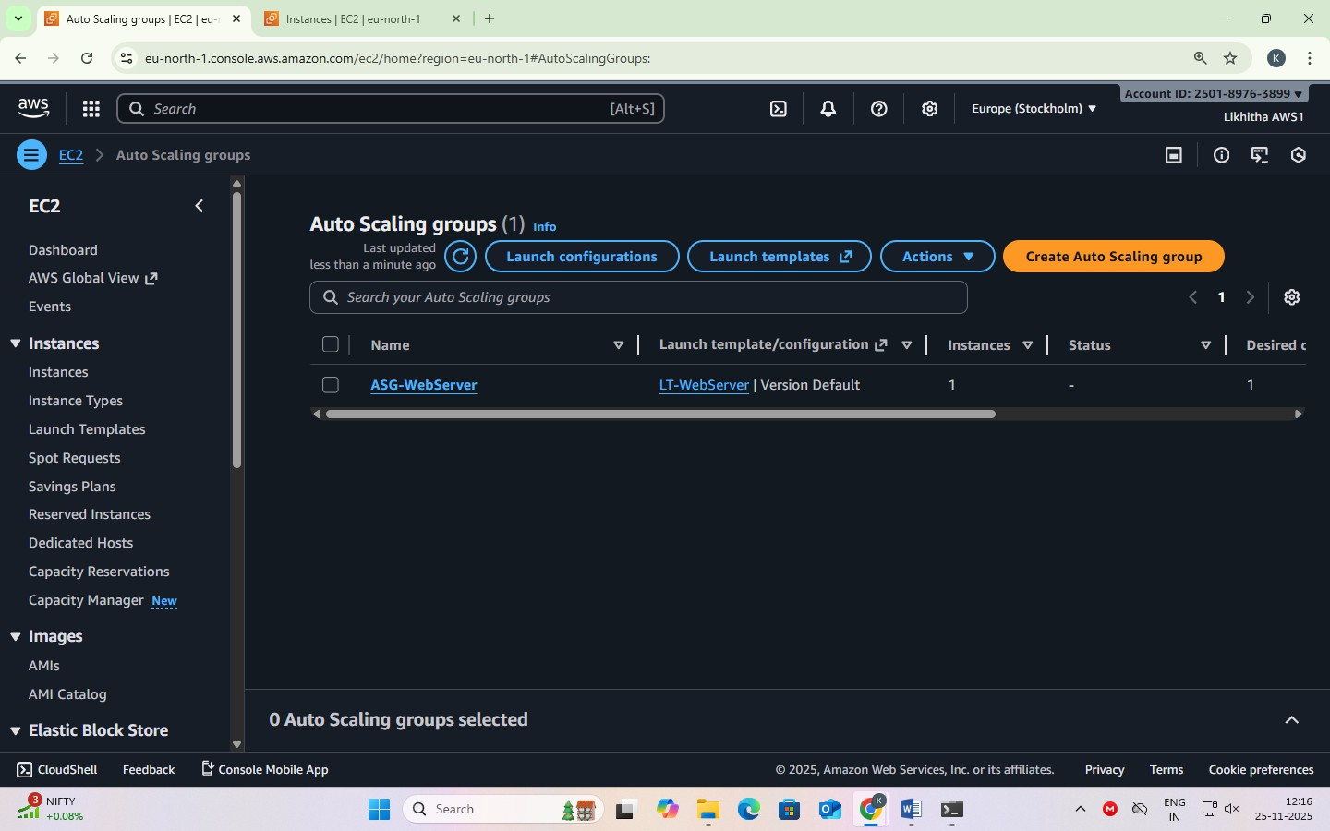

This instance was launched automatically by the ASG using custom AMI through the Launch Template.

Now that ASG is created and one instance is running, we will add Auto Scaling Policies so the group can:

* Scale OUT (add more instances when CPU is high)
* Scale IN (remove instances when CPU is low)

**STEP 8 — Configure Auto Scaling Policies (Scale Out & Scale In)**

### PART 1 – Create High-CPU Alarm (for Scale-OUT)

Open CloudWatch and start alarm

Go to CloudWatch → left menu Alarms → All alarms. Click Create alarm.

Choose metric (CPU of ASG) Click Select metric.

Navigate:

EC2 → By Auto Scaling Group (or By AutoScalingGroupName). Click your group ASG-WebServer.

Select CPUUtilization.

Click Select metric. Set condition (CPU > 60)

Statistic: Average Period: 1 minute Under Conditions:

Threshold type: Static

“Whenever CPUUtilization is…” → choose Greater “than…” → 60

In Additional configuration, datapoints to alarm: 1 out of 1 (default is fine).

Click Next.

Skip actions (no SNS, no ASG here)

On Configure actions page, do NOT add anything. Just click Next.

If a popup says *“No actions configured”*, click Proceed without actions.

Name and create

Alarm name: ASG-CPU-High-60

Description (optional): CPUUtilization > 60% for 1 minute (ASG-WebServer) Click Next, then Create alarm.

You now have one metric alarm with no actions.

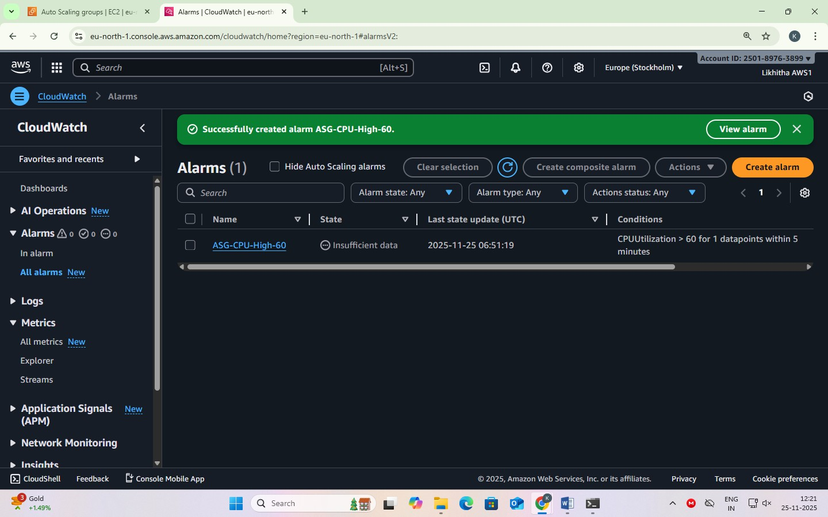

### PART 2 – Attach High-CPU alarm to ASG as Scale-OUT Policy

Open ASG automatic scaling

Go to EC2 → left menu Auto Scaling groups. Click ASG-WebServer.

Go to the Automatic scaling tab.

Create Scale-OUT policy

Click Create dynamic scaling policy. Policy type: Simple scaling

Scaling policy name:

CloudWatch alarm:

Click the dropdown and select ASG-CPU-High-60.

Take the action:

Action: Add Value: 1

Unit: capacity units

And then wait: 300 seconds (default is fine). Click Create.

Now your ASG knows:

When alarm ASG-CPU-High-60 goes to ALARM → Add 1 instance.

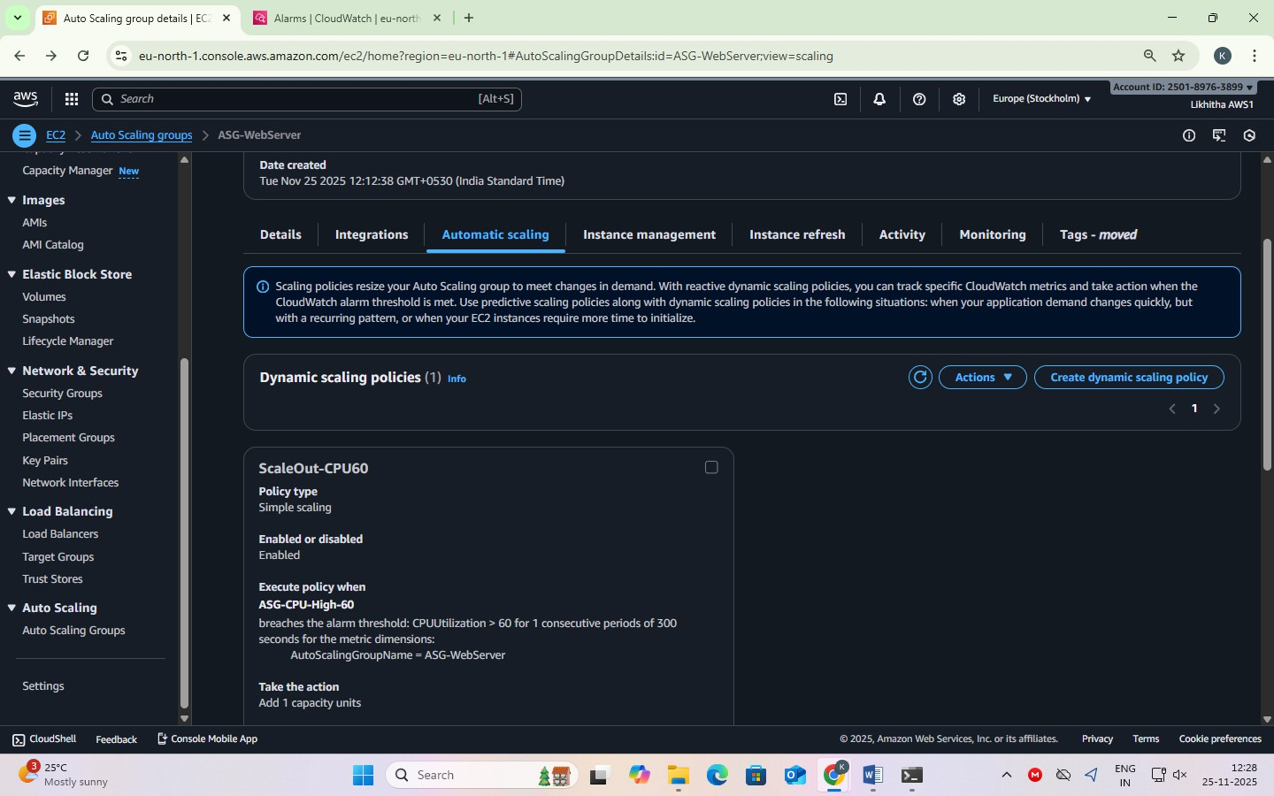

### PART 3 – Create Low-CPU Alarm (for Scale-IN)

Create another alarm in CloudWatch

Go again to CloudWatch → Alarms → Create alarm. Select metric exactly like before:

EC2 → By Auto Scaling Group → ASG-WebServer → CPUUtilization → Select metric.

Set condition (CPU < 20) Statistic: Average Period: 1 minute Conditions:

Threshold type: Static

“Whenever CPUUtilization is…” → Lower “than…” → 20

Datapoints to alarm: 1 out of 1 (default).

Click Next.

Skip actions again

Do not add SNS / Auto Scaling / EC2 actions.

Click Next → if popup appears, Proceed without actions.

Name and create

Alarm name: ASG-CPU-Low-20

Description (optional): CPUUtilization < 20% for 1 minute (ASG-WebServer) Next → Create alarm.

### PART 4 – Attach Low-CPU alarm to ASG as Scale-IN Policy

Open ASG automatic scaling again

Back to EC2 → Auto Scaling groups → ASG-WebServer. Go to Automatic scaling tab.

Create Scale-IN policy

Click Create dynamic scaling policy. Policy type: Simple scaling

Scaling policy name: scalein-cpu20 CloudWatch alarm:

Choose ASG-CPU-Low-20 from the dropdown.

Take the action:

Action: Remove Value: 1

Unit: capacity units And then wait: 300 seconds. Click Create.

### CHECK the resources created in STEP 8-

In EC2 → Auto Scaling groups → ASG-WebServer → Automatic scaling

* + You should see:
  + ScaleOut-CPU60 – Simple scaling – Add 1 capacity units – Alarm: ASG-CPU-

High-60

* + scalein-cpu20 – Simple scaling – Remove 1 capacity units – Alarm: ASG-CPU- Low-20

In CloudWatch → Alarms

* + ASG-CPU-High-60
  + ASG-CPU-Low-20
  + Both will show Actions: No actions – this is OK because ASG is using them.

### STEP 9 — Perform Stress Testing for Auto Scaling Validation

To artificially increase CPU load on EC2 instances and observe automatic scaling behavior triggered by CloudWatch alarms.

### Part A — Connect to the ASG-launched EC2 Instance

Go to AWS Console → EC2 → Instances Select the instance launched by ASG

(NOT the original base instance you created manually) Click Connect

Choose EC2 Instance Connect → Connect

### Part B — Install Stress Testing Tool

For Amazon Linux 2023:

sudo dnf install stress-ng -y Confirm installation:

stress-ng --version

### Part C — Apply CPU Load (Trigger Scale Out)

Run stress tool for 2 minutes with 4 CPU workers:

stress-ng --cpu 4 --timeout 120

✔ This will spike CPU usage above **60%**

✔ Your Scale-Out Policy should activate

✔ CloudWatch alarm → ALARM state → ASG launches 1 more instance

### Part D — Monitor Auto Scaling Activity

Check scaling progress in:

|  |  |
| --- | --- |
| **Service** | **What to Monitor** |
| EC2 → Auto Scaling Groups → Activity | Shows launching of new instance |
| EC2 → Instances | New instance appears with different host- name |
| CloudWatch → Alarms | High CPU alarm turns ALARM |

Scaling may take **2–4 minutes**

Refresh page to see updates

### Part E — Test Load Balancing

Copy ALB DNS Name → paste in browser → refresh multiple times: You should see:

Hello from Instance 1 — ip-xx-xx-xx-xx Hello from Instance 2 — ip-aa-aa-aa-aa

✔ Confirms ALB is distributing traffic across multiple instances

### Part F — Scale In (CPU comes down)

After 2 minutes, stress test stops automatically → CPU drops below 20%

✔ Low CPU alarm triggers

✔ ASG removes the extra instance

✔ Only 1 instance remains (desired capacity) Scaling-in may take 3–5 minutes

Extra points

This exercise imitates a production-grade architecture used in companies.

#### What is a Target Group?

A Target Group is a collection of EC2 instances that receive traffic from the Application Load Balancer (ALB).

It defines:

* Which instances to send traffic to
* On which port (example: 80)
* Health check rules (path /, interval, threshold) In simple words:

Target Group = list of servers behind the load balancer.

#### Why do we need two steps: Create Launch Template and Create Auto Scaling Group?

Because both have different roles:

Launch Template = WHAT to launch

It contains the configuration of one EC2 instance, such as:

* AMI
* Instance type
* Security Group
* Key pair
* Storage
* User data

This is just a blueprint.

Auto Scaling Group = WHEN & HOW MANY to launch The ASG uses the Launch Template to automatically:

* Launch new instances
* Remove instances
* Maintain desired capacity
* Scale based on CPU/memory demand

#### Where to find http://<alb-dns-name>?

You can find the ALB DNS Name in the AWS Console:

Path: EC2 → Load Balancers → Select your ALB → Description tab

There you will see: DNS name: mywebapp-alb-12345678.ap-south-1.elb.amazonaws.com Use it in your browser as: [http://mywebapp-alb-12345678.ap-south-1.elb.amazonaws.com](http://mywebapp-alb-12345678.ap-south-1.elb.amazonaws.com/) This is the public URL of your Load Balancer.

#### What is ALB DNS?

ALB DNS is the publicly accessible DNS name automatically created by AWS for your Application Load Balancer.

Example: myapp-alb-123456789.ap-south-1.elb.amazonaws.com When a user types this URL:

* Traffic goes to the ALB
* ALB forwards to Target Group
* Target Group sends request to one of the EC2 instances ALB DNS = The website URL of your Load Balancer.

DNS means Domain Name System.

DNS is a system that converts domain names to IP addresses. Example: [www.amazon.com](http://www.amazon.com/) → 52.95.120.1

A DNS Server is only one part of this system. DNS = System that translates names to IPs.

DNS Server = Machine that performs the translation.

#### Why Do we NEED CloudWatch alarms for ASG scaling exercise?

We are using “Simple Scaling”

* Based on CPU > 60 and CPU < 20
* Which requires manually created CloudWatch alarms Without the alarms, ASG has NO trigger, so it cannot scale.

### Delete these resources in this exact order

To avoid dependency errors:

### Delete Auto Scaling Group (ASG)

* + EC2 → Auto Scaling Groups
  + Select ASG-WebServer
  + Actions → Delete

This will automatically terminate any instances managed by ASG.

### Delete Launch Template

* + EC2 → Launch Templates
  + Select your template
  + Actions → Delete template

### Delete Application Load Balancer

* + EC2 → Load Balancers
  + Select your ALB
  + Actions → Delete

### Delete Target Group

* + EC2 → Load Balancing → Target Groups
  + Select your target group
  + Actions → Delete

### **5. Delete the Custom AMI

* + EC2 → AMIs
  + Select your AMI → **Deregister**
  + Check Snapshots → delete the related snapshot also.

### Delete any Manual EC2 Instances and other resources

If you still have any instances running:

* EC2 → Instances → Select → **Terminate Resource clean-up NOTE:**
* **ALB** charges per hour
* **ASG instances** can launch unexpectedly
* **Custom AMI snapshot** costs storage
* **Running EC2** will cost hourly

# DATE: 21-11-25

**Exercise–15:**

**Hosting a WordPress Content Management Website on Amazon Lightsail.(Only Demo) Amazon LightSail** is a beginner-friendly cloud platform in AWS that provides:

* Virtual servers (simplified EC2)
* Fixed monthly pricing (predictable cost)
* Simple UI and easy setup
* One-click application launch (WordPress, LAMP, Node.js, etc.)
* Built-in networking (Static IP, DNS, Firewall)
* Automatic SSH terminal
* Snapshots (backups) It is ideal for:
* Personal websites
* Student projects
* Small web apps
* WordPress blogs
* Quick prototyping

#### Why Lightsail Instead of EC2?

Lightsail = “EC2 with all hard things simplified.”

|  |  |  |
| --- | --- | --- |
| **Feature** | **EC2** | **Lightsail** |
| Pricing | Pay per hour | Fixed monthly |
| Setup | Complex (VPC, SG, AMI) | Simple |
| SSH | Need .pem or PuTTY | Built-in SSH |
| DNS | Basic | Easy DNS panel |
| Apps | Install manually | One-click WordPress, LAMP |

#### What is WordPress in Lightsail?

WordPress is a full-stack content management system (CMS) pre-installed on Lightsail. It includes:

Frontend (UI)

* + HTML, CSS, JS
  + Themes
  + Templates
  + Page layouts Backend
  + PHP (server-side logic)
  + WordPress core engine Database
  + MySQL/MariaDB

Stores pages, media, lessons, posts, settings.

Server

* + Apache web server Hosting
  + Lightsail VM + static IP + firewall

Thus, WordPress is a full-stack application (LAMP stack).

#### Lightsail Free-Tier Eligibility

* + 3 months free
  + Only for the 512 MB RAM plan
  + Suitable for WordPress, but slightly slow
  + After 3 months → ~₹350–₹400/month
  + recommended: 1 GB RAM plan.

#### PART A — Create Server on Lightsail

Step 1 — Open Lightsail Console

AWS Console → Search “Lightsail” → Open it. Lightsail dashboard appears.

Step 2 — Create Instance

Click Create Instance.

Step 3 — Select Platform:

Choose Linux/Unix. (WordPress works best on Linux)

Step 4 — Select Blueprint → App + OS → WordPress [Lightsail will install automatically:

* Apache
* PHP
* MySQL/MariaDB
* WordPress application No manual setup required.]

Step 5 — Choose Instance Plan

512 MB RAM (free-tier for 3 months but slower)

Step 6 — Name the Instance

Give a name (example MyCMS) Click Create Instance.

Step 7 — Wait Until Status = Running

Takes 1–2 minutes.

#### PART B — Access and Configure WordPress Step 8 — Connect Through Browser-Based SSH

Click **Connect → Connect using SSH**

(Lightsail gives built-in SSH. No need for .pem file.)

#### Step 9 — Retrieve WordPress Admin Password

In SSH terminal, run:

cat bitnami_application_password

This outputs a long randomly generated password.

Copy it — you need it for login. [example: INBV03eMcWX:]

#### Step 10 — Open Your WordPress Website

Copy the **Public IP** from the instance details. Visit: http://<your-lightsail-ip>

You will see a WordPress homepage.

#### Step 11 — Login to WordPress Admin

Visit: http://<your-lightsail-ip>/wp-admin Login:

* Username: **user**
* Password: *paste the password from SSH*

You now have full access to your site's backend.

#### PART C — Build ‘CMS Website’ [Experiential learning]

Step 12 — Install a Clean Education Theme Go to:

Dashboard → Appearance → Themes → Add New Recommended theme: Astra (best)

Activate the theme. [install and activate] Step 13 — Create Main Website Pages

Dashboard → Pages → Add New Create:

1. Home
2. Courses & Subjects
3. Lesson Notes
4. Assignments
5. Study Material (PDFs/PPTs)
6. Contact

Step 14 — Create Lesson-Wise Pages Step 15 — Upload PDFs, PPTs, Notes

Go to:

Dashboard → Media → Add New Upload:

* + PDFs
  + DOCX files
  + PPTs
  + Images
  + Notes

Then insert into pages using “Add Media”.

Step 16 — Create Menus

Dashboard → Appearance → Menus Add:

Home | Courses | Notes | Assignments | Contact Add submenus under Courses and Notes.

#### PART D — Secure & Finalize

Step 18 — Attach Static IP

Lightsail → Networking → Create Static IP → Attach to instance. Reason:

Without this, your IP changes → site breaks.

Step 19 — Take Snapshot

Lightsail → Snapshots → Create snapshot. Acts as a backup of your entire site.

# DATE: 21-11-25

### Exercise–16: Building a Basic Python Flask Web Application — Fundamentals of Web Requests & Form Handling (Pre-Requisite for AWS RDS Connectivity Lab)

[Prerequisite for AWS RDS exercise. This particular exercise is a local Python Flask exercise. No AWS service is used here.]

To design and implement a simple Web Application using Python Flask that:

* Displays an HTML form to accept Name and Password.
* Reads the form data on the server side when the form is submitted.
* Displays the submitted values on a new result page.

After completing this exercise, you will be able to:

* Understand how an HTML form sends data to the server.
* Explain how Flask receives form data using the request object.
* Read request parameters (request.form) in Flask.
* Understand basic frontend–backend communication.
* Handle a simple HTTP POST request in a Flask application.

#### Folder Structure

Create the following structure manually: FlaskFormApp/

├── app.py

├── templates/

├── form.html

├── result.html

#### Requirements

* Python installed (3.x)
* Flask library
* Any code editor (VS Code / PyCharm / Notepad etc.)
* Web browser (Chrome / Edge / Firefox)

#### STEP 1: Install Flask

Open **Command Prompt / Terminal** and run: pip install flask

#### STEP 2: Create Project Folder

Create a folder, for example: C:\Users\MCA\FlaskFormApp

#### STEP 3: Create templates Folder

Inside C:\Users\MCA\FlaskFormApp, create a sub-folder named templates FlaskFormApp/templates/

All HTML files will be placed in this templates folder.

#### STEP 4: Create HTML Form — templates/form.html

Create a new file form.html inside templates folder and type the following code:

<!DOCTYPE html>

<html>

<head>

<title>HTML Form</title>

</head>

<body>

<h2>Enter Your Details</h2>

<form action="/submit" method="post">

Name: <input type="text" name="uname"><br><br> Password: <input type="password" name="pwd"><br><br>

<button type="submit">Submit</button>

</form>

</body>

</html>

Note:

* action="/submit" – sends the form data to the /submit route.
* method="post" – form data is sent using HTTP POST method.
* name="uname" and name="pwd" – these names are used in Flask to read values.

#### STEP 5: Create Result Page — templates/result.html

Create another file result.html inside templates folder:

<!DOCTYPE html>

<html>

<head>

<title>Result</title>

</head>

<body>

<h2>Form Submission Result</h2>

<p><strong>Name:</strong> {{ name }}</p>

<p><strong>Password:</strong> {{ password }}</p>

</body>

</html>

Note:

* {{ name }} and {{ password }} are **placeholders** (Jinja2 template syntax) that Flask will fill with the values sent from app.py.

#### STEP 6: Create Flask Backend — app.py

In the FlaskFormApp folder, create app.py and type:

from flask import Flask, request, render_template app = Flask( name )

@app.route('/') def home():

return render_template('form.html')

@app.route('/submit', methods=['POST']) def submit():

name = request.form['uname'] password = request.form['pwd']

return render_template('result.html', name=name, password=password)

if name == " main ": app.run(debug=True)

Explanation:

* @app.route('/') → Home URL, shows the form using form.html.
* @app.route('/submit', methods=['POST']) → Handles form submission.
* request.form['uname'] → Reads the value of input with name="uname".
* render_template('result.html', name=name, password=password) → Sends values to result page.

#### STEP 7: Run the Application

* Open **Command Prompt / Terminal** inside the FlaskFormApp folder.
* Run:
* python app.py
* You will see something like:
* * Running on [http://127.0.0.1:5000](http://127.0.0.1:5000/)
* Open a browser and type the URL: [http://127.0.0.1:5000](http://127.0.0.1:5000/)
* To stop the Flask server, go to the terminal where it is running and press **Ctrl + C**.

#### EXERCISE 17: Flask Web App with Registration & Login Using AWS RDS (MySQL) (Full Deployment on AWS EC2 + AWS RDS)

To design and deploy a Python Flask web application on an AWS EC2 instance that allows:

1. User Registration – store Name and Password in AWS RDS MySQL database.
2. User Login – validate user credentials from the RDS database.
3. Welcome Page – display a message on successful login.

This exercise demonstrates a complete cloud-based web application workflow using Flask + MySQL (RDS).

#### System Architecture

Flow: Browser → Flask App (on EC2) → MySQL Database (RDS)

* + Frontend: HTML templates (registration form, login form, welcome page)
  + Backend: Python Flask application running on EC2
  + Database: AWS RDS – MySQL engine
  + Hosting: Linux EC2 instance
  + Web Server: Flask’s built-in development server (Apache/NGINX not used in this exercise)

#### Folder Structure (on EC2 instance)

Create the following structure inside the EC2 instance: FlaskLoginApp/

├── app.py

├── db_config.py

└── templates/

├── register.html

├── login.html

├── success.html

├── error.html

└── welcome.html

#### From EC2Create Database and Table in RDS MySQL

Where:

The SQL commands are executed from the EC2 instance, by connecting to the RDS MySQL database using the MySQL client.

When:

After the RDS MySQL instance status becomes “Available”

and after allowing EC2 security group access in RDS inbound rules.

Create:

* A database: flaskdb
* A table: users

#### SQL: Create Database and Table

CREATE DATABASE flaskdb; USE flaskdb;

CREATE TABLE users (

id INT AUTO_INCREMENT PRIMARY KEY, name VARCHAR(50) NOT NULL,

password VARCHAR(50) NOT NULL

);

* + id – unique identifier for each user (auto-increment primary key).
  + name – username (cannot be NULL).
  + password – password (cannot be NULL).

Note: For learning purposes, we store plain text. In real systems, passwords must be **hashed**. **Flask Application Code (Backend)**

#### db_config.py

This file stores the **RDS MySQL connection details**. # db_config.py

db_config = {

'host': 'your-rds-endpoint.amazonaws.com',

# e.g., flaskdb-instance.xxxxxx.ap-south-1.rds.amazonaws.com 'user': 'admin', # master username created in RDS

'password': 'YourPasswordHere', # master password created in RDS 'database': 'flaskdb' # database name created in MySQL

}

Replace host, user, and password with the actual values from the RDS instance.

#### app.py

This is the **main Flask application**. # app.py

from flask import Flask, request, render_template import mysql.connector

from db_config import db_config

app = Flask( name )

# Function to create a new database connection def get_connection():

return mysql.connector.connect(**db_config)

@app.route('/') def home():

return render_template('register.html')

@app.route('/register', methods=['POST']) def register():

name = request.form['uname'] password = request.form['pwd']

conn = get_connection() cur = conn.cursor()

sql = "INSERT INTO users (name, password) VALUES (%s, %s)" cur.execute(sql, (name, password))

conn.commit()

cur.close() conn.close()

# Use HTML template for success page return render_template('success.html')

@app.route('/login') def login():

return render_template('login.html')

@app.route('/validate', methods=['POST']) def validate():

name = request.form['uname'] password = request.form['pwd']

conn = get_connection() cur = conn.cursor()

sql = "SELECT * FROM users WHERE name = %s AND password = %s" cur.execute(sql, (name, password))

user = cur.fetchone()

cur.close() conn.close()

if user:

# Successful login -> welcome page

return render_template('welcome.html', username=name) else:

# Invalid login -> error page

return render_template('error.html')

if name == " main ": app.run(host='0.0.0.0', port=5000, debug=True)

#### HTML Templates (Frontend)

All HTML files go inside the templates/ folder.

* 1. **templates/register.html**

<!DOCTYPE html>

<html>

<head>

<title>User Registration</title>

</head>

<body>

<h2>User Registration</h2>

<form action="/register" method="post">

<label>Name:</label>

<input type="text" name="uname" required><br><br>

<label>Password:</label>

<input type="password" name="pwd" required><br><br>

<button type="submit">Register</button>

</form>

<br>

<a href="/login">Already registered? Click here to Login</a>

</body>

</html>

* 1. **templates/login.html**

<!DOCTYPE html>

<html>

<head>

<title>User Login</title>

</head>

<body>

<h2>User Login</h2>

<form action="/validate" method="post">

<label>Name:</label>

<input type="text" name="uname" required><br><br>

<label>Password:</label>

<input type="password" name="pwd" required><br><br>

<button type="submit">Login</button>

</form>

<br>

<a href="/">New user? Click here to Register</a>

</body>

</html>

* 1. **templates/welcome.html**

<!DOCTYPE html>

<html>

<head>

<title>Welcome</title>

</head>

<body>

<h2>Welcome, {{ username }}!</h2>

<p>You have successfully logged in.</p>

</body>

</html>

* 1. **templates/success.html**

<!DOCTYPE html>

<html>

<head>

<title>Registration Successful</title>

</head>

<body>

<h3>Registration Successful!</h3>

<a href="/login">Click here to Login</a>

</body>

</html>

* 1. **templates/error.html**

<!DOCTYPE html>

<html>

<head>

<title>Login Error</title>

</head>

<body>

<h3>Invalid Username or Password</h3>

<a href="/login">Try Again</a>

</body>

</html>

**Deployment Steps –**

**PHASE 1 – Launch EC2 Linux Instance**

* + - Open AWS Management Console → EC2 → Launch instance.
    - Configuration:
      * Name: FlaskLoginServer
      * AMI: Amazon Linux 2023 (Free Tier eligible)
      * Instance type: t3.micro (Free Tier)
      * Key pair: create or select existing
      * Network: Default VPC and any public subnet
      * Auto-assign Public IP: Enable
    - Security Group for EC2 – Inbound rules:

|  |  |  |  |
| --- | --- | --- | --- |
| Type | Port | Source | Purpose |
| SSH | 22 | My IP | To connect via SSH/EC2 Connect |
| Custom TCP | 5000 | 0.0.0.0/0 | To test Flask app in browser |

* + - Outbound: Allow all traffic.
    - Click Launch instance.

#### PHASE 2 – Connect to EC2 and Install Dependencies

* + - Go to EC2 → Instances → Select instance → Connect.
    - Choose EC2 Instance Connect (browser-based SSH) → Connect. Or open PowerShell on windows and connect using ssh command
    - Update packages:

sudo yum update -y

* + - Check Python version (Amazon Linux 2023 has Python 3): python3 --version
    - Install pip (if not already installed):

sudo dnf install python3-pip -y

* + - Install Flask and MySQL Connector for Python: pip3 install flask

pip3 install mysql-connector-python

#### PHASE 3 – Create Flask Project Structure on EC2

* + - Create project folder:

mkdir FlaskLoginApp cd FlaskLoginApp

* + - Create templates folder:

mkdir templates

* + - Create the Python and HTML files using nano:

nano db_config.py → paste code for db_config.py nano app.py → paste code for app.py

nano templates/register.html → paste register page nano templates/login.html → paste login page

nano templates/welcome.html → paste welcome page Save each file using: CTRL + O → Enter → CTRL + X

#### PHASE 4 – Create RDS MySQL Instance

* + - Go to AWS Console → RDS → Databases → Create database.
      * Engine type: MySQL
      * Templates: Free tier
      * DB instance identifier: flaskdb-instance
      * Master username: admin (example)
      * Master password: <your-password>
      * DB instance class: db.t3.micro (Free tier)
      * Storage: e.g. 20 GB (Free tier)
      * Connectivity:
        + Connect to an EC2 compute resource → YES
        + Select the same EC2 instance (or its security group)
        + (AWS automatically performs the following:

Selects the same VPC as EC2

Creates/associates an RDS security group

Adds inbound rule: MySQL (3306) from EC2 security group)

* + - Public access: No
    - Click Create database.

Wait until the status becomes “Available”.

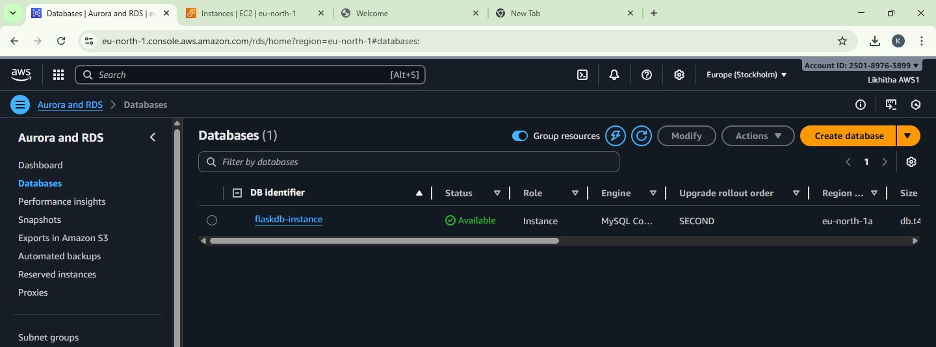

#### PHASE 5 – Verify RDS Security Group (Auto-configured)

* + - Go to AWS Console → RDS → Databases → flaskdb-instance.
    - Open Connectivity & security section.
    - Under VPC security groups, click the linked security group name.
    - In Inbound rules, verify that the following rule exists:

|  |  |  |
| --- | --- | --- |
| Type | Port | Source |
| MySQL / Aurora | 3306 | EC2 Security Group |

1. If the rule exists, EC2 to RDS connectivity is correctly configured.

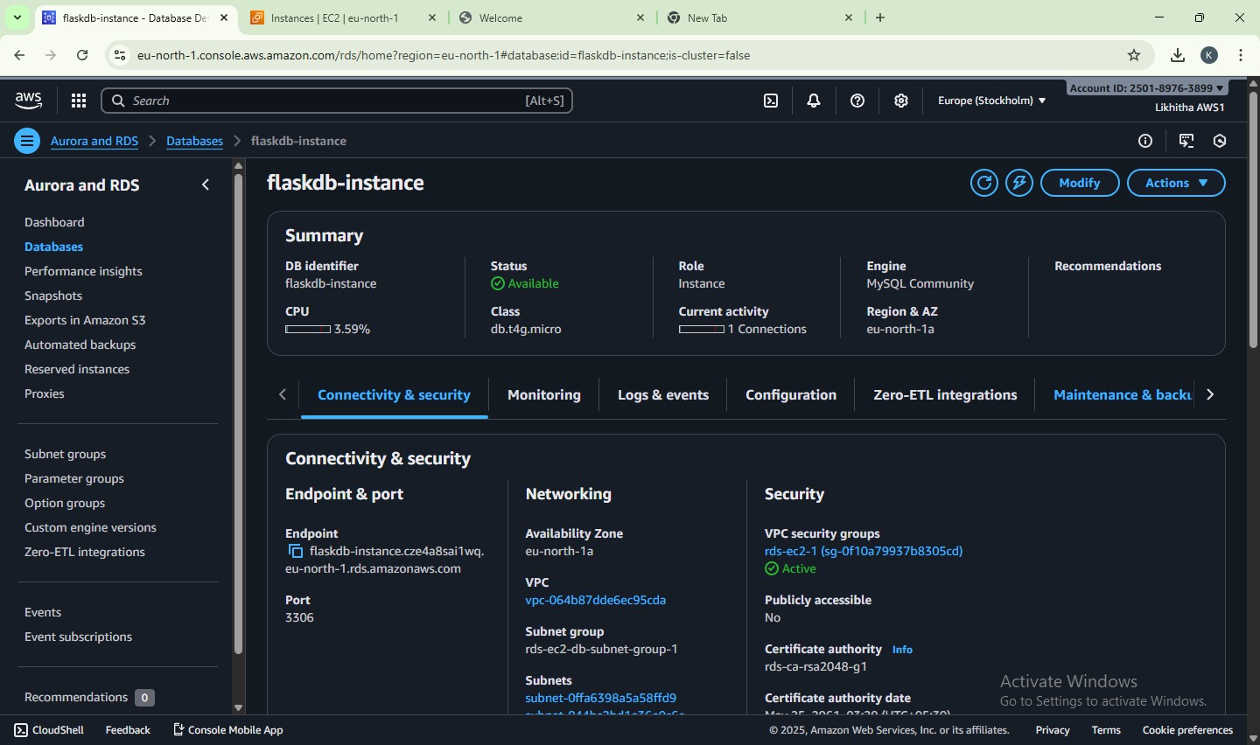

#### PHASE 6 – Create Database and Table in RDS from EC2

* + From the EC2 terminal, install MySQL client (MariaDB client): sudo dnf install mariadb105 -y

# if this fails, try: sudo dnf install mariadb -y

* + Connect to the RDS MySQL instance from EC2: mysql -h <RDS-endpoint> -u admin -p

Example: mysql -h flaskdb-instance.xxxxxx.ap-south-1.rds.amazonaws.com -u admin –p

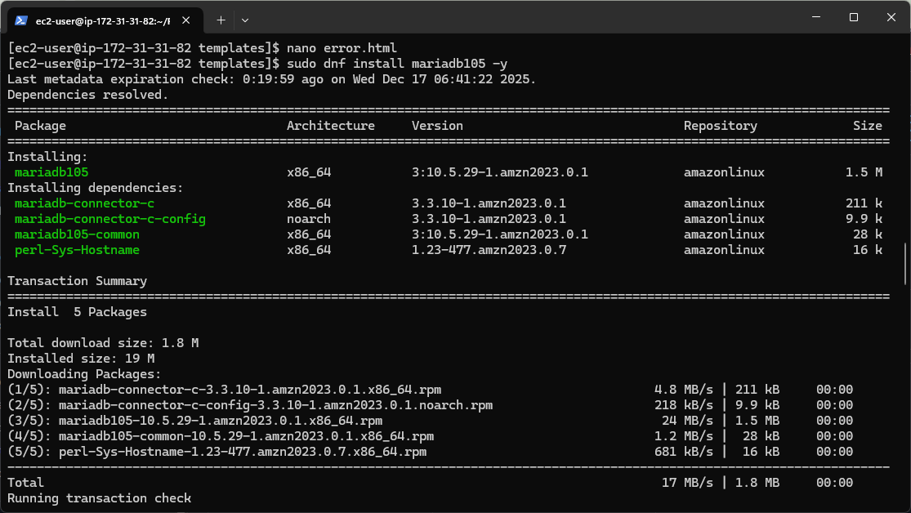

* + Inside the MySQL prompt, run following commands:

CREATE DATABASE flaskdb; USE flaskdb;

CREATE TABLE users (

id INT AUTO_INCREMENT PRIMARY KEY, name VARCHAR(50) NOT NULL,

password VARCHAR(50) NOT NULL

);

* + Exit MySQL: exit;

#### PHASE 7 – Configure Flask to Use RDS and Run Application

* + Open db_config.py on EC2 and update with **correct RDS details**: nano db_config.py

Ensure:

db_config = {

'host': 'your-rds-endpoint.amazonaws.com', 'user': 'admin',

'password': 'YourPasswordHere', 'database': 'flaskdb'

}

Save and exit.

* + Start the Flask app:

cd ~/FlaskLoginApp python3 app.py

You should see: * Running on [http://0.0.0.0:5000](http://0.0.0.0:5000/)

#### PHASE 8 – Test the Application from Browser

* + In your local system browser, open: http://<EC2-public-IP>:5000 Example: [http://13.232.122.81:5000](http://13.232.122.81:5000/)

You should see: Registration Page (default route /)

* + After registration → success message with link to /login
  + Login Page → if correct credentials → Welcome Page

Check that data is stored in flaskdb.users table in RDS. - SELECT * FROM users;

#### Expected Output

1. Registration Page
   * User enters Name and Password.
   * On submit, data is inserted into users table in RDS MySQL.
2. Login Page
   * User enters same Name and Password.
   * Flask executes SELECT query on users table to check match.
3. Welcome Page
   * For valid credentials:

“Welcome, <username>! You have successfully logged in.”

* + For invalid credentials:

“Invalid Username or Password” message with link to try again.

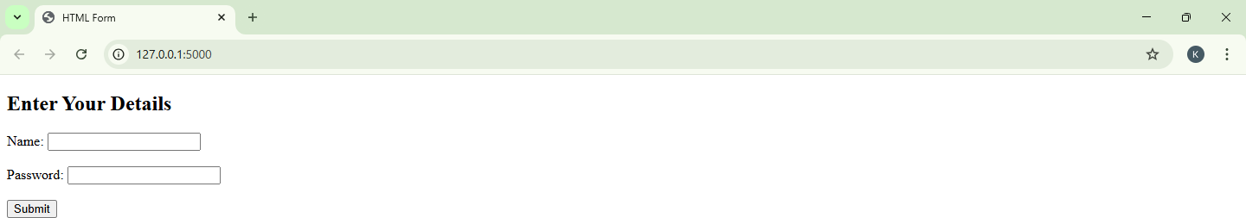

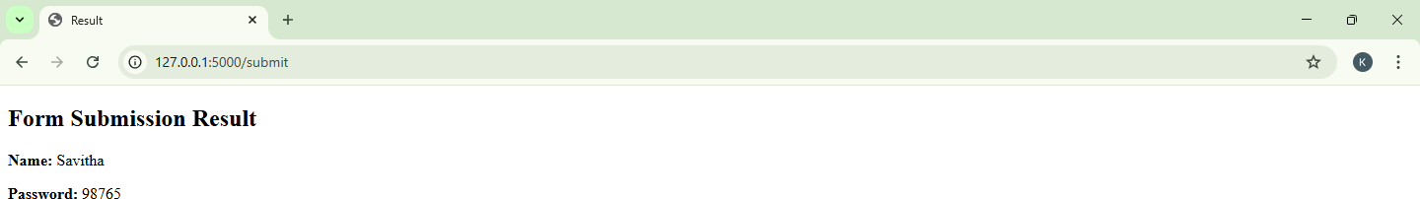

#### Result

A **fully working cloud-based registration and login system** was successfully deployed using:

* **Flask** as the backend web framework
* **HTML** templates for frontend pages
* **MySQL** database hosted on **AWS RDS**
* **AWS EC2** instance as the application server

This exercise demonstrates a **complete end-to-end mini project** on AWS using **Flask + MySQL (RDS)**.

**Exercise 18: Creating and Operating a NoSQL Key-Value Database using Amazon DynamoDB**

To create an Amazon DynamoDB table and perform CRUD operations (Create, Read, Update, Delete) using the AWS Management Console, and understand Partition Key, Sort Key, Query vs Scan, and table cleanup.

#### Phase 1: Create DynamoDB Table

Create a DynamoDB table to store Student Records.

Store items like: USN, Name, Semester, Course, Attendance, IA1Marks

#### Step 1: Open DynamoDB

* + Login to AWS Console
  + Search → type DynamoDB → open Amazon DynamoDB

#### Step 2: Create a Table

* + Left menu → Tables
  + Click Create table
  + Fill details: Table details
  + Table name: MCA_StudentLabInternals
  + Partition key (PK): USN (Type: String)
  + Sort key (SK): CourseCode (Type: String) (Enable sort key option by setting sort key)

Why this design?

* + One student can have multiple courses → Sort key separates records per course.
  + This creates a composite primary key (PK + SK).

#### Step 3: Table settings

* + Under Table settings, choose:

Default settings (recommended for lab)

* + Ensure Capacity mode is: On-demand (default already selected)

#### Step 4: Create

* + Click Create table
  + Wait until table status becomes Active

#### Phase 2: Insert Items (Create Data) Step 5: Open Table and Add Items

* + Click the table: MCA_StudentLabInternals
  + Click: Explore table items
  + Click Create item

#### Step 6: Add Item 1 (Student 1 - Course 1)

* + You will see attributes:
    - USN (String)
    - CourseCode (String)

Enter:

* + - * USN = 1MS24MCA001
      * CourseCode = CCL301

Now add additional attributes (click **Add new attribute**):

* + - * Name (String) = Arun
      * Semester (Number) = 3
      * Attendance (Number) = 86
      * IA1Marks (Number) = 18 Click **Create item**

#### Step 7: Add Item 2 (Same student - another course)

Repeat Create item with:

* + - * USN = 1MS24MCA001
      * CourseCode = DBS301
      * Name = Arun
      * Semester = 3
      * Attendance = 88
      * IA1Marks = 20

#### Step 8: Add Item 3 (Another student)

Create item:

* + - * USN = 1MS24MCA002
      * CourseCode = CCL301
      * Name = Chitra
      * Semester = 3
      * Attendance = 74
      * IA1Marks = 14

You should now see 3 items in the table list.

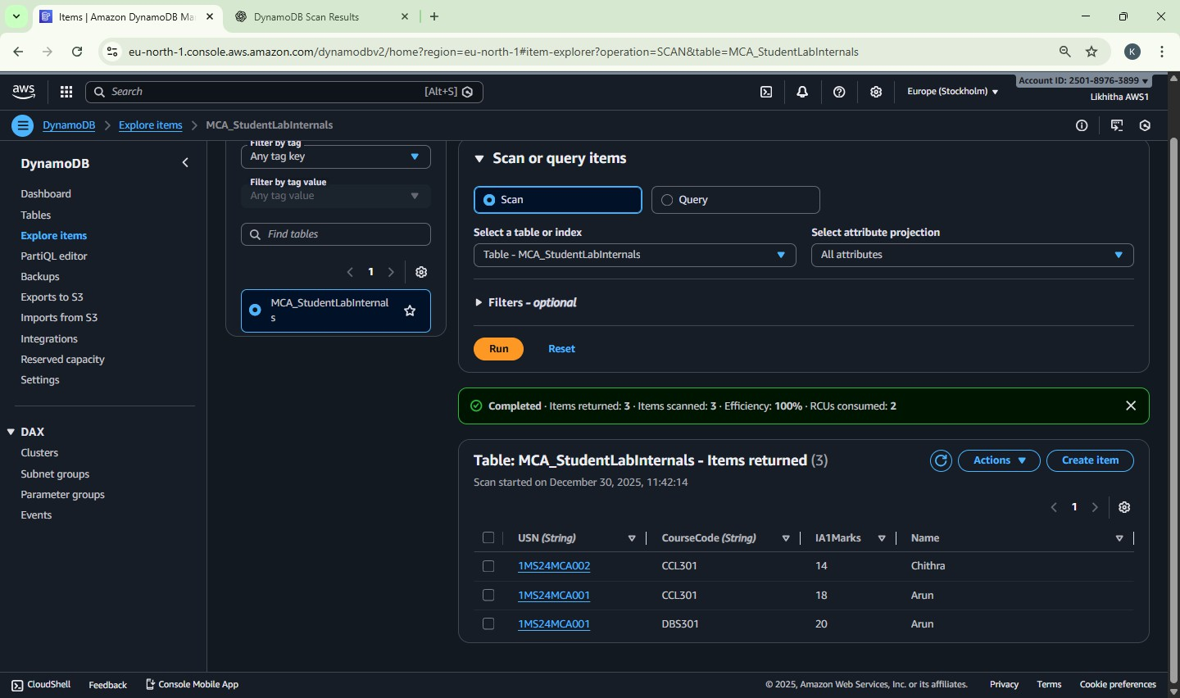

#### Phase 3: Read Data (Get / Query / Scan) Step 9: Get a single item (exact PK + SK)

* + - * In “Explore table items”, use search/filter:
      * Use USN = 1MS24MC001 and CourseCode = CCL301
      * Open the item → verify all attributes

#### Key concept:

To uniquely identify an item in a PK+SK table, you must provide **both**.

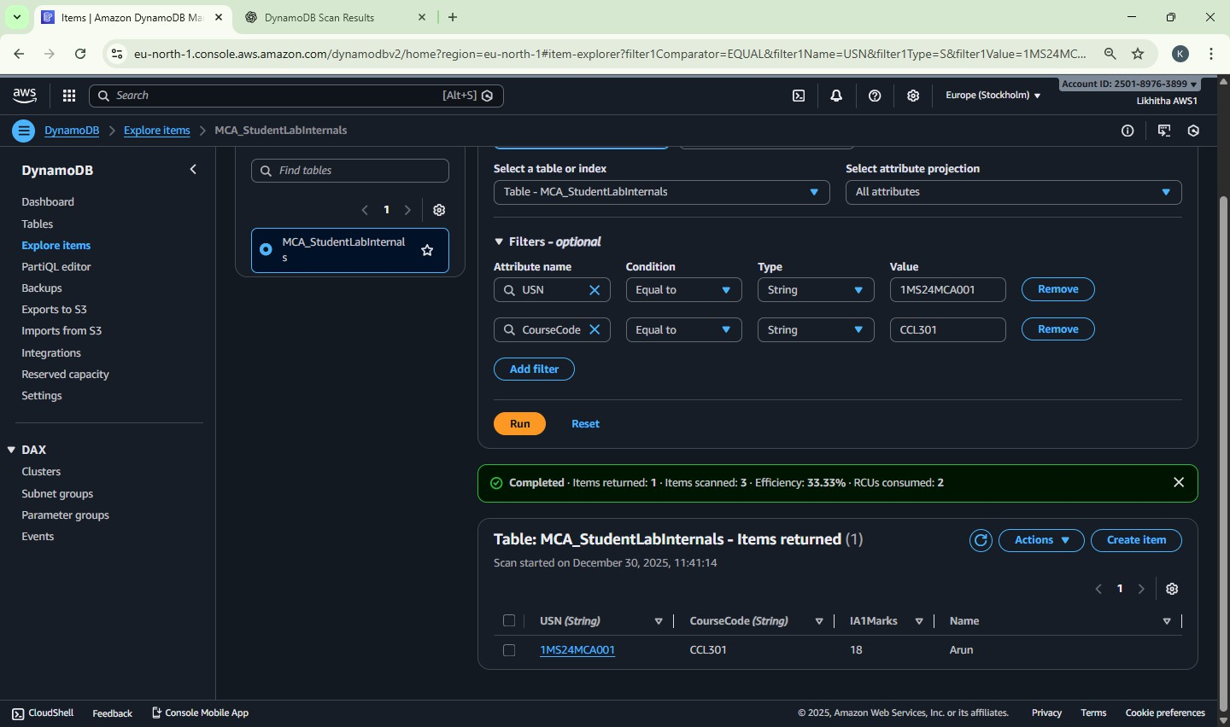

#### Step 10: Query – fetch all courses for one student

* + - * Click Run query
      * Set Partition key condition: USN equals 1MS24MCA001
      * Run Expected output:
      * Items for Arun in both CCL301 and DBS301

Key concept:

Query works only with Partition Key (and optional Sort Key conditions). It is efficient.

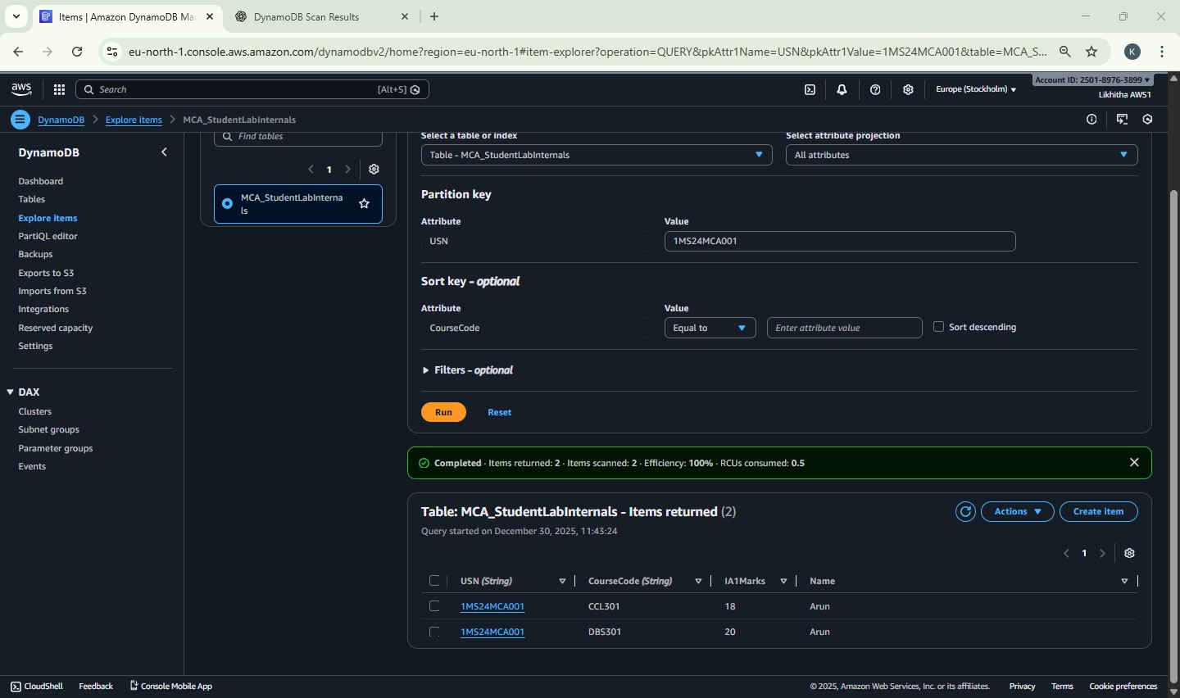

**Step 11: Scan** (Not for large tables)

* + - * + Click Scan
        + Run scan without filters Expected output:
      * All items (Arun + Chitra)

Key concept:

Scan reads the entire table → slow/costly for big tables.

#### Phase 4: Update Data

**Step 12: Update IA1 marks of Chitra for CCL301**

* + - * + Open item where:

USN = 1MS24MCA002

CourseCode = CCL301

* + - * + Click Edit
        + Change: IA1Marks from 14 to 20
        + Click Save changes Verify updated value appears.

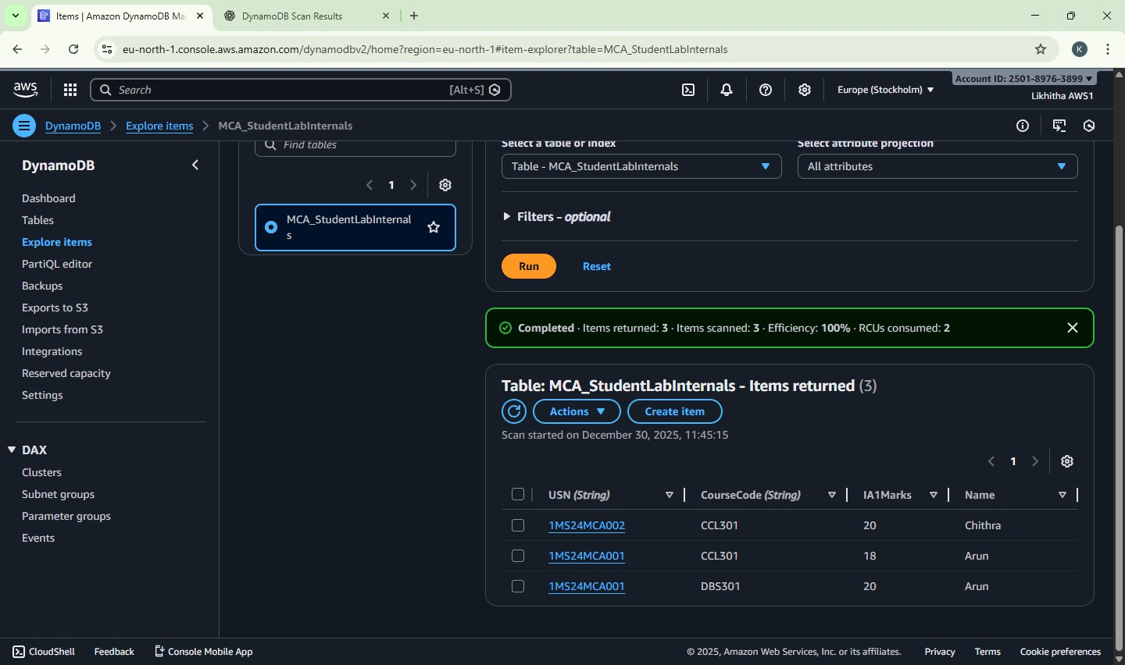

#### Phase 5: Delete Data

**Step 13: Delete one item (Arun’s DBS301 record)**

* + - * + Select item:

USN = 1MS24MCA001

CourseCode = DBS301

* + - * + Click **Delete**
        + Confirm delete Now total items should reduce by 1.

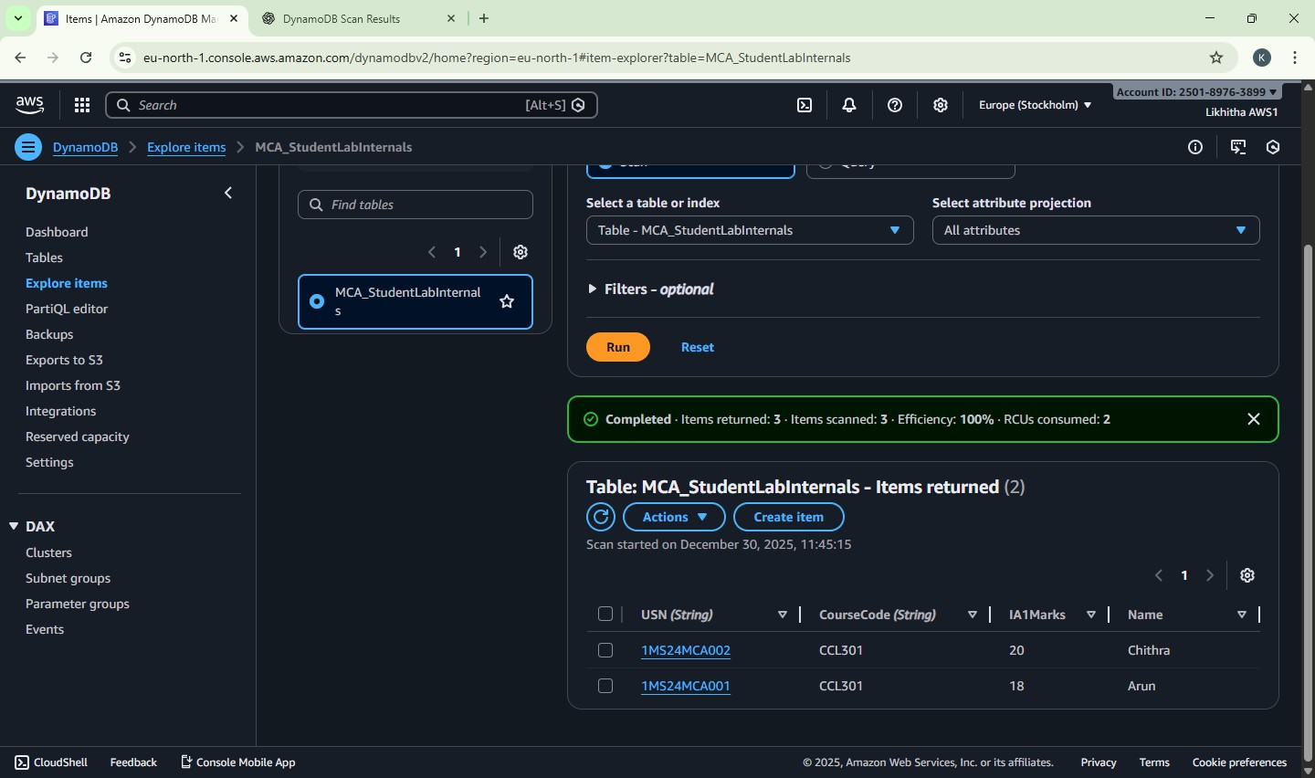

#### Phase 6: Cleanup (Must Do to avoid charges) Step 15: Delete the Table

* + - * + DynamoDB → Tables
        + Select MCA_StudentLabInternals
        + Click Delete
        + Type confirmation (if asked) and delete Ensure table disappears from list.

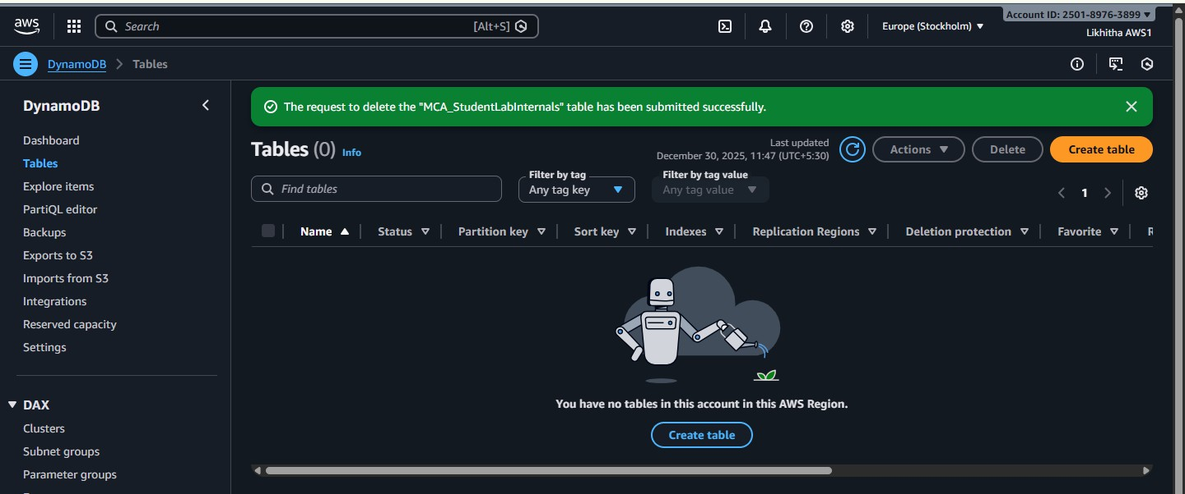

**Exercise 19: ElastiCache (Redis) as an In-Memory Cache**

To implement Amazon ElastiCache (Redis) as an in-memory caching service by deploying a Redis cluster and performing basic cache operations from an EC2 instance.

#### Application-Level Data Flow (Logical)

Step 1: User requests data

Step 2: Application checks ElastiCache (Redis) Step 3: If data exists → return from cache (FAST) Step 4: If data does not exist → fetch from RDS Step 5: Store fetched data in ElastiCache

Step 6: Return data to user

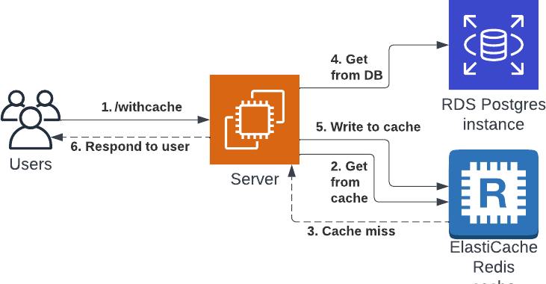

This exercise provides **exposure** to an industry-used in-memory data store.

Redis improves performance by serving frequently accessed data from memory and is typically used **in front of databases** in real-world applications.

|  |  |  |
| --- | --- | --- |
| **Feature** | **RDS** | **ElastiCache** |
| Storage | Disk | RAM |
| Data lifetime | Permanent | Temporary |
| Access speed | Slower | Very fast |
| TTL support | No | Yes |

Phase-1 → EC2 + valkey-cli ready Phase-2 → Redis cache created

Phase-3 → Connect EC2 → Redis and run commands

#### Phase-1: Launch EC2 Client using Amazon Linux 2023 (for Valkey / Redis Client) Purpose of Phase-1

To create an EC2 instance using **Amazon Linux 2023** that will act as a **client machine** to connect to Amazon ElastiCache (Redis OSS) using **valkey-cli**.

#### Step 1: Select AWS Region

* Choose ONE region and stick to it for the entire exercise ap-south-1 (Mumbai) *(recommended)*
* Ensure ElastiCache and EC2 will be in the SAME region

#### Step 2: Launch EC2 Instance

1. Go to **AWS Console → EC2**
2. Click **Launch instance**

#### Step 3: Configure Instance Basics

* + Name: RedisClient-AL2023
  + AMI: Select Amazon Linux 2023 AMI
  + Instance Type: Select t3.micro (Free Tier eligible)
  + Key Pair: Select an existing key pair OR create a new one (RSA, .pem)
  + Network & Security
    - Network
      * VPC: Default VPC
      * Subnet: No preference
      * Auto-assign public IP: Enabled
  + Security Group (VERY IMPORTANT) Create a new security group:
    - Security Group Name: SG-RedisClient
    - Description: Security group for Redis client EC2 Inbound Rules

|  |  |  |
| --- | --- | --- |
| Type | Port | Source |
| SSH | 22 | My IP (or Anywhere for lab) |

Do NOT add Redis (6379) here (The client does not listen on 6379) Outbound rules: Allow all (default)

#### Step 5: Storage

* + Keep default

#### Step 6: Launch Instance

* + Click Launch instance
  + Wait until Instance State = Running

#### Step 7: Connect to EC2

1. EC2 → Instances → select RedisClient-AL2023
2. Click Connect
3. Choose EC2 Instance Connect
4. Click Connect

You are now inside the EC2 terminal.

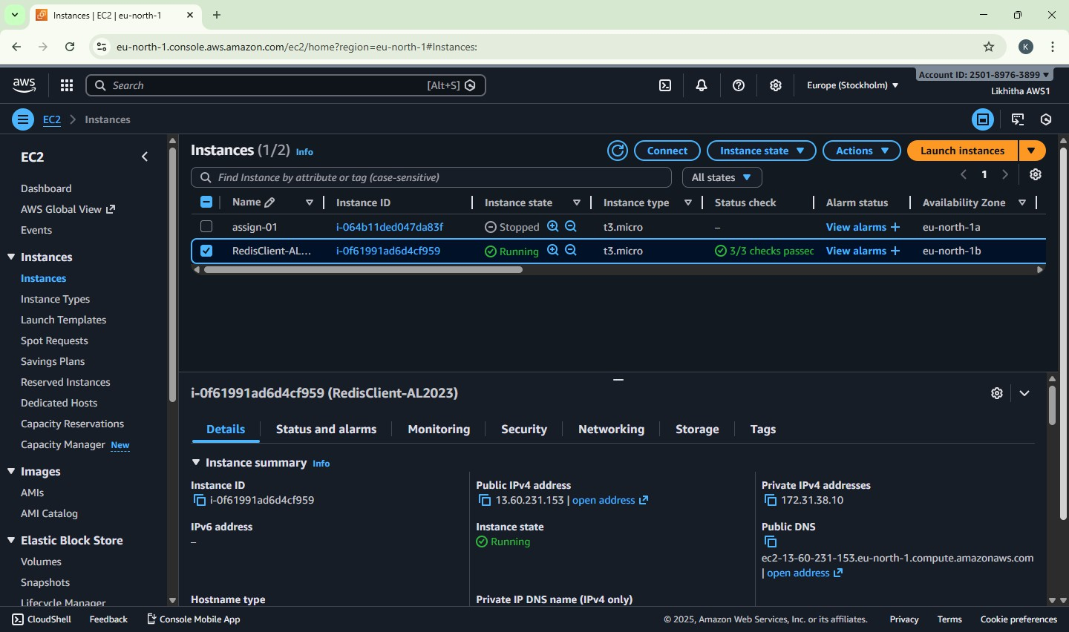

**Step 8: Install Valkey Client** Run the following commands: sudo dnf update -y

sudo dnf install -y valkey Verify installation: valkey-cli --version

#### Expected Output (example)

valkey-cli 8.x.x

This confirms the EC2 is ready as a Redis-compatible client.

Note: why install valkey and not redis??

Amazon Linux 2023 does not provide redis-cli directly.

AWS now provides **Valkey**, which is fully Redis-protocol compatible. Hence, we use **valkey-cli** to connect to ElastiCache Redis.

#### Phase-2: Create Amazon ElastiCache (Redis OSS) Cluster Purpose of Phase-2

To create an Amazon ElastiCache Redis OSS cluster that will act as an in-memory cache, accessible from

the EC2 client created in Phase-1.

#### Step 1: Confirm AWS Region

* Ensure you are in the **same region** used in Phase-1

EC2 and ElastiCache must be in the SAME region and VPC*.*

#### Step 2: Open ElastiCache Console

1. AWS Console → **Services**
2. Select ElastiCache
3. Click Create cache

**Step 3: Select Cache Engine**

* + **Engine**: **Redis OSS**

**Step 4: Choose Deployment Settings**

* + Deployment option: Node-based cluster
  + Creation method: Easy create

Easy create is used to avoid advanced production settings.

#### Step 5: Select Configuration

* + **Configuration**: **Demo**

This automatically selects:

* + A small, low-cost node (e.g., cache.t4g.micro)
  + Suitable for labs and practice

#### Step 6: Provide Cluster Information

* + Cache name: lab-redis
  + Description: Optional (lab-redis)

#### Step 7: Configure Network and Subnet Group Network

* + Network type: IPv4

#### Subnet Group

* + Select: Create a new subnet group
    - Subnet group name: redis-subnet-group
    - VPC: Default VPC
    - Subnets: Leave AWS auto-selected subnets unchanged No manual subnet selection required.

#### Step 8: Configure Security Security Group

* + Create or select a security group:
    - Name: SG-RedisCache

#### Inbound Rule for Redis

Add **one inbound rule** to SG-RedisCache:

|  |  |  |
| --- | --- | --- |
| **Type** | **Port** | **Source** |
| Custom TCP | 6379 | SG-RedisClient |

This allows only the EC2 client to access Redis.

#### Step 9: Authentication

* + Authentication: Disabled

#### Step 10: Create Cache

1. Review all settings
2. Click Create
3. Wait until Status = Available This may take a few minutes.

#### Step 11: Note the Redis Endpoint

1. Click on the cache name lab-redis
2. Copy the **Primary Endpoint**
   * Example: lab-redis.xxxxxx.cache.amazonaws.com This endpoint will be used in **Phase-3** to connect from EC2.

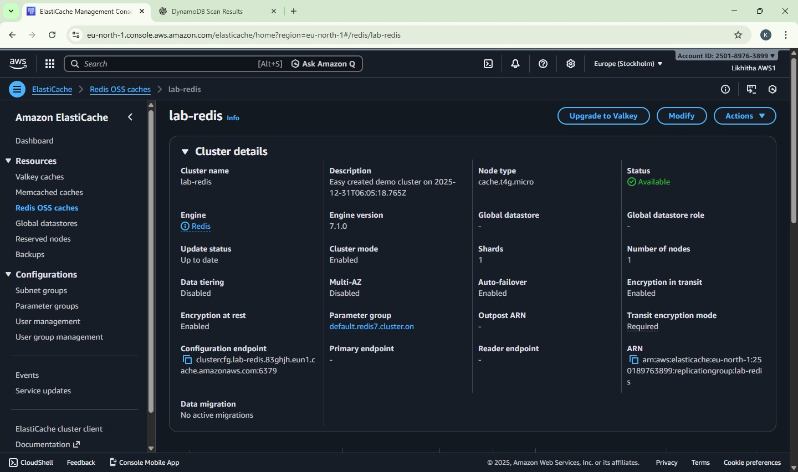

Note:

We have created an in-memory Redis cache using Amazon ElastiCache. It runs inside the AWS VPC and does not have a public IP.

Only our EC2 client is allowed to access it using port 6379.

#### Phase-3: Connect EC2 to ElastiCache Redis and Execute Cache Commands

**Purpose of Phase-3**

To connect the EC2 client (Amazon Linux 2023) to the ElastiCache Redis OSS cluster using valkey-cli and demonstrate basic in-memory cache operations.

**Pre-checks -** Before connecting, confirm:

* EC2 and ElastiCache are in the same AWS region
* EC2 security group = SG-RedisClient
* Redis security group = SG-RedisCache
* Redis security group allows port 6379 from SG-RedisClient
* Redis Status = Available
* You have copied the Primary Endpoint

#### Step 1: Connect to EC2

1. AWS Console → **EC2**
2. Select instance RedisClient-AL2023
3. Click **Connect**
4. Choose **EC2 Instance Connect**
5. Click **Connect**

You are now inside the EC2 terminal.

**Step 2: Verify Valkey Client** Run: valkey-cli --version Expected Output (example) valkey-cli 8.x.x

This confirms the EC2 is ready to act as a Redis-compatible client.

#### Step 3: Connect to ElastiCache Redis

Use the Primary Endpoint from Phase-2.

valkey-cli -h <PRIMARY_ENDPOINT> -p 6379

**Example:** valkey-cli -h lab-redis.xxxxxx.cache.amazonaws.com -p 6379

#### Expected Result

You should see a prompt like:

lab-redis.xxxxxx.cache.amazonaws.com:6379> This means the connection is successful.

#### Step 4: Execute Redis / Valkey Commands

These commands simulate what an application does internally.

#### Test Connectivity

PING

#### Expected Output

PONG

#### Store and Retrieve Data (SET / GET)

SET course "Cloud Computing" GET course

#### Expected Output

"Cloud Computing"

Demonstrates **key–value storage in memory**.

#### Counter Example (INCR)

INCR visits INCR visits GET visits

#### Expected Output

"2"

NOTE: Common real-world use - page views, hit counters.

#### Set Data with Expiry (TTL)

SET notice "Results Published" EX 60 TTL notice

GET notice

#### Expected Output

* + - TTL shows a value **≤ 60**
    - GET returns: "Results Published"

Shows **temporary cache data**.

#### Verify Automatic Expiry

Wait ~60 seconds, then run:

GET notice **Expected Output** (nil)

Confirms data is **automatically removed from memory**.

#### Delete Data Manually

DEL course GET course

#### Expected Output

(nil)

#### Step 5: Exit Redis Client

EXIT

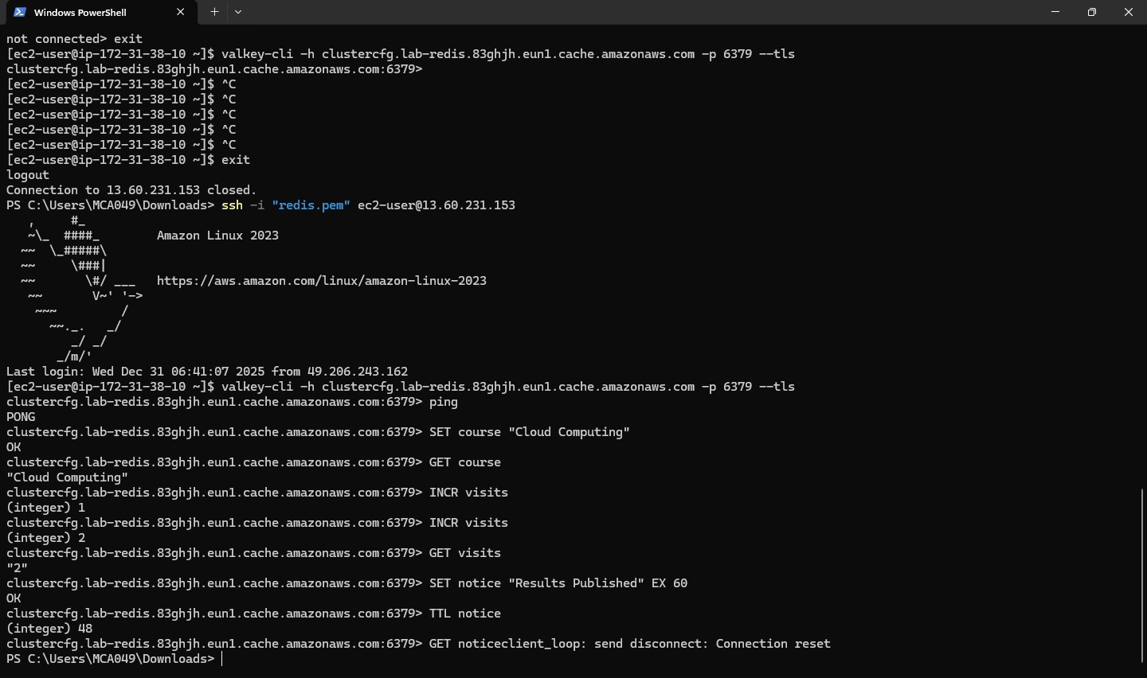

#### Note:

“The application first checks Redis.

If data is present, it is returned immediately from memory.

If not present, the application fetches data from the database and stores it in Redis with a TTL. Redis automatically removes the data after expiry.”

#### Phase-3 Outcome

* EC2 successfully connected to ElastiCache Redis
* In-memory key–value operations verified
* Temporary storage and TTL behavior observed
* Redis used as a **cache**, not as a primary database

#### Common Errors & Quick Fix

|  |  |  |
| --- | --- | --- |
| **Problem** | **Reason** | **Fix** |
| Connection timeout | Wrong SG or region | Check SG-RedisCache inbound rule |
| Command hangs | Redis not Available | Wait & retry |

|  |  |  |
| --- | --- | --- |
| **Problem** | **Reason** | **Fix** |
| (nil) output | Key expired | Expected behavior |

**Clean-Up (Mandatory) Step 1: Delete Redis Cluster**

* ElastiCache → Select lab-redis → Delete
* Disable snapshots

#### Step 2: Terminate EC2 Instance

* EC2 → Instances → Terminate RedisClient-EC2

#### Step 3: Optional

* Delete unused security groups

#### Redis Commands Explanation

* **SET** course "Cloud Computing"
* **GET** course
* **EXPIRE** course 30
* **TTL** course
* The above commands simulate application caching behavior.

The SET command represents storing frequently accessed data in cache.

The EXPIRE command shows that cached data is temporary and stored in memory. After expiry, the application would fetch fresh data from the database again.

# DATE: 05-12-25

**Exercise–20:** Deploy a simple Flask application on AWS Elastic Beanstalk and verify it using the public URL.

#### Phase A — Create the Flask App

**Step A1: On your system, create a folder**

Create a folder: eb-flask-lab

#### Step A2: Create application.py

Create a file named application.py:

from flask import Flask app = Flask( name )

@app.route("/") def home():

return "Hello from Flask on Elastic Beanstalk!"

@app.route("/health") def health():

return "OK"

if name == " main ": app.run()

#### Step A3: Create requirements.txt

Create a file named **requirements.txt** and add:

Flask==3.0.3 gunicorn==22.0.0

#### Step A4: Create Procfile (MOST IMPORTANT)

Create a file named **exactly**: Procfile (no extension) Contents:

web: gunicorn application:app

[Windows Notepad method:

File name: Procfile, Save as type: **All Files,** Encoding: UTF-8]

#### Step A5: Verify folder contents

Your folder must contain exactly these 3 files: eb-flask-lab

**├─** application.py

**├─** requirements.txt

└─ Procfile (Type should show as “File”, NOT Procfile.txt)

#### Phase B — Create the ZIP correctly (root-level ZIP) Step B1: Select the 3 files

Select:

* application.py
* requirements.txt
* Procfile

#### Step B2: Create ZIP

Right click → Compress to → ZIP file Rename the ZIP as:

eb-flask-lab.zip

**Step B3: Confirm ZIP contents (one-time check)** Open the ZIP and confirm it shows (at top level): application.py

requirements.txt Procfile

If you see a folder inside the ZIP, that is wrong.

#### Phase C — Deploy on Elastic Beanstalk (AWS Console) Step C1: Open Elastic Beanstalk

AWS Console → Search Elastic Beanstalk → Open Ensure region is Asia Pacific (Mumbai) (ap-south-1)

#### Step C2: Create Environment

Click Create environment

Environment tier - Select: Web server environment

#### Application information

* Application name: EB-Flask-Lab (or any name)

#### Environment information

* Environment name: EB-Flask-Lab-env (or any name)
* Domain: leave blank (auto)

#### Platform

* Platform: Python
* Platform branch: latest Python on Amazon Linux
* Platform version: recommended

#### Step C3: Upload your code (IMPORTANT SETTINGS)

In Application code:

1. Select: Upload your code
2. Version label: type v1
3. Source code origin: Local file

(Do NOT choose “Public S3 URL”)

1. Click Choose file and select:
2. eb-flask-lab.zip Presets

Select: Single instance (free tier eligible)

Click Next

#### Phase D — Configure Service Access (IAM Roles)

On Configure service access page:

#### Step D1: Service role

If dropdown shows “No options”:

* Click Create role (opens IAM)
* Use case: Elastic Beanstalk
* Keep default permissions (AWS auto selects)
* Create role name:
* aws-elasticbeanstalk-service-role

Return to EB tab → click Refresh → select this role.

#### Step D2: EC2 instance profile

If dropdown shows “No options”:

* Click Create role
* Use case: EC2
* Attach policy: AWSElasticBeanstalkWebTier
* Role name: aws-elasticbeanstalk-ec2-role Return to EB tab → refresh → select this role. **Step D3: EC2 Key pair**

Leave blank (optional)

Click Next

Leave remaining pages as default → Create environment

#### Part E — Wait for Deployment Step E1: Monitor

Open Events tab.

Final success condition:

* Green message: Environment successfully launched
* Health: OK
* 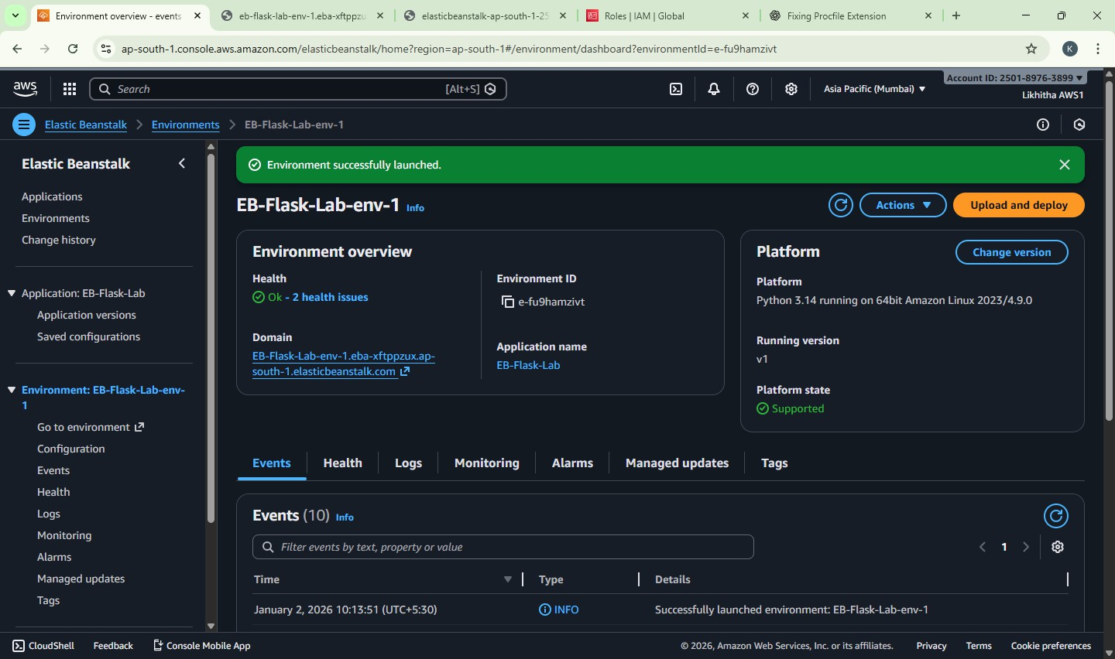Domain URL appears

**Phase F — Test the Application Step F1: Open the domain URL** Click the Domain link shown in EB.

Expected output: Hello from Flask on Elastic Beanstalk!

#### Step F2: Test /health

In the browser address bar, append /health

Example: http://<your-domain>.elasticbeanstalk.com/health Expected output: Hello from Flask on Elastic Beanstalk!



#### Phase G — Cleanup (must do after lab) Step G1: Terminate Environment

Elastic Beanstalk → Environment

#### Actions → Terminate environment

(Optional) After termination: Delete application if required.

#### Common Mistakes (quick checklist)

Procfile must be Procfile (no .txt)

ZIP must contain files at root level (not folder) Upload must be **Local file** (not Public S3 URL) IAM roles must be created/selected if “No options”

1. What is Elastic Beanstalk?

Elastic Beanstalk is a Platform as a Service (PaaS) provided by AWS that allows developers to deploy and manage applications without manually handling the underlying infrastructure such as EC2, load balancers, or auto scaling.

The user only uploads the application code, and Elastic Beanstalk automatically:

* + Creates required AWS resources
  + Deploys the application
  + Handles scaling, monitoring, and health checks

1. What does “Single instance environment” mean?

A Single instance environment means the application runs on one EC2 instance only, without a load balancer or auto scaling.

It is mainly used for:

* + Learning and lab exercises
  + Development and testing
  + Low-traffic applications

It is cost-effective and simple, but not fault-tolerant.

1. Why do we need requirements.txt?

The requirements.txt file lists all Python libraries and their versions required for the application. Elastic Beanstalk uses this file to:

* + Automatically install dependencies using pip
  + Ensure the application runs consistently across environments Without requirements.txt, the application may fail due to missing modules.

1. What is Procfile used for?

A Procfile tells Elastic Beanstalk how to start the application. It specifies:

* + The process type (e.g., web)
  + The command to run the application (e.g., Gunicorn for Flask) Example:

web: gunicorn application:app

Without a Procfile, Elastic Beanstalk may not know which command to execute, leading to deployment errors.

1. What happens if you zip the parent folder instead of the files?

If the parent folder is zipped, Elastic Beanstalk cannot locate key files like:

* + application.py
  + requirements.txt
  + Procfile As a result:
  + Deployment fails
  + Application shows errors such as *“Application version not found”* or *502 Bad Gateway*

Elastic Beanstalk expects all required files at the root level of the ZIP file.

**EXERCISE 21:** Deploy a Flask App on AWS **Elastic Beanstalk** and Perform CRUD on

**DynamoDB** (Using AWS SDK/boto3)

1. LOCALLY — Prepare Folder + Code (Before AWS)
   1. Create folder

Create a folder named: flask-ddb-lab

* 1. Inside it, create 4 files

Your folder must look like: flask-ddb-lab/ application.py requirements.txt

Procfile runtime.txt

* 1. Paste code into application.py

from flask import Flask, request, jsonify import boto3

import os

app = Flask( name )

REGION = os.getenv("AWS_REGION", "ap-south-1") TABLE_NAME = os.getenv("TABLE_NAME", "Students")

dynamodb = boto3.resource("dynamodb", region_name=REGION) table = dynamodb.Table(TABLE_NAME)

@app.route("/") def home():

return "Flask + DynamoDB on Elastic Beanstalk is working!"

@app.route("/health") def health():

return jsonify(status="ok")

# CREATE

@app.route("/student", methods=["POST"]) def create_student():

data = request.get_json() table.put_item(Item={

"StudentID": data["StudentID"], "Name": data["Name"],

"Dept": data.get("Dept", "")

})

return jsonify(message="Student created"), 201

# READ

@app.route("/student/<student_id>", methods=["GET"]) def get_student(student_id):

resp = table.get_item(Key={"StudentID": student_id}) item = resp.get("Item")

if not item:

return jsonify(error="Student not found"), 404 return jsonify(item)

# UPDATE

@app.route("/student/<student_id>", methods=["PUT"]) def update_student(student_id):

data = request.get_json() resp = table.update_item(

Key={"StudentID": student_id}, UpdateExpression="SET #n = :n, Dept = :d", ExpressionAttributeNames={"#n": "Name"},

ExpressionAttributeValues={":n": data["Name"], ":d": data.get("Dept", "")}, ReturnValues="UPDATED_NEW"

)

return jsonify(message="Student updated", updated=resp["Attributes"])

# DELETE

@app.route("/student/<student_id>", methods=["DELETE"]) def delete_student(student_id):

table.delete_item(Key={"StudentID": student_id}) return jsonify(message="Student deleted")

* 1. requirements.txt

Flask==3.0.0 boto3==1.34.0 gunicorn==21.2.0

* 1. Procfile

web: gunicorn application:app

* 1. runtime.txt

python-3.11

* 1. Zip it

Select these 4 files together → right click → Send to → Compressed (zipped) folder.

Rename the zip: flask-ddb-lab.zip

When you open the zip, you must directly see:

* + - application.py
    - requirements.txt
    - Procfile
    - runtime.txt

(No extra folder inside.)

1. AWS — DynamoDB Table Create table

AWS Console → DynamoDB → Tables → Create table

* Table name: Students
* Partition key: StudentID (String) Create → wait till ACTIVE

1. AWS — IAM Role (for EB EC2 to access DynamoDB) Create role

AWS Console → IAM → Roles → Create role

* Trusted entity: AWS service
* Use case: EC2
* Attach policy: AmazonDynamoDBFullAccess
* Role name: EB-EC2-DynamoDB-Role Create role

[once role is created, for next time it will be automatically selected. No need to create again]

1. AWS — Elastic Beanstalk Environment (Sample app first) Create EB app/environment

AWS Console → Elastic Beanstalk → Create application

* Environment tier: Web server environment
* Application name: flask-ddb-lab
* Platform: Python
* Application code: Sample application
* Presets: Single instance (free tier eligible)

Configure service access

On Configure service access page:

* Service role: leave default
* EC2 instance profile: select EB-EC2-DynamoDB-Role Next → Next → Review → Create environment

Wait until you can open the EB domain and see sample page.

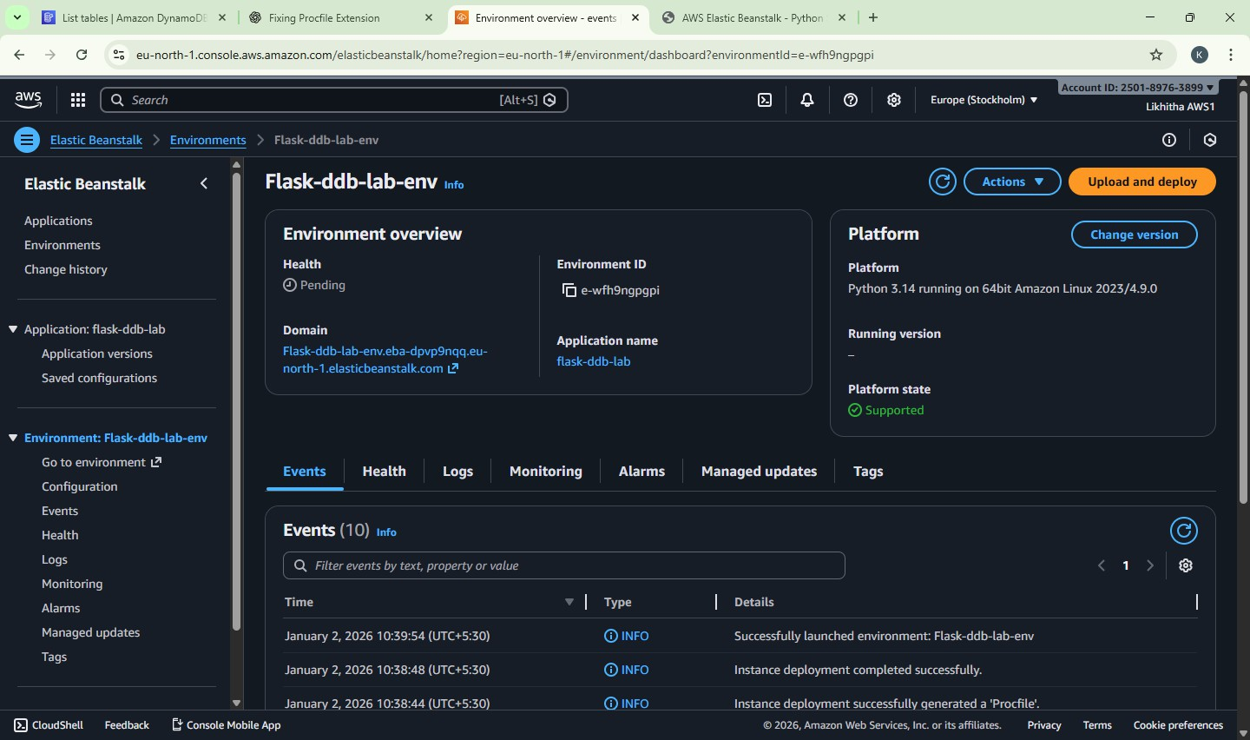

Click on Domain: [Flask-ddb-lab-env.eba-jtqiug36.ap-south-1.elasticbeanstalk.com](http://flask-ddb-lab-env.eba-jtqiug36.ap-south-1.elasticbeanstalk.com/)

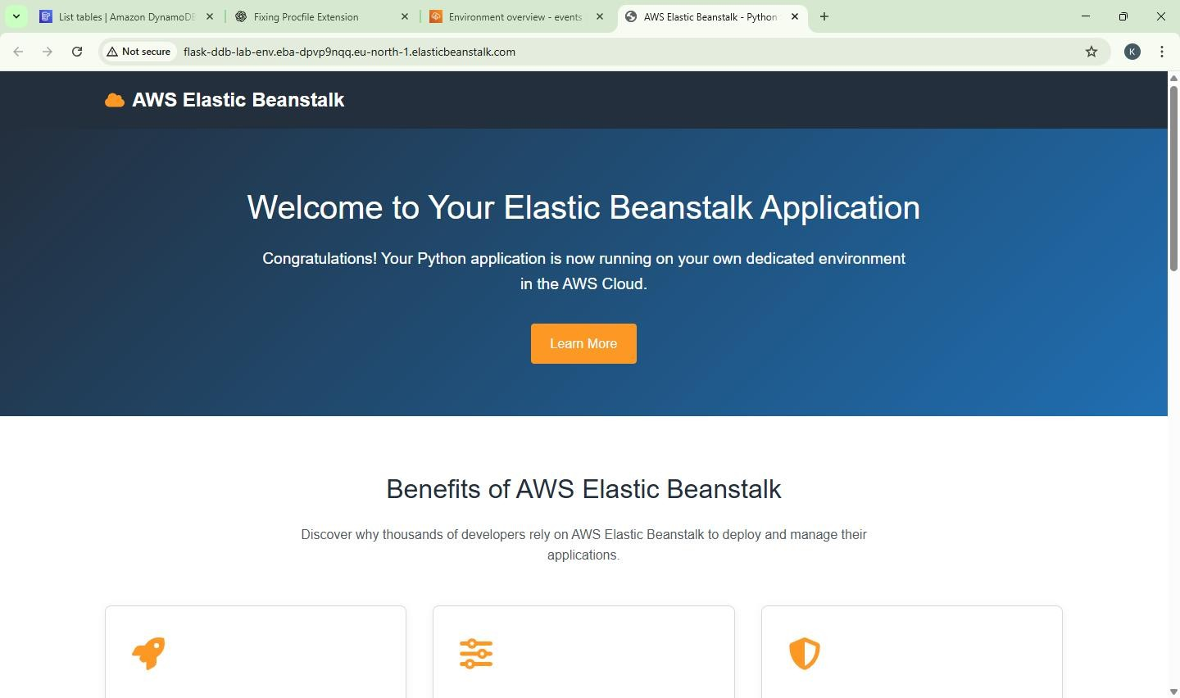

1. AWS — Deploy Your ZIP Upload and deploy

EB Environment → Upload and deploy

* Upload: flask-ddb-lab.zip
* Version label: v1 Click Deploy

After deploy, opening the EB domain should show: “Flask + DynamoDB on Elastic Beanstalk is working!”



1. Add Environment Variables in Elastic Beanstalk (MANDATORY) Step 1

Go to: AWS Console → Elastic Beanstalk → Environments → flask-ddb-lab-env Step 2

Click: Configuration Step 3

Under Software, click: Edit Step 4

Scroll to Environment properties Add these two entries:

|  |  |
| --- | --- |
| Name | Value |
| TABLE_NAME | Student |
| AWS_REGION | ap-south-1 |

Step 5 Click: Apply Step 6

Wait for Environment update to complete

(Status may show Updating / Pending — wait until it finishes)

1. Verify Application After Env Update Open the EB Environment URL in browser:

http://<your-eb-domain>/

Expected output: Flask + DynamoDB on Elastic Beanstalk is working!

1. Test Health Endpoint (GET) Step 1

Open AWS CloudShell (or Command Prompt / PowerShell) Step 2

Run: curl <http://flask-ddb-lab-env.eba-rziry7cp.us-east-2.elasticbeanstalk.com/health> Expected output: {"status":"ok"}

AWS CloudShell - Steps

1. In AWS Console (top right)
2. Search CloudShell in the search bar
3. Wait until terminal opens (you’ll see $ prompt)
4. Paste the following command (replace domain):
5. CREATE Item in DynamoDB (POST) Step 1

Run:

curl -X POST http:// [Flask-ddb-lab-env-1.eba-k9hmvizi.ap-south-1.elasticbeanstalk.com](http://flask-ddb-lab-env-1.eba-k9hmvizi.ap-south-1.elasticbeanstalk.com/) /Student \

-H "Content-Type: application/json" \

-d '{"StudentID":"101","Name":"Anita","Dept":"MCA"}'

Expected output:

{"message":"Student created"}

1. READ Item from DynamoDB (GET) Run:

curl http://<your-eb-domain>/student/101 Expected output (JSON with student data).

1. UPDATE Item (PUT)

Run:

curl -X PUT http://<your-eb-domain>/student/101 \

-H "Content-Type: application/json" \

-d '{"Name":"Anita S","Dept":"MCA-III"}'

Expected output:

{"message":"Student updated"}

1. DELETE Item (DELETE)

Run:

curl -X DELETE http://<your-eb-domain>/student/101 Expected output:

{"message":"Student deleted"}

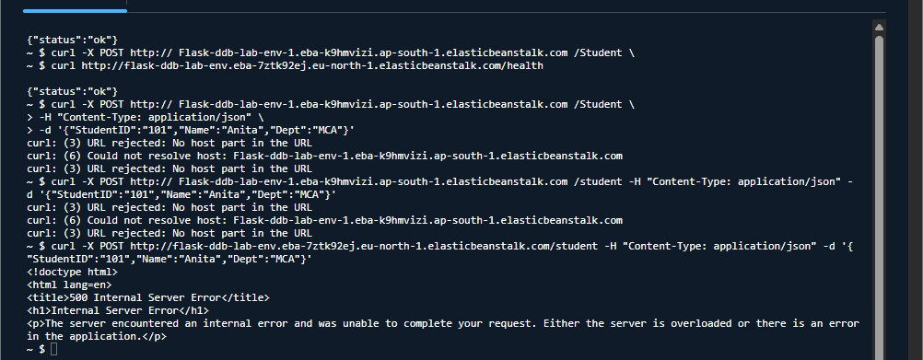

1. Verify in DynamoDB Console Go to:

AWS Console → DynamoDB → Tables → Students → Explore table items Confirm record creation / update / deletion.

#### Exercise 22: CloudFormation – Launch EC2 (Amazon Linux 2023) + Install Apache using UserData

Create an EC2 instance using **AWS CloudFormation (YAML template)** and automatically install **Apache web server (httpd)** using **UserData**, then verify the website from a browser.

#### Pre-requisites

* Region set to **Asia Pacific (Mumbai) – ap-south-1**
* Basic knowledge of EC2 and Security Groups

#### Part A — Create Key Pair (One-time setup) Step A1: Open EC2 Key Pairs

1. AWS Console → Search **EC2**
2. Left menu → **Key Pairs** (under “Network & Security”)

#### Click Create key pair Step A2: Create key pair

* + Name: pemkeypair (any name is fine)
  + Key pair type: **RSA**
  + Private key file format:
    - **.pem** (recommended) Click **Create key pair**

A file will download like: pemkeypair.pem

**Note:** CloudFormation uses **key pair NAME** (pemkeypair), not the file name.

#### Part B — Create CloudFormation Template File (Amazon Linux 2023 + Apache) Step B1: Create YAML file on your computer

1. Open **Notepad**
2. Paste the full YAML template given below
3. Save as: **ec2-apache-al2023.yaml**
   * Save type: **All files**
   * Encoding: UTF-8 (if asked)

#### Full CloudFormation Template (Amazon Linux 2023)

Important:

* Do **not** add .pem anywhere.
* You will select Key Pair from dropdown during stack creation.

AWSTemplateFormatVersion: "2-09-09"

Description: Launch EC2 (Amazon Linux 2023) and install Apache (httpd) using UserData

Parameters:

KeyName:

Type: AWS::EC2::KeyPair::KeyName

Description: Select an existing EC2 Key Pair to enable SSH access

Resources:

WebServerSG:

Type: AWS::EC2::SecurityGroup Properties:

GroupDescription: Allow SSH (22) and HTTP (80) SecurityGroupIngress:

* IpProtocol: tcp FromPort: 22

ToPort: 22 CidrIp: 0.0.0.0/0

* IpProtocol: tcp FromPort: 80

ToPort: 80 CidrIp: 0.0.0.0/0

WebServerInstance:

Type: AWS::EC2::Instance

Properties: InstanceType: t3.micro

KeyName: !Ref KeyName SecurityGroups:

- !Ref WebServerSG

# Amazon Linux 2023 AMI for Mumbai (ap-south-1) ImageId: ami-02b49a24cfb95941c

UserData:

Fn::Base64: | #!/bin/bash dnf update -y

dnf install -y httpd systemctl enable httpd systemctl start httpd

echo "<h1>Apache Installed via CloudFormation UserData (Amazon Linux 2023)!</h1>" >

/var/www/html/index.html

Outputs:

InstanceId:

Description: EC2 Instance ID Value: !Ref WebServerInstance

WebsiteURL:

Description: Apache Website URL

Value: !Sub "http://${WebServerInstance.PublicDnsName}"

#### Part C — Create CloudFormation Stack (Console Steps) Step C1: Open CloudFormation

1. AWS Console → Search **CloudFormation**
2. Click **Stacks**

#### Click Create stack → With new resources (standard) Step C2: Prepare template (select correct options)

1. Under **Prepare template**:

Select **Choose an existing template**

1. Under **Template source**: Select **Upload a template file**
2. Click **Choose file** → select ec2-apache-al2023.yaml
3. Click **Next**

#### Part D — Specify Stack Details Step D1: Stack name

* + Stack name: EC2-Apache-AL2023 Click **Next**

#### Step D2: Parameters

* + Under **KeyName**, select your key pair name from dropdown Example: pemkeypair

Click **Next**

#### Part E — Configure Stack Options (keep default)

1. Leave everything as default
2. Click **Next**

#### Part F — Review and Create

1. Scroll down
2. Click **Create stack**

#### Part G — Monitor Stack Creation

1. Wait for Stack status to become:

#### CREATE_COMPLETE

1. Open the stack → click **Outputs** tab
2. Copy **WebsiteURL**
3. Paste URL in browser Expected Output in browser:

#### Apache Installed via CloudFormation UserData (Amazon Linux 2023)!

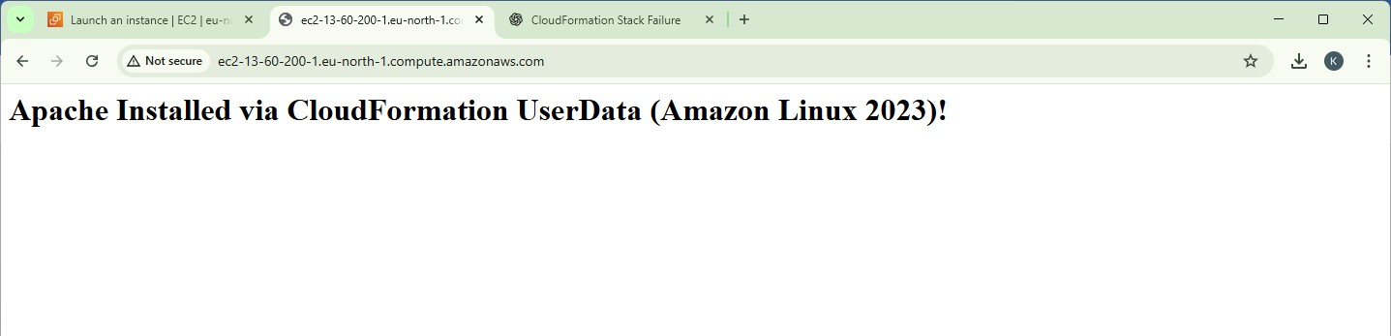

**Part H — Verify in EC2 (Optional)**

1. Go to **EC2 → Instances**
2. Instance should be running
3. Security group should allow: HTTP 80 & SSH 22

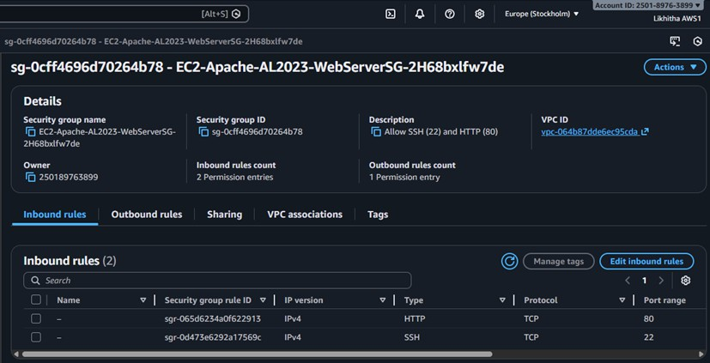

#### Troubleshooting (Common Errors)

1. **Website not opening**

Check:

* + EC2 instance status checks are **2/2 passed**
  + Security group has **port 80 open**
  + Wait 2–3 minutes (UserData takes time)

#### Stack went to ROLLBACK

Go to stack → **Events tab** → check the failure reason Most common reason:

* + Wrong Key Pair selected / key pair does not exist

#### Part I — Clean-up

To avoid charges:

1. CloudFormation → Stacks
2. Select EC2-Apache-AL2023
3. Click **Delete**
4. Confirm

This deletes EC2 + Security Group automatically.

#### Exercise 23: EC2 + S3 (Static Content Pulled from S3 using CloudFormation)

Create an **S3 bucket** using CloudFormation. Upload a static HTML file (index.html) to S3.

Launch **EC2 (Amazon Linux 2023) + Apache** using CloudFormation. EC2 will **pull index.html from S3** and host it via Apache.

#### Pre-requisites

* + Region: **Mumbai (ap-south-1)**
  + A Key Pair exists (example: pemkeypair)

#### PART 0 — One-time: Create Key Pair

EC2 → Key Pairs → Create key pair

* + Name: pemkeypair
  + Format: .pem

Download it and keep safe.

#### PART 1 — Stack-1: Create S3 Bucket (CloudFormation) Step 1.1: Create S3 template file

Create a file: **stack1-s3-bucket.yaml** and paste: AWSTemplateFormatVersion: "2010-09-09"

Description: Create an S3 bucket to store website content (index.html)

Resources:

WebsiteBucket:

Type: AWS::S3::Bucket

Outputs:

BucketName:

Description: S3 Bucket Name (use this to upload index.html)

Value: !Ref WebsiteBucket

#### Step 1.2: Create stack

CloudFormation → Stacks → Create stack → With new resources

* + Choose an existing template
  + Upload a template file → stack1-s3-bucket.yaml
  + Stack name: S3-Website-Bucket
  + Create stack

#### Step 1.3: Copy bucket name

Open stack → **Outputs** → copy **BucketName**

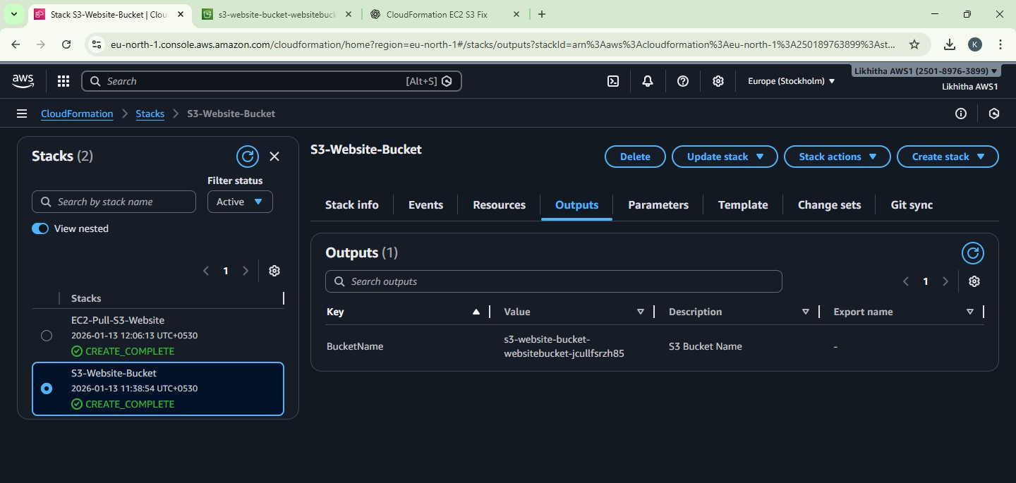

#### PART 2 — Upload Static Content to S3 (Manual) Step 2.1: Create index.html on your PC

Create a file named **index.html** with this content:

<!DOCTYPE html>

<html>

<head>

<title>EC2 + S3 Demo</title>

</head>

<body>

<h1>Hello! This page was pulled from S3 to EC2 automatically.</h1>

<p>Deployed using CloudFormation + UserData</p>

</body>

</html>

#### Step 2.2: Upload to S3 bucket

S3 → Buckets → open your bucket (from Output) → Upload

* + Upload **index.html**
  + Keep it at **root** (no folder)
  + Upload

Now S3 has: s3://<your-bucket-name>/index.html

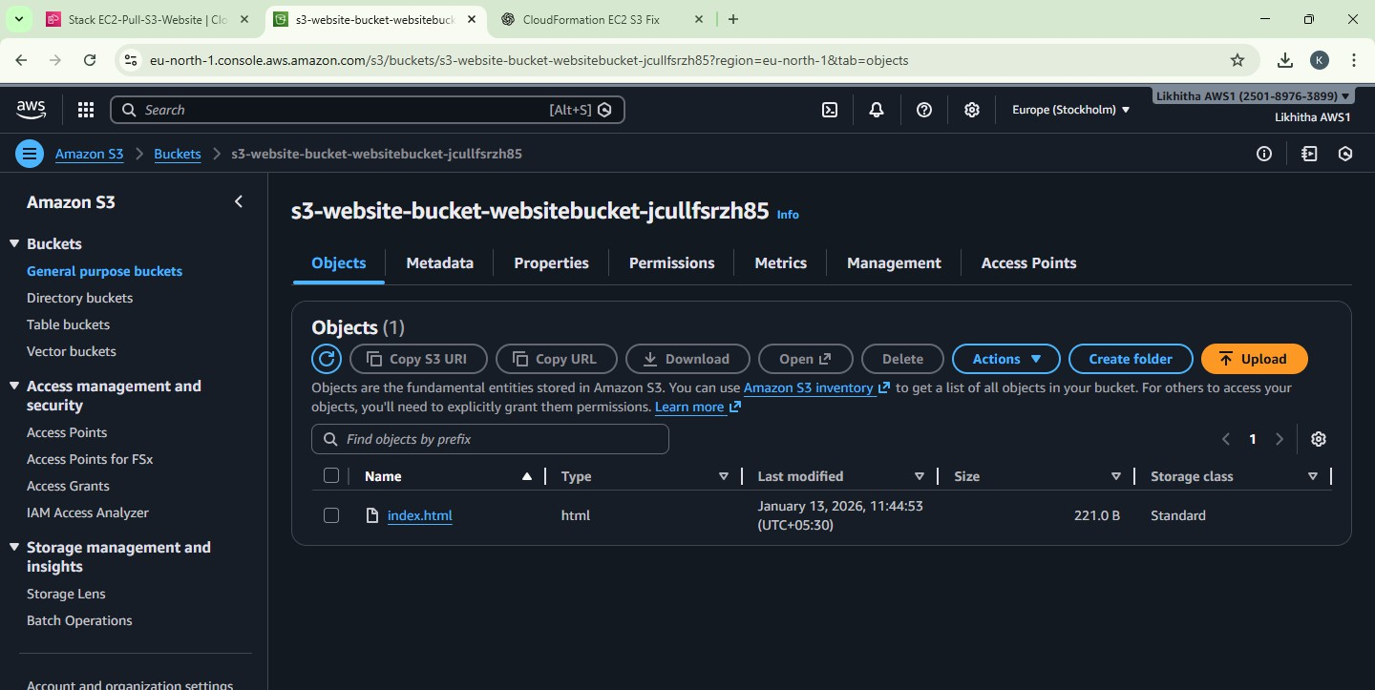

#### PART 3 — Stack-2: Launch EC2 + Apache + Pull from S3

This stack will:

* + Create IAM Role (permission to read the bucket)
  + Create Security Group (22, 80)
  + Launch EC2 (Amazon Linux 2023)
  + Install Apache
  + Copy index.html from S3 to /var/www/html/index.html

#### Step 3.1: Create EC2 template file

Create a file: **stack2-ec2-pull-from-s3.yaml** and paste:

AWSTemplateFormatVersion: "2010-09-09"

Description: Launch EC2 (Amazon Linux 2023), install Apache, and pull index.html from S3

Parameters:

KeyName:

Type: AWS::EC2::KeyPair::KeyName

Description: Select an existing EC2 Key Pair to enable SSH access

BucketName:

Type: String

Description: Enter the S3 bucket name created in Stack-1 (Output)

SubnetId:

Type: AWS::EC2::Subnet::Id

Description: Select a PUBLIC subnet (default VPC public subnet recommended)

VpcId:

Type: AWS::EC2::VPC::Id

Description: Select the VPC (default VPC recommended)

Resources:

WebServerRole:

Type: AWS::IAM::Role Properties: AssumeRolePolicyDocument:

Version: "2012-10-17" Statement:

- Effect: Allow Principal:

Service: ec2.amazonaws.com Action: sts:AssumeRole

Policies:

- PolicyName: S3ReadOnlyForWebsiteBucket PolicyDocument:

Version: "2012-10-17" Statement:

- Effect: Allow Action:

- s3:GetObject

* s3:ListBucket Resource:
* !Sub "arn:aws:s3:::${BucketName}"
* !Sub "arn:aws:s3:::${BucketName}/*"

WebServerInstanceProfile:

Type: AWS::IAM::InstanceProfile Properties:

Roles:

- !Ref WebServerRole

WebServerSG:

Type: AWS::EC2::SecurityGroup Properties:

GroupDescription: Allow SSH (22) and HTTP (80) VpcId: !Ref VpcId

SecurityGroupIngress:

* IpProtocol: tcp FromPort: 22

ToPort: 22 CidrIp: 0.0.0.0/0

* IpProtocol: tcp FromPort: 80

ToPort: 80 CidrIp: 0.0.0.0/0

WebServerInstance:

Type: AWS::EC2::Instance Properties:

InstanceType: t2.micro KeyName: !Ref KeyName SubnetId: !Ref SubnetId SecurityGroupIds:

* !Ref WebServerSG

IamInstanceProfile: !Ref WebServerInstanceProfile

# Amazon Linux 2023 AMI for Mumbai (ap-south-1) ImageId: ami-02b49a24cfb95941c

UserData: Fn::Base64: !Sub | #!/bin/bash

dnf update -y

dnf install -y httpd systemctl enable httpd systemctl start httpd

# pull index.html from S3 to Apache web root

aws s3 cp s3://${BucketName}/index.html /var/www/html/index.html systemctl restart httpd

Outputs:

WebsiteURL:

Description: Open this URL in browser

Value: !Sub "http://${WebServerInstance.PublicDnsName}"

#### Step 3.2: Create stack

CloudFormation → Stacks → Create stack

* + Upload template → stack2-ec2-pull-from-s3.yaml
  + Stack name: EC2-Pull-S3-Website
  + Parameters:
    - **KeyName**: select your key pair (e.g., pemkeypair)
    - **BucketName**: paste bucket name from Stack-1 Output
    - **VpcId**: select **default VPC**
    - **SubnetId**: select a **PUBLIC subnet** in default VPC

(usually the subnet name shows “public” or you can pick any default subnet that gives pub- lic IP; default subnets generally work)

Create stack → wait for **CREATE_COMPLETE**

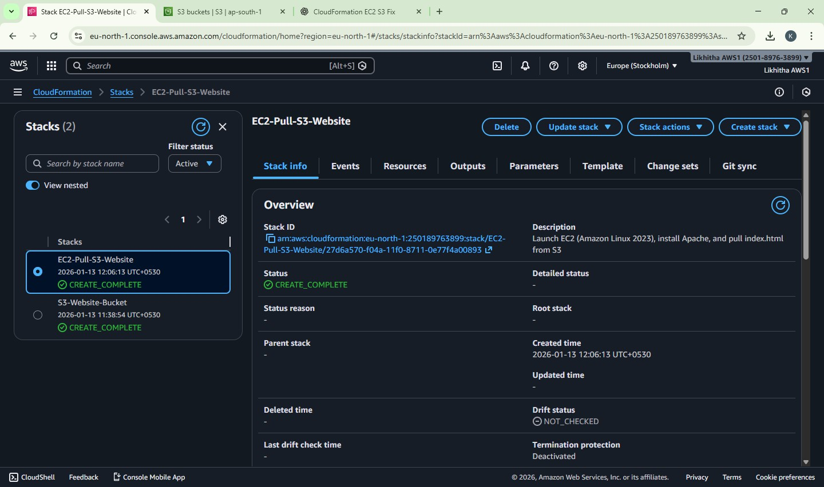

#### PART 4 — Verify Output

Stack-2 → **Outputs** → copy **WebsiteURL** → open in browser.

✅ Expected page:

“Hello! This page was pulled from S3 to EC2 automatically…”

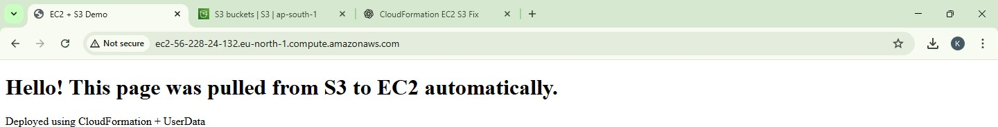

#### Troubleshooting (common)

1. **Website not opening**
   * Wait 1–2 minutes (UserData takes time)
   * Ensure Security Group has **HTTP 80 open**
   * Ensure you selected a **public subnet** (needs internet to reach S3)

#### Stack-2 fails with S3 access error

* + BucketName typed wrong
  + index.html not uploaded at root of bucket

#### Clean-up

**Delete Stack-2 first**

CloudFormation → select EC2-Pull-S3-Website → Delete

#### Empty the S3 bucket

S3 → bucket → delete index.html (empty bucket)

#### Delete Stack-1

CloudFormation → select S3-Website-Bucket → Delete

#### Viva-ready questions

1. What is the purpose of **UserData** in EC2?
2. Why do we need an **IAM Role + Instance Profile**?
3. Why is S3 bucket not made public in this lab?
4. What happens when a CloudFormation stack is deleted?
5. Which ports are required for web hosting and SSH?

**Exercise 24:**

#### AWS Lambda: Input Processing, Business Logic Execution, and CloudWatch Logging

Create one Lambda function that:

1. prints a welcome message
2. reads JSON input event
3. performs business logic (grade calculation)
4. writes logs → view them in CloudWatch Logs

Yes — this is the **first combined Lambda lab exercise** (basics + input + logic + logging). Below is a

#### complete step-by-step procedure using AWS Console.

**Create the Lambda Function Step 1: Open Lambda**

AWS Console → Search Lambda → Open AWS Lambda

#### Step 2: Create function

Click Create function

* Select - Author from scratch
* Function name: StudentGradeLogger
* Runtime: Python 3.11
* Architecture: x86_64 (default) **Step 3: Permissions (Execution Role)** Under “Permissions”
* Choose: Create a new role with basic Lambda permissions This automatically gives permission to write logs to CloudWatch. Click **Create function**

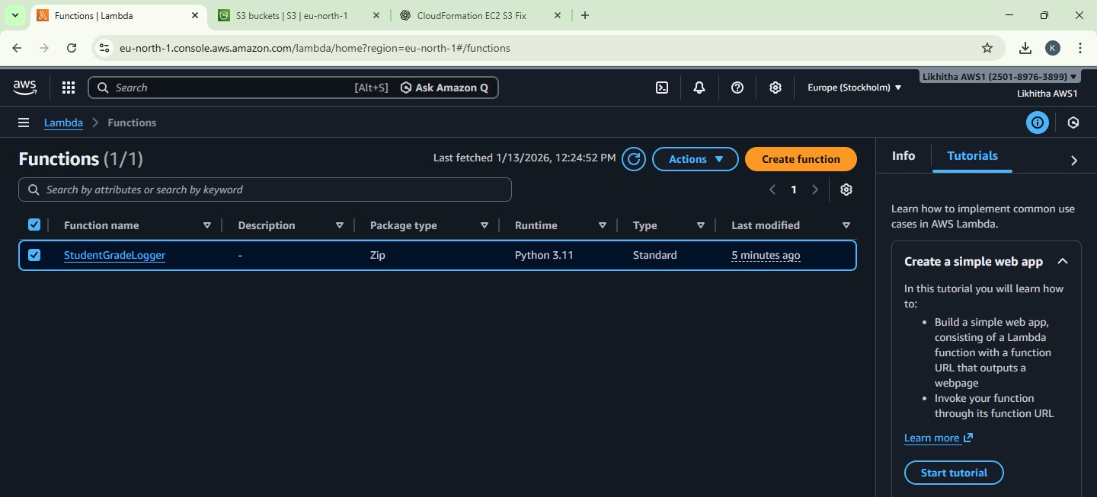

#### Add Code (Business Logic + Logs) Step 4: Paste this code

In **Code** tab → lambda_function.py → paste and **Deploy**

import json

def lambda_handler(event, context): # Welcome message

print("Lambda invoked successfully")

# Read input from event

student_name = event["StudentName"] marks = event["Marks"]

# Business logic: grade calculation if marks >= 75:

result = "Pass" grade = "A"

else:

result = "Fail" grade = "F"

# Log output

print("Student:", student_name) print("Marks:", marks) print("Grade:", grade) print("Result:", result)

# Return response return {

"statusCode": 200, "body": json.dumps({

"StudentName": student_name, "Marks": marks,

"Grade": grade, "Result": result

})

}

Click **Deploy**.

#### Test with Input Events (JSON)

**Step 5: Create a test event (Valid case)**

Go to Test (top right) → Configure test event

* Event name: ValidInput
* Paste this JSON:

{

"StudentName": "Anita", "Marks": 86

}

Click **Save**

#### Step 6: Run test

Click **Test**

Expected response (sample):

* statusCode: 200
* 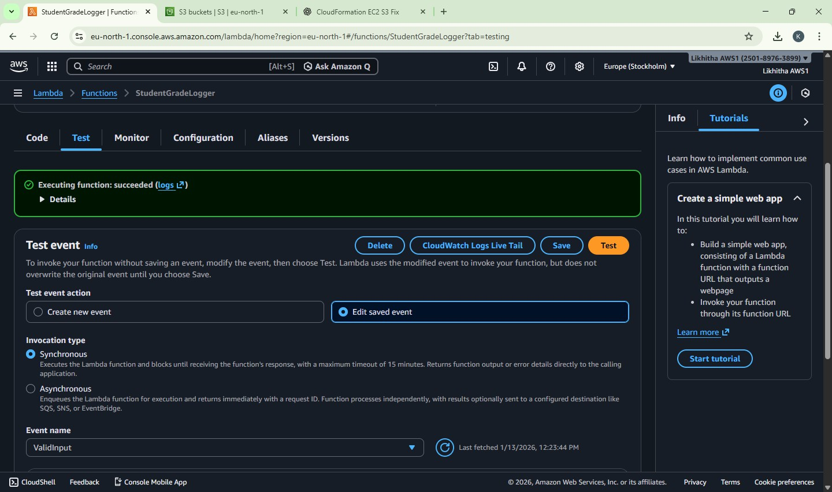body will include Grade A and Result Pass

#### Step 7: Test invalid input (Missing Marks)

Create another test event:

* Event name: MissingMarks

{

"StudentName": "Rahul"

}

Run **Test**

Expected:

* statusCode: 400
* message: Missing 'Marks'

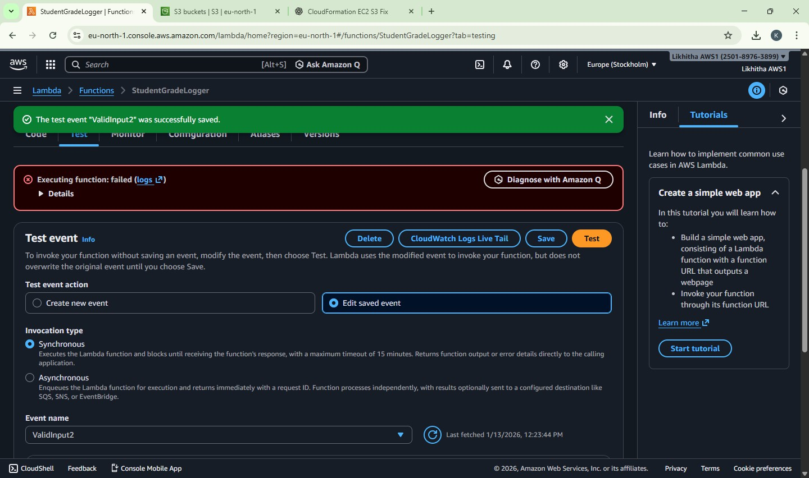

#### Step 8: Test invalid marks range

Event name: InvalidMarks

{

"StudentName": "Priya", "Marks": 150

}

Expected:

* statusCode: 400
* message: Marks must be 0–100

#### View Logs in CloudWatch

**Step 9: Open logs from Lambda directly**

On the Lambda function page:

* Go to **Monitor** tab
* Click **View CloudWatch logs**

You will see:

* Log group: /aws/lambda/StudentGradeLogger
* Open latest **log stream**
* You should see all print() outputs:
  + “Lambda invoked successfully!”
  + “Received event…”
  + grade/result logs
  + error logs for invalid tests

#### Cleanup (Avoid charges, keep account clean)

Lambda itself usually costs nothing in small use, but cleanup is good practice:

1. Lambda → Functions → select StudentGradeLogger → **Delete**
2. CloudWatch → Log groups → find /aws/lambda/StudentGradeLogger → **Delete**
3. IAM role created (optional):
   * IAM → Roles → search role name created for Lambda → delete (only if not used else- where)

# DATE: 24-12-25

**Exercise–25:** Mini Project: Event-Driven Notification System using AWS Lambda and Amazon SNS. Simulating real-time alerts from events using serverless computing.

* An event in JSON format is given as input to an AWS Lambda function.
* The Lambda function processes the event and generates a notification message.
* The message is published to an Amazon SNS topic.
* SNS sends the notification to the subscribed email address.
* The execution details are verified using CloudWatch Logs.

#### Create SNS Topic + Email Subscription Step 1: Open SNS

AWS Console → Search SNS → Open Simple Notification Service

#### Step 2: Create a Topic

SNS → Topics → Create topic

* Type: Standard
* Name: NotificationTopic Click Create topic

#### Step 3: Copy Topic ARN

Open the created topic → copy Topic ARN (You will paste it into Lambda code later)

#### Step 4: Create an Email Subscription

Inside the same topic:

Click Create subscription

* Protocol: Email
* Endpoint: (your email id) Click Create subscription

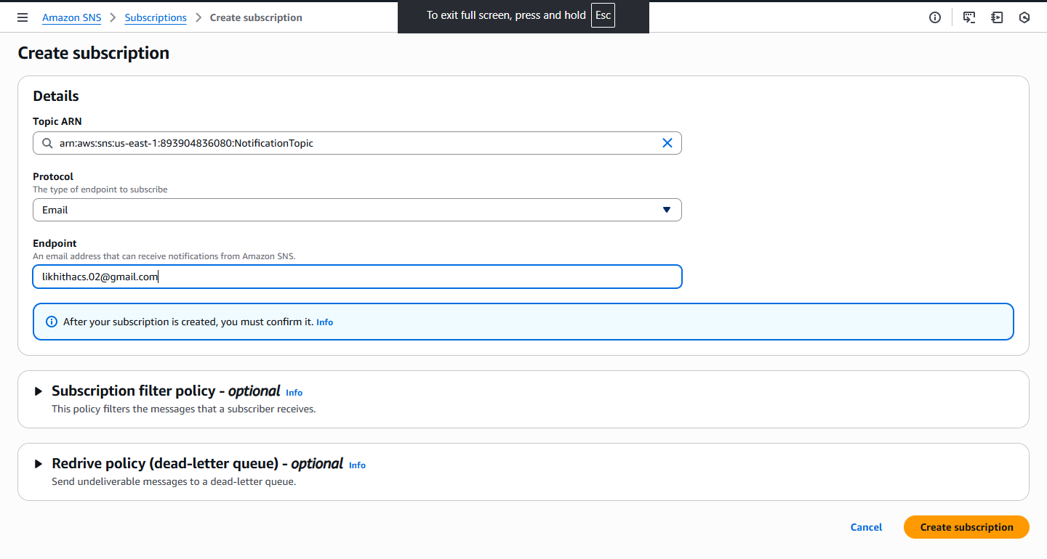

#### Step 5: Confirm Subscription

Open your email inbox → find AWS SNS confirmation mail → click Confirm subscription

→ Status in SNS should become Confirmed.

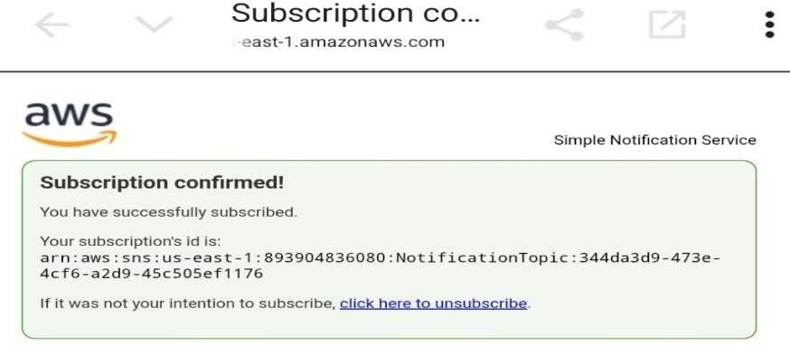

#### Create Lambda Function Step 6: Open Lambda

AWS Console → Search Lambda → Open AWS Lambda

#### Step 7: Create function

Click Create function

* Select: Author from scratch
* Function name: NotificationSimulator
* Runtime: Python 3.11
* Permissions: Create a new role with basic Lambda permissions Click Create function

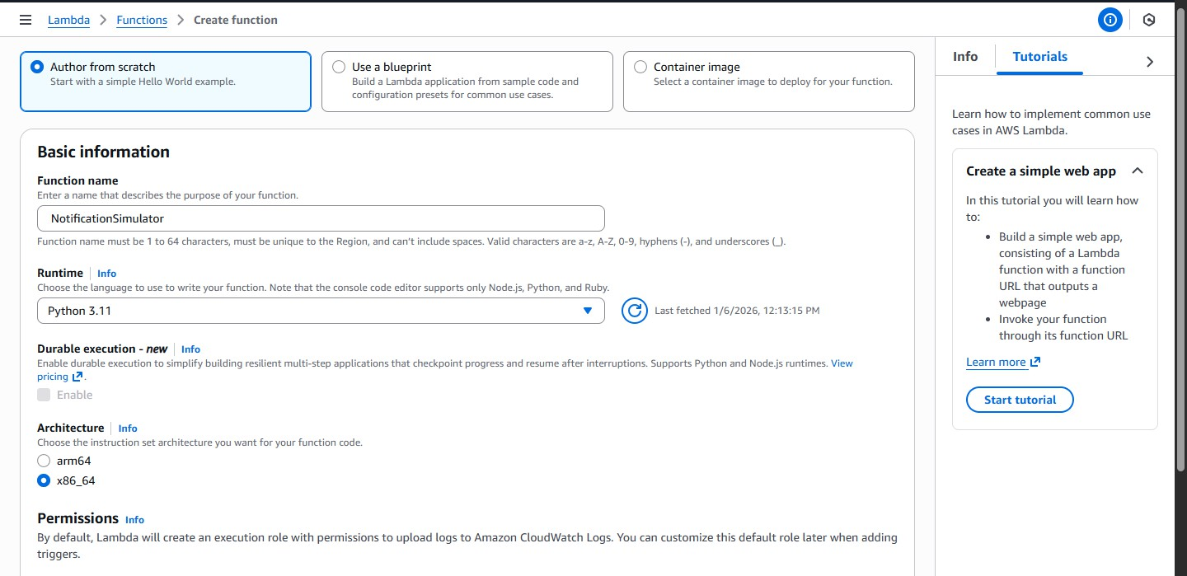

#### Add Lambda Code (with SNS Publish) Step 8: Paste code in lambda_function.py

Lambda → **Code** tab → open lambda_function.py → remove existing code → paste: Replace <SNS_TOPIC_ARN> with your copied Topic ARN.

import json import boto3

sns = boto3.client('sns')

TOPIC_ARN = "<SNS_TOPIC_ARN>"

def lambda_handler(event, context): print("Notification Simulator invoked")

event_type = event["eventType"] user = event["user"]

if event_type == "ORDER_PLACED":

message = f"Hi {user}, your order is placed successfully." priority = "NORMAL"

elif event_type == "PAYMENT_FAILED":

message = f"Hi {user}, your payment has failed. Please retry." priority = "HIGH"

elif event_type == "LOW_ATTENDANCE":

message = f"Hi {user}, your attendance is low. Please take action."

priority = "HIGH"

else:

message = f"Hi {user}, unknown event received." priority = "LOW"

print("Event Type:", event_type) print("Message:", message) print("Priority:", priority)

# Publish to SNS (Actual notification delivery)

sns.publish(TopicArn=TOPIC_ARN, Message=message, Subject=f"{event_type} [{priority}]")

return {

"statusCode": 200, "body": json.dumps({

"EventType": event_type, "Message": message, "Priority": priority

})

}

Click **Deploy**

Wait for “Successfully updated function…”

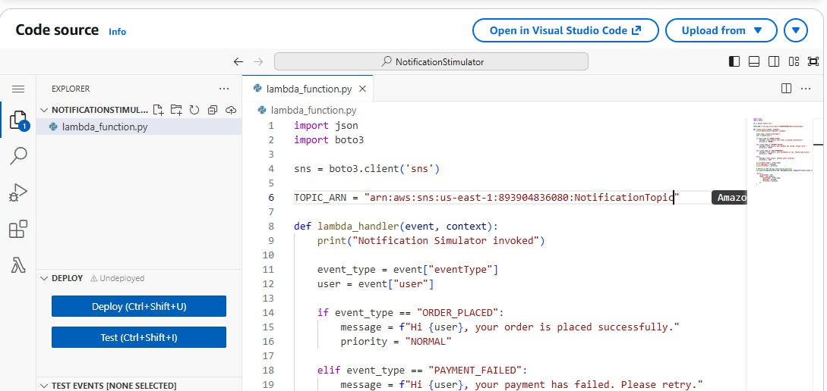

#### Give Lambda Permission to Publish to SNS Step 10: Open Lambda Execution Role

Lambda → Configuration → Permissions Click the Role name (execution role link)

#### Step 11: Attach SNS Publish Policy

IAM Role page → Add permissions → Attach policies Attach: AmazonSNSFullAccess

Click Add permissions

Now Lambda can publish to SNS.

#### Test the Mini Project

**Step 12: Create a test event**

Lambda → Test tab → Create new test event Event name: PaymentFailed

Paste:

{

"eventType": "PAYMENT_FAILED", "user": "Anita"

}

Click **Save**

**Step 13: Run Test** Click **Test** Expected:

* Execution: **Succeeded**
* Email should arrive within a few seconds: Subject like: PAYMENT_FAILED [HIGH]

Message: “Hi Anita, your payment has failed. Please retry.”

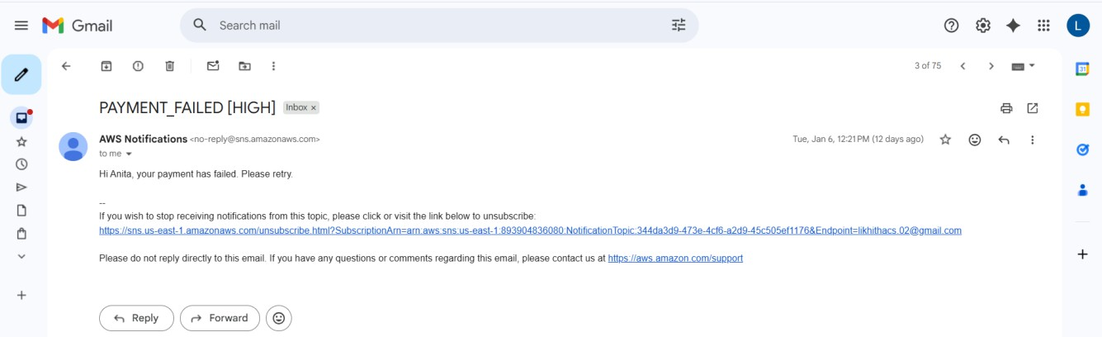

#### Verify CloudWatch Logs Step 14: View logs

Lambda → Monitor → View CloudWatch logs Open latest log stream.

Verify these prints exist:

* Notification Simulator invoked
* Event Type:
* Message:
* Priority:

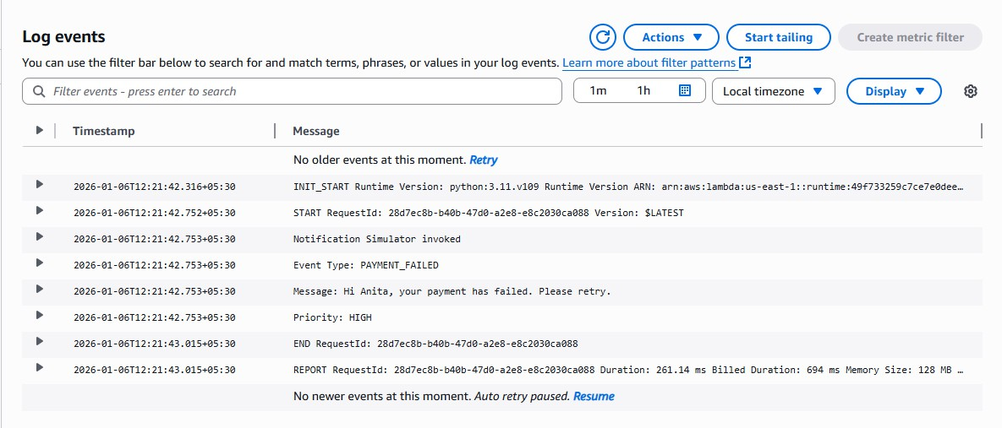

#### Expected Outputs

1. Lambda test status: Succeeded
2. Email received from SNS with correct message
3. CloudWatch logs showing event type and generated message

#### Cleanup

1. Delete Lambda function: NotificationSimulator
2. SNS → delete topic NotificationTopic (subscriptions removed automatically)
3. CloudWatch → delete log group for Lambda
4. (Optional) Delete IAM role if not used elsewhere

# DATE: 26-12-25

**Exercise–26:** Analyze a CSV File in S3 Using Amazon Athena (No Server)

Upload a small CSV to **S3**, then use Athena to run SQL queries like count, average, max, group by.

#### Part A — Create Sample CSV (on your PC)

1. Open **Notepad**
2. Paste this data and save as: **students.csv**

StudentID,Name,Dept,Marks,Result 101,Anita,MCA,85,Pass 102,Ravi,MCA,72,Pass 103,Meera,MBA,64,Pass 104,John,MCA,35,Fail 105,Sneha,MBA,91,Pass 106,Arun,MCA,49,Fail 107,Kiran,MBA,58,Pass

108,Divya,MCA,77,Pass

#### Part B — Create S3 Bucket and Upload CSV

* + Go to **AWS Console → S3**
  + Click **Create bucket**
  + Bucket name: athena-lab-<yourname>-<number> (must be globally unique)
  + Keep defaults → Click **Create bucket**
  + Open the bucket → Click **Upload**
  + Upload **students.csv**
  + Click **Upload**

Now your CSV is in S3.

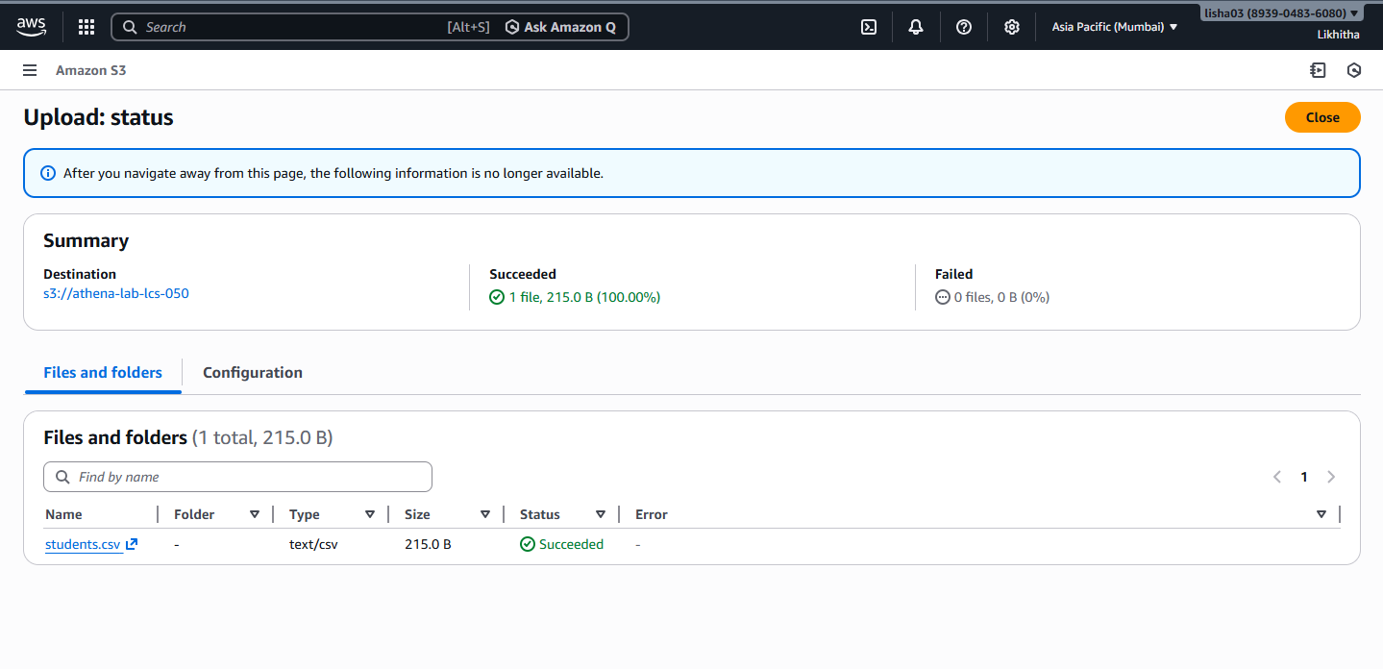

#### Part C — Open Athena and Set Query Result Location (IMPORTANT)

* + Go to **AWS Console → Amazon Athena**
  + If it shows “Get started” / “Query editor”, open it.
  + It will ask to set a **Query result location**
  + Click the link/button like **Settings / Manage / Edit**
  + Set query result location to something like:
    - s3://your-bucket-name/athena-results/
  + Click **Save**

This is required so Athena can store query outputs.

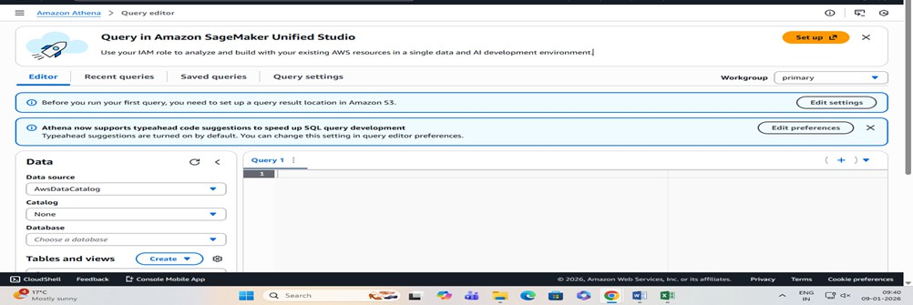

#### Part D — Create a Database in Athena

In Athena query editor, run:

CREATE DATABASE labdb;

Then on the left side, select:

* + **Data source:** AwsDataCatalog
  + **Database:** labdb

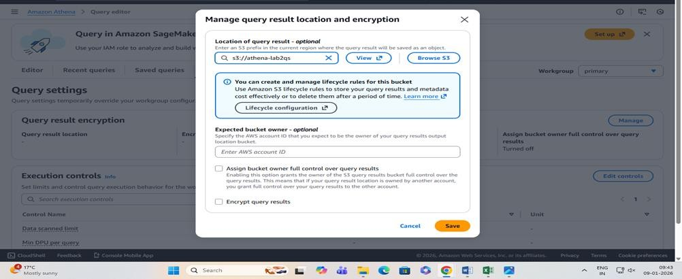

#### Part E — Create a Table for the CSV in S3

Run this (replace YOUR_BUCKET_NAME with your actual bucket name):

CREATE EXTERNAL TABLE IF NOT EXISTS students (

StudentID int, Name string, Dept string, Marks int, Result string

)

ROW FORMAT SERDE 'org.apache.hadoop.hive.serde2.OpenCSVSerde' WITH SERDEPROPERTIES (

'separatorChar' = ',',

'quoteChar' = '"', 'escapeChar' = '\\'

)

STORED AS TEXTFILE

LOCATION 's3://YOUR_BUCKET_NAME/'

TBLPROPERTIES ('skip.header.line.count'='1');

This tells Athena: “My CSV is in S3, treat it like a table.”

#### Part F — Run Simple Analysis Queries (Core Part)

1. **View all rows**

SELECT * FROM students; Expected: 8 records.

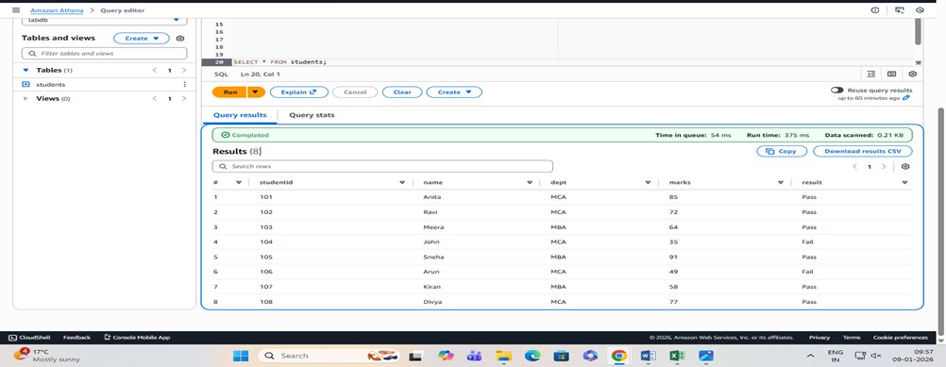

#### Total students

SELECT COUNT(*) AS total_students FROM students; Expected: 8

#### Pass vs Fail count

SELECT Result, COUNT(*) AS cnt FROM students

GROUP BY Result;

Expected (based on data): Pass = 6, Fail = 2

#### Average marks overall

SELECT AVG(Marks) AS avg_marks

FROM students;

1. **Department-wise average marks** SELECT Dept, AVG(Marks) AS avg_marks FROM students

GROUP BY Dept;

#### Top scorer

SELECT Name, Dept, Marks FROM students

ORDER BY Marks DESC LIMIT 1;

Expected: Sneha (91)

#### List failed students

SELECT StudentID, Name, Dept, Marks FROM students

WHERE Result = 'Fail'; Expected: John, Arun

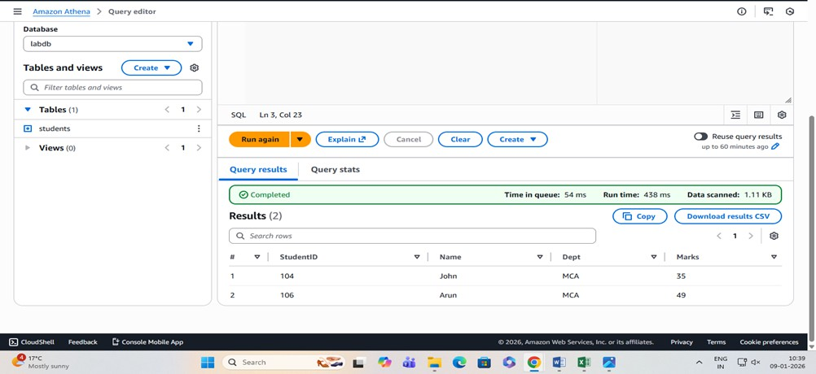

#### Cleanup (to avoid any charges)

* 1. In Athena, you can keep DB/table (no cost by itself), but clean S3:
  2. Go to **S3 bucket**
  3. Delete:
     + students.csv
     + athena-results/ folder contents (query outputs)
  4. Delete the bucket (must be empty to delete)

#### Cost Note (Simple)

* **S3 storage**: tiny (almost negligible for this)
* **Athena**: charges based on **data scanned**; with this tiny CSV it’s usually minimal, but **always delete outputs and bucket** after lab.

# DATE: 31-12-25

**Exercise–27:** Smart Sensor Monitoring System using AWS IoT Core

Cloud-Based IoT Data Ingestion and Processing using AWS - To understand how IoT device data is sent to the cloud, processed automatically, and logged using AWS managed services.

In this lab, a simulated IoT device sends sensor data (such as temperature and humidity) in JSON format to the AWS cloud.

The data is received by AWS IoT Core, which acts as the central message broker for IoT devices. Whenever new sensor data arrives:

* AWS IoT Core detects the event
* The data is processed automatically
* The processed output is stored or logged in the cloud for monitoring and verification

This exercise demonstrates how real-time device data can be handled without managing servers, highlighting the principles of IoT, cloud computing, and event-driven architecture.

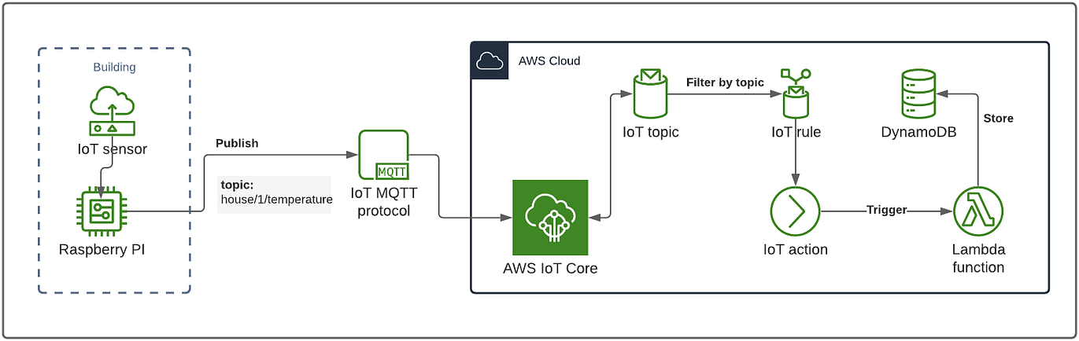

#### Concepts Covered

* Internet of Things (IoT)
* Device-to-Cloud communication
* Event-driven processing
* JSON data format
* Serverless cloud services
* Real-time data handling

#### Input

Simulated sensor data (example: temperature and humidity values)

#### Output

* IoT message successfully received by AWS
* Automatic processing triggered
* Cloud logs showing received and processed data

#### Learning Outcome

After completing this lab, students will be able to:

* Explain how IoT devices communicate with the cloud
* Understand the role of AWS IoT Core in IoT solutions
* Describe event-based data processing in cloud environments
* Relate IoT concepts to real-world smart systems (smart homes, healthcare, industry)

#### STEP 1: Open IoT Service

* Core dashboard

#### STEP 2: Create an IoT Thing (Device)

1. Go to Manage → Things
2. Click Create things
3. Choose Create single thing
4. Give a name (example: TempSensor01)
5. Skip advanced settings
6. Create the thing

This represents a sensor device (even though no real hardware is used).

#### STEP 3: Create Device Certificate

1. Choose Auto-generate certificate
2. Activate the certificate
3. Download:
   * Device certificate
   * Private key
   * Root CA
4. Attach the certificate to the Thing Certificate = identity of the device

#### STEP 4: Create and Attach IoT Policy

1. Go to Secure → Policies
2. Create a new policy
3. Allow:
   * Connect
   * Publish
   * Subscribe
   * Receive
4. Use * (for lab simplicity)
5. Attach the policy to the certificate Policy = permission for device to talk to AWS

#### STEP 5: Test Device Messages (No Hardware)

Go to Test → MQTT test client Subscribe to a topic

Example: sensor/temperature Publish a message:

{

"deviceId": "TempSensor01", "temperature": 32,

"humidity": 65

}

Verify message appears instantly IoT data successfully reached the cloud

#### STEP 6: Create a Rule (Automation)

1. Go to Act → Rules
2. Create a rule
3. Rule query example:
4. SELECT * FROM 'sensor/temperature'
5. Choose action:
   * Send to CloudWatch Logs

*(or Lambda / DynamoDB if required)*

Rule = “when data arrives, do something”

#### STEP 7: Verify Output

1. Open CloudWatch → Logs
2. Check log group created by IoT Rule
3. Confirm sensor data entries Automatic processing confirmed

Sensor data is sent to AWS IoT Core, where rules automatically process and store the data without using any

server.

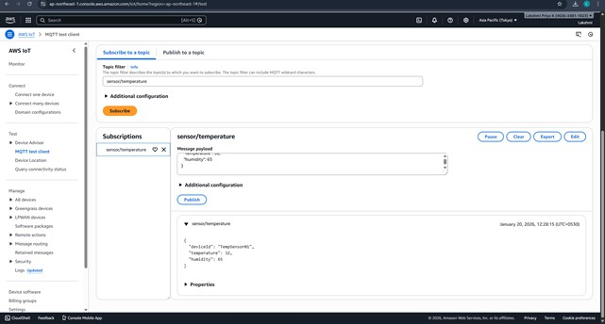

# DATE: 02-01-26

**Exercise–28:** Accelerate an S3 Static Website Using Amazon CloudFront (CDN)

#### Pre-requisite

* + You already have an **S3 bucket** with at least:
    - index.html
    - (optional) error.html

#### Part A - Ensure S3 is ready

* + Open **S3 → your bucket**

#### Go to Properties → Static website hosting

* + Enable it, set:
    - Index document: index.html
    - Error document: error.html (optional) Note down the **S3 Website endpoint** shown there.

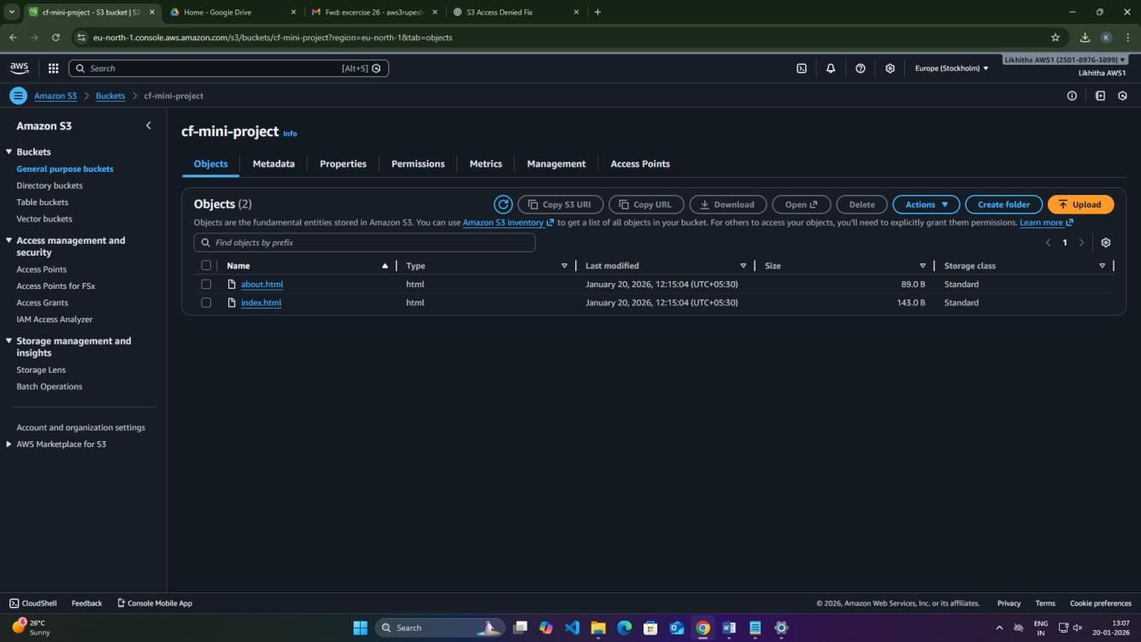

**Part B - Create CloudFront Distribution**

* + Go to **CloudFront → Create distribution**
  + **Origin domain**
    - Select your **S3 bucket** (not the website endpoint)

#### Origin access

* + - Choose **Origin access control (OAC)** (recommended)
    - Click **Create control setting** if asked

#### Viewer protocol policy

* + - Choose **Redirect HTTP to HTTPS**

#### Default root object

* + - Set: index.html
  + Click **Create distribution**

Copy the **Distribution domain name** (looks like dxxxxx.cloudfront.net)

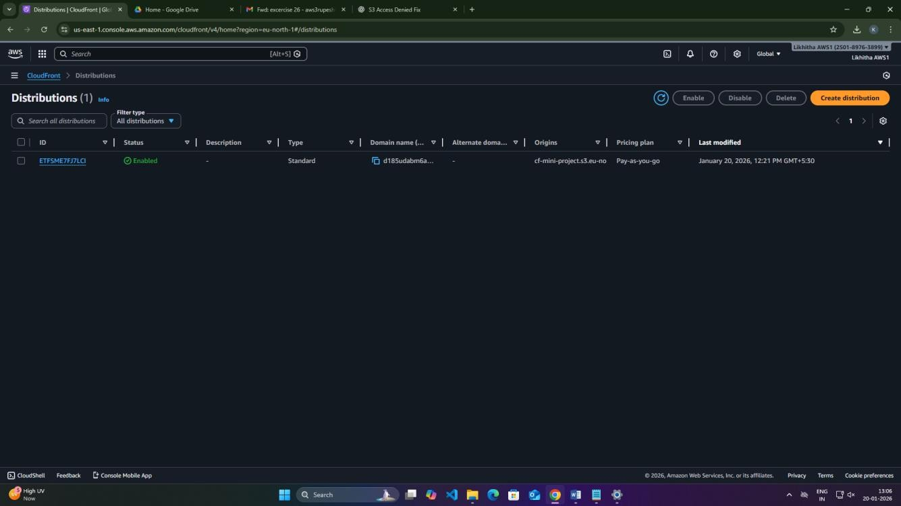

#### Part C - Allow CloudFront to read the bucket (important)

After creating distribution, CloudFront usually shows a message like **“S3 bucket policy needs update”**.

* + Click **Copy policy**

#### Go to S3 → Bucket → Permissions → Bucket policy

* + Paste and **Save**

This step ensures **public users cannot directly access S3**, but CloudFront can.

#### Part D - Test

* + Wait until Distribution status becomes **Enabled** (and “Deployed”)
  + Open in browser:
    - https://dxxxxx.cloudfront.net

Expected:

* + Your index.html loads via CloudFront.

#### Viva

* + **S3** stores the website files
  + **CloudFront** caches them at edge locations (faster)
  + **OAC** ensures S3 is not public; CloudFront accesses it securely

# DATE: 02-01-26

**Exercise–29 Mini Project –**

### Global Static Website Delivery using S3 + CloudFront with Cache Update Demo

Host a static website in S3, deliver it through CloudFront (CDN), then do a content update and observe caching behavior (old page still showing). Finally, force the latest version using CloudFront Invalidation.

#### Prerequisites

* + AWS Account
  + An S3 bucket
  + 2 small HTML files ready:
    - index.html
    - about.html

**index.html (Version 1)**

<html>

<body>

<h1>My CloudFront Mini Project</h1>

<h2>Version: V1</h2>

<p>Loaded via CloudFront CDN</p>

</body>

</html>

**about.html**

<html>

<body>

<h1>About Page</h1>

<h2>Version: V1</h2>

</body>

</html>

1. **Step-by-step Execution Step 1: Create S3 Bucket**

Go to S3 → Create bucket

Bucket name: cf-mini-project-<yourname> Region: (keep default)

Block Public Access: Keep ON Click Create bucket

**Step 2: Upload Website Files** Open your bucket → Upload Upload:

* index.html
* about.html Click Upload

#### Step 3: Create CloudFront Distribution (with secure access)

Go to CloudFront → Create distribution Origin domain

* Select your S3 bucket (from dropdown)

Origin **access**

* Choose Origin access control (OAC)
* Click Create control setting (if asked) → Create Viewer protocol policy
* Select Redirect HTTP to HTTPS Default root object
* Enter: index.html Click Create distribution

#### Step 4: Add Bucket Policy for OAC (important)

After distribution creation, CloudFront page will show a message like:

* “S3 bucket policy needs to be updated” Click Copy policy

Go to S3 → your bucket → Permissions → Bucket policy Paste policy → Save changes

Now: S3 is NOT public, but CloudFront can fetch objects.



#### Step 5: Test the Website Using CloudFront

Go back to CloudFront Open your distribution

Copy the Distribution domain name, like:

* dxxxxx.cloudfront.net Open in browser:
* https://dxxxxx.cloudfront.net Also test:
* https://dxxxxx.cloudfront.net/about.html Screenshot evidence:
* CloudFront distribution details page (domain + status)
* Browser output showing **Version V1**

#### Cache Demo (Version Update + See Old Content) Step 6: Update Website Content in S3 (V2)

Edit your index.html and change:

From:

<h2>Version: V1</h2> To:

<h2>Version: V2</h2>

Now re-upload updated index.html:

S3 → bucket → Upload → add updated index.html Upload

#### Step 7: Observe CloudFront Caching

Immediately refresh:

* https://dxxxxx.cloudfront.net

Many times you may still see **V1** (cached), even though S3 has V2.

This is the caching behavior demonstration. Tip for students:

* Do a hard refresh: Ctrl + Shift + R
* Still might show V1 because cache is on CloudFront edge. Take screenshot if it still shows V1.

#### Force Latest Content Using Invalidation Step 8: Create CloudFront Invalidation

CloudFront → your distribution Go to Invalidations tab

Click Create invalidation In “Object paths”, enter:

* /index.html

(or use /* to clear everything) Click **Create invalidation**

Wait until status becomes **Completed**.

#### Step 9: Verify Latest Version

Refresh the CloudFront URL again: https://dxxxxx.cloudfront.net Now it should show **Version: V2**

Screenshot evidence:

* Invalidation status “Completed”
* Browser showing V2

#### Cleanup (to avoid charges)

1. CloudFront: Disable distribution → wait → Delete distribution
2. S3: Empty bucket → Delete bucket

#### Mini-Project Output Checklist:

S3 bucket file list (index.html, about.html) CloudFront distribution domain name Browser output **V1**

S3 updated file showing **V2**

Browser still showing **V1** (optional if observed) CloudFront invalidation completed

Browser output **V2**

#### Viva Questions

1. Why use CloudFront instead of accessing S3 directly?
2. What does “cache” mean?
3. Why was invalidation needed?
4. What is OAC and why is it useful?

# DATE: 07-01-26

**Exercise–30 Mini Project – Deploying a Containerized App on AWS using Amazon EKS**

* + Create an EKS cluster on AWS
  + Add worker nodes (managed node group)
  + Connect using kubectl
  + Deploy Nginx and expose it

#### Region

Use **Mumbai (ap-south-1)** (or keep consistent with your account).

**Prerequisites**

* + Logged in with root email + password

#### AWS CloudShell

**Method: CloudShell + eksctl Step A1: Open CloudShell**

AWS Console (Mumbai region) → click **CloudShell** icon (terminal opens in browser)

#### Step A2: Check tools

Run:

aws --version

kubectl version --client eksctl version

If eksctl is not found, install it (CloudShell often has it).

#### Step A3: Create EKS cluster + node group (single command)

Run:

eksctl create cluster \

--name eks-lab-cluster \

--region ap-south-1 \

--nodes 2 \

--node-type t3.medium \

--managed

#### If eksctl asks / fails due to IAM (rare, but in case)

Run: aws sts get-caller-identity If it shows:

* + Your **root account ID**
  + 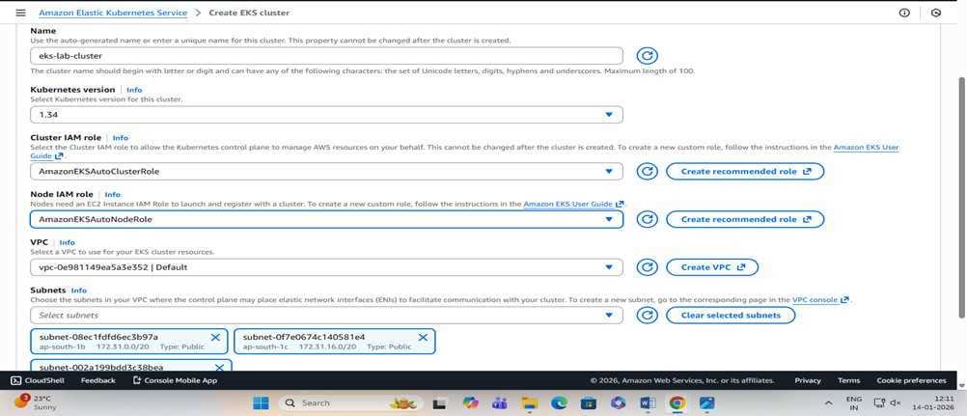ARN ending with :root Then IAM is **100% fine**.

This automatically:

* + Creates a **new VPC** with correct subnets/routes
  + Creates the **EKS cluster**
  + Creates the **Managed Node Group (worker nodes)**
  + Configures kubeconfig for you

Wait until it completes (it will print “cluster created”)

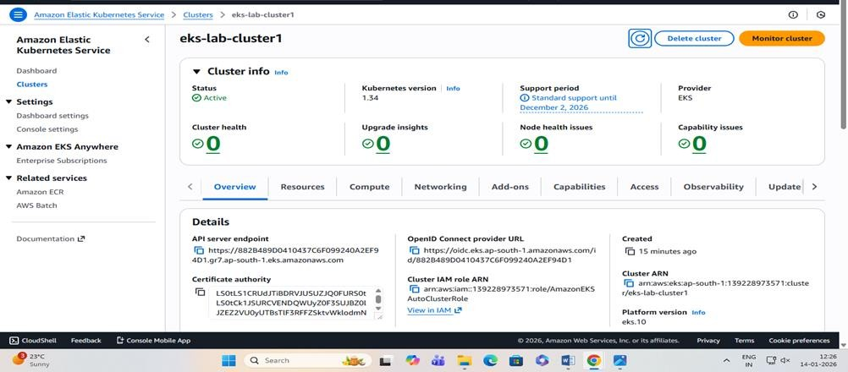

#### Step A4: Verify nodes

kubectl get nodes

Expected: 2 nodes in **Ready** state.

#### Step A5: Deploy Nginx

kubectl create deployment webapp --image=nginx kubectl get pods

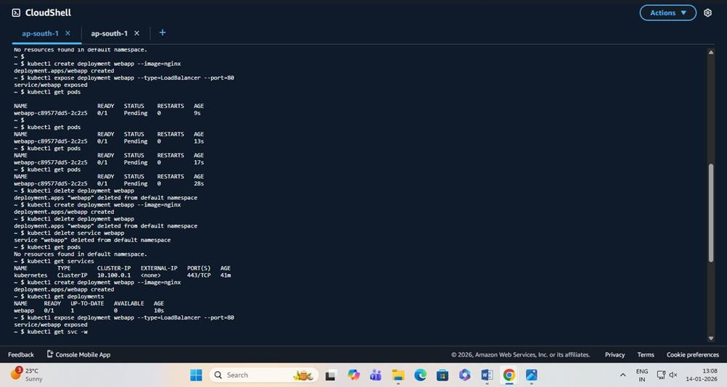

#### Step A6: Expose using LoadBalancer

kubectl expose deployment webapp --type=LoadBalancer --port=80 kubectl get svc

Wait until EXTERNAL-IP becomes a value (not <pending>).

#### Step A7: Open in browser

Copy the EXTERNAL-IP and open: http://<EXTERNAL-IP>

Expected: **Nginx welcome page**

